Meeting Highlights for October 4, 2016

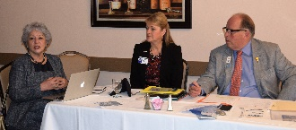
The meeting today featured District 5170 Governor (DG) Jeff Orth and his wife, Barbara. The DG visits every Club in the District at least once during the year. Today’s visit was #31 for DG Orth. He also meet with the Board of Directors for an hour prior to lunch to share his goals for Rotary and to learn what the Club was doing. Information from that meeting will be included in the Board Minutes.

Membership
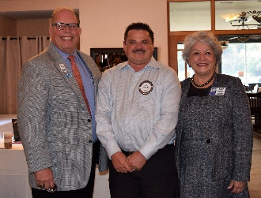
DG Jeff Orth formally presented Todd Anglin with his Blue Badge. Todd earned his Blue Badge in less than five months as a member. Walt Schneider was Todd’s sponsor. Good work, Walt.

DG Jeff Orth also challenged each of us to recruit a new member within the next 90 days and the clock is ticking.

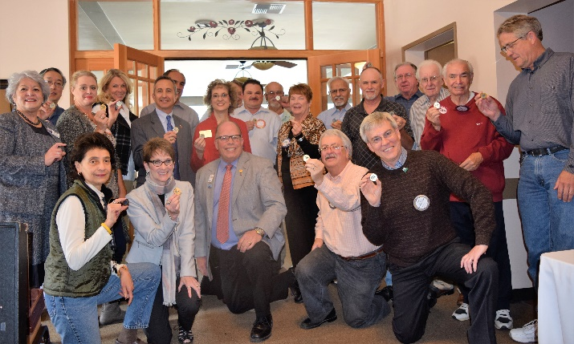
The Rotary Foundation (TRF)
This year is the 100th Anniversary of The Rotary Foundation, which does great work throughout the world. Dwight Perry, co-foundation chair with Dan Willits, reviewed what TRF does and asked that all members contribute whatever they can to TRF. Members who contribute at least $200 are considered Double Sustainers. This year, DG Orth has created a 100th Anniversary coin to present to all Double Sustainers.

Stinking Rose Award
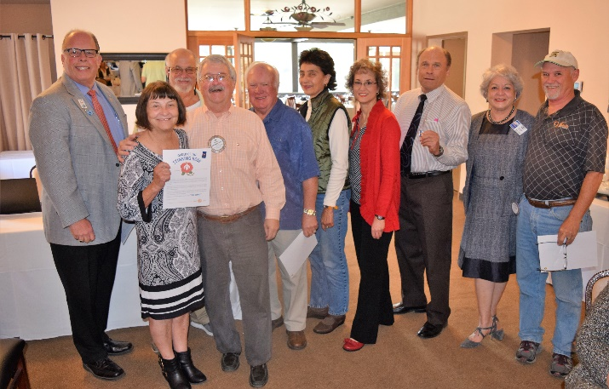
Since DG Orth is a member of the Rotary Club of Gilroy, he has created a special award with a proclamation and pin that he presents to Rotarians for Service Above Self. Dwight Perry helped create the pin. The proclamation for the Stinking Rose Award is You Stink! The award was presented to Ceta Dochterman, Bill Nott, Jim Negri, Dwight Perry, Margie Ramos, Heidi Hausauer, Gary Bosley, Carol Wikle, Randy Vanderbilt and not picture Obse Lubo and Ken O'Donnell for their year round valuable service to the club.

Save the Date – Breathing for Life Gala
President Carol reminded all members to purchase tickets online and recruit sponsors for the Breathing for Life Gala on October 22nd at Redwood Canyon Golf Course. The deadline to purchase tickets is fast approaching. If you cannot attend, please consider making a donation in any amount to support the project. Please mark "Breathing for Life" on the note section of the check and make sure that your name and address are included in order to receive a receipt from District 5170 501 (c)3 94-306176. The goal for the Gala is to raise the Club’s $25,000 for the project. Your support is greatly appreciated.
Barbara Orth – Read Me a Picture
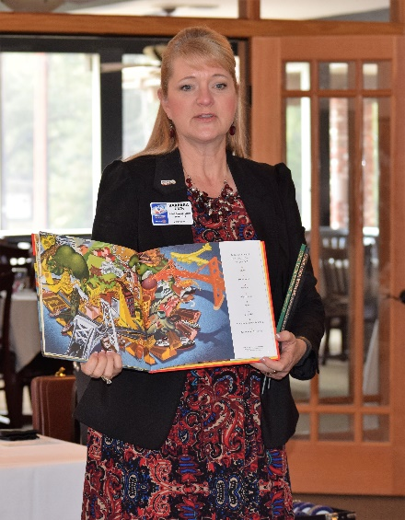
One of the traditions in District 5170 is that the spouse of the District Governor (DG) identifies a project to support a need in the District or world. President Carol introduced Barbara Orth, the DG Jeff Orth’s wife, who is sponsoring the program Read Me a Picture that provides every low income, K-1 student with a book of famous artwork. Barbara has arranged a 50% discount on the price of the books with Barnes & Noble. All of the funds donated to this project by Club members will purchase books that the Club can distribute to Castro Valley students.

Dawn Ortiz and Jim Negri each pledged $100 to the project. To make a donation, make your check in any amount to the Rotary Club of Castro Valley and give it to Todd Anglin at the next meeting or mail it to the P.O. Box. The Club will send the donations to District 5170. (More information is available at http://preview.tinyurl.com/ReadMeAPicture.
.
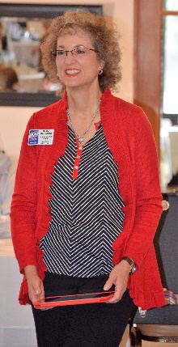
District Governor Jeff Orth
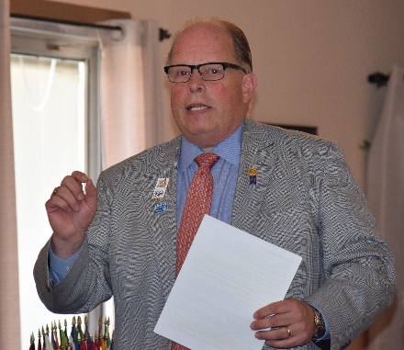
Heather Hausauer, District 5170 Assistant Governor for Area 2, introduced District Governor Jeff Orth who is visiting all the Clubs in District 5170 describe and build support for his vision for the District. DG Orth focused on

- Each Club more actively recruiting new and younger members, which takes a different approach than when we became Rotarians.
- Each Club being more involved with Community Projects on both the local and international levels.

- All members to be more involved in the projects of the clubs (e.g., Breathing for Life).
- All Rotarians in this District in the forefront and participating in as many projects as possible for helping humanity throughout the world.

He concluded his presentation with a short video clip promoting the District 5170 Conference on May 6-7 at the Santa Cruz Boardwalk. Details on the District 5170 website.

More Photo Highlights
