Rotary Club of Castro Valley
Meeting Highlights – October 9, 2018

David Stark – Update on the Current State of the Real Estate Market in Central Alameda County

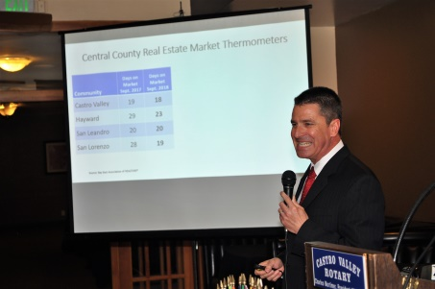
David Stark, Bay East Public Affairs Director, spoke to the club about the local real estate market. David started with an overview of how we got to where we are state-wide with the housing markets (creating more jobs but not enough housing to keep up) and then focused on the local housing market showing multiple charts to illustrate his conclusions that the housing market will remain strong due to supply and demand. He stressed multiple times that we are blessed to live in Castro Valley where the average residential home now sells for $880,000 . . .

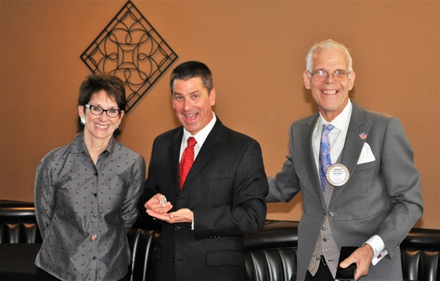
President Charles and Murline present David with the presidential pin and other speaker gifts.

Other items of note:

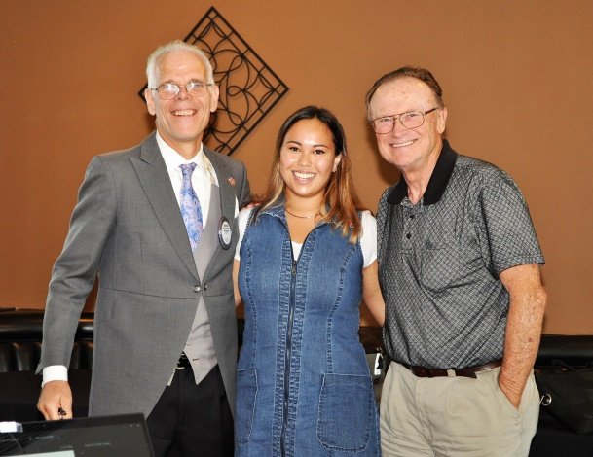
RYLA Attendee Update: Sonja Chen, 2013 graduate of Redwood Christian High School, presented an update on her life that illustrated how our investment in her attending Camp RYLA in 2012 has been multiplied many times as she has returned as a volunteer to Camp RYLA for the last five summers and is now a member of the leadership team. She graduated in 2017 from the University of California at San Diego State with a degree in Anthropology. She has a book in the works which is a creative non-fiction about the historic and modern immigrant experience in the Santa Clara Valley, spanning the canning industry, the industrialization and militarization of the region, and the Silicon Valley era, including examining the legal limits and industry changes in each of the three eras. We, the Rotary Club of Castro Valley, are so very proud of Sonja! What a great return on our investment in her life!
(With President Charles and Bruce Johnson in the photo)

Song: Ben Gulule led us in My Country ‘Tis of Thee (America) for a change of pace. President Charles inserted the words to “God Save the Queen” in reference to his being a Yorkshireman.

Thought for the Day: Bob Shayler per Benjamin Franklin "We are all born ignorant, but one must work hard to remain stupid."

Four Way Test: Ceta Dochterman gave a tremendous presentation of practical application of the Four Way Test . . . extremely well done . . . ask her if you missed it . . .

Birthday Boy: Randy Vanderbilt turned 60 as did his San Francisco Giants . . . donning the Giants 60th anniversary polo to make his point! Randy was serenaded with the Happy Birthday song!

Drawing: Michaela Thompson’s ticket was drawn and she reached into the bag and . . . and won $135!

Pay it forwards: None this week!
Upcoming Dates:
Nov. 9 – San Leandro Rotary Crab Feed; $80 ticket
Nov. 14 - HARD Senior Center Luncheon; Two shifts:
8:30 am – 11:30 am; Prepare food and room
11:30 am – 1:00 pm; Serving and cleanup
Sign up with Carol Bigelow
