ROTARY

BASICS

a reference guide for members



Rotary(®

ROTARY’S VISION STATEMENT

TOGETHER WE SEE A WORLD WHERE PEOPLE UNITE AND TAKE ACTION
TO CREATE LASTING
CHANGE ACROSS THE GLOBE,
IN OUR COMMUNITIES, AND IN OURSELVES

CONTENTS

WHO WE ARE 2
HOW WE’RE STRUCTURED 3
Clubs 3
Members 4
Meetings 4
Districts and zones 5
Our leaders 6
OUR HISTORY 7
WHAT WE VALUE 8
Avenues of Service 8
Areas of focus 9
The Four-Way Test 10
The Object of Rotary 11
A culture of belonging 11
ROTARY INTERNATIONAL OFFICES 13
OUR IMPACT 16
The Rotary Foundation 16
Eradicating polio worldwide 17
Rotary Peace Centers 18
Rotary grants 18
The Cadre of Technical Advisers 19
Rotary partnerships 20

ROTARY’S IMAGE 21
Rotary.org and My Rotary 22
Social media 23
INTERNATIONAL EXPERIENCES 24
The Rotary International Convention 24
Project fairs 25
Rotary Fellowships and Rotary Action
Groups 25
Rotary Friendship Exchange 26
Rotary Community Corps 26
PROGRAMS FOR YOUNG LEADERS 27
Interact 27
Rotary Youth Exchange 27
Rotary Youth Leadership Awards (RYLA) 28
LEARNING AND SKILL BUILDING 29
WHAT’S NEXT? 30
APPENDIX: OPTIMIZE YOUR MEMBER EXPERIENCE 31
ROTARY GLOSSARY 33

WHO WE ARE

Rotary is a global network of more than
1.2 million people of action who belong to more than 45,000 Rotary and Rotaract clubs. What they all share is a passion for solving problems and improving people’s lives. Our members work in their own communities and partner with other clubs on international projects that address today’s most pressing challenges. In taking action and making a difference, they develop their leadership skills, get a sense of accomplishment, and form lifelong friendships. We have Rotary and Rotaract clubs in almost every country
DID YOU KNOW?
The name Rotary was selected by early members
because their meeting location rotated among their offices.
in the world.

HOW WE’RE STRUCTURED

Rotary is made up of two parts: Rotary International and The Rotary Foundation. Rotary and Rotaract clubs belong to the global association Rotary International, or RI. Rotary International supports its clubs by coordinating global programs and initiatives. The Rotary Foundation helps fund our humanitarian work, from local service projects to worldwide initiatives.
If you’re unfamiliar with a term, refer to the glossary on page 33.

CLUBS
DID YOU KNOW?
If you know someone who would enjoy getting involved but can’t attend your club’s meetings, you can
refer them to join.rotary.org to connect with another club.
The club is the most important component of Rotary’s organizational structure.
Rotary clubs bring together professionals and other leaders who meet regularly for service, connection, and personal growth. Rotary clubs are for people who are looking for friendship, service, and networking opportunities, across generations and industries.
Rotaract clubs bring together people ages 18 and older who take action through
community and international service while learning leadership skills and developing professionally. Rotaract clubs are especially for younger professionals who want to have fun through service.

MEMBERS
Members of Rotary clubs are also known as Rotarians, and members of Rotaract clubs are called Rotaractors. Each Rotary or Rotaract club, in turn, is considered a member of Rotary International. Although all of our clubs address local and global issues through various initiatives, they are autonomous, so what it’s like to be a member varies from club to club. Strong, well-run clubs enhance our members’ experiences and deliver valuable service to our communities.
As a member, you have far greater potential to do good in your community than you did before you joined. You’ll have many opportunities to use your expertise, skills, and talents to make a difference in the lives of others and for causes you care about while you make connections with other professionals and community leaders.

MEETINGS
Rotary and Rotaract club meetings differ by club. Some clubs meet weekly in person while others meet online, less frequently, or less formally. All clubs offer service and social opportunities, and some focus on particular causes, invite guest speakers, or plan annual events. Rotary is apolitical and nonreligious, and all clubs are expected to create a welcoming and inclusive environment that offers a positive club membership experience for everyone.

DISTRICTS AND ZONES
B
S
Clubs are grouped into more than 500 districts around the world. Each district is led by a governor along with a team of assistant governors and district committees. Together, they support and strengthen
clubs and motivate them to carry out service projects. The district leadership team organizes learning seminars, supports membership development and the formation of new clubs, facilitates grants, strengthens Rotary’s public image, and connects clubs with each other and to Rotary resources. District leaders ensure that clubs have the tools and support they need to thrive.
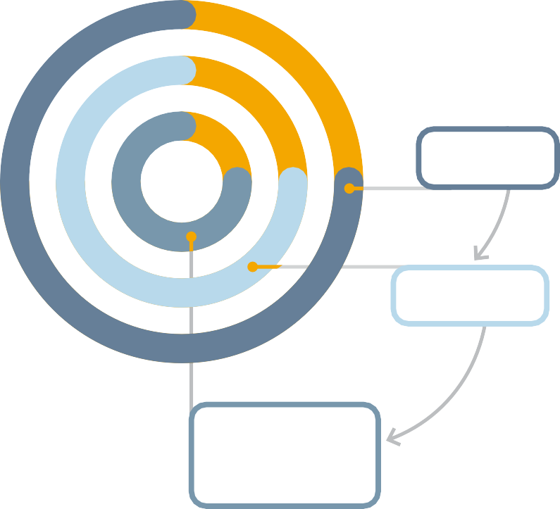
Districts are organized into 34 zones that have approximately equal numbers of members. These zones nominate members for our Board of Directors and elect the committee that nominates the president of Rotary International.
34 regional
ZONES
More than 500
DISTRICTS
More than 36,000 Rotary CLUBS and more than 9,000
Rotaract CLUBS
D
C
I
S
Z
L
T
O
N
R
U
E
I
S
C
T
S

OUR LEADERS
Our leaders at Rotary exemplify the qualities that make our members extraordinary: integrity, expertise, and a commitment to service.
The executive staff, led by the general secretary, manages Rotary’s operations in the areas of programs and engagement, member and participant experience, financial services, information technology, polio eradication and philanthropy, communications and marketing, strategy, legal services, and people and talent at our world headquarters and offices around the world.
Rotary International’s president presides over the Board of Directors and is elected to a one-year term.
DID YOU KNOW?
The first Rotary club formed in Chicago, Illinois, USA, on 23 February
1905.
The Board of Directors establishes Rotary International’s policies and provides guidance that helps our clubs thrive. Rotary clubs elect the directors, who serve two-year terms.
The Board of Trustees manages the business of The Rotary Foundation, the charitable arm of our organization. The RI president-elect nominates trustees, and the Board of Directors elects them to four-year terms.

OUR HISTORY

We’ve been making history and bringing our world closer together for more than 120 years. The first Rotary club was started in Chicago,
Illinois, USA, in 1905 by an attorney named Paul Harris. Harris wanted to bring together a group of professionals with different backgrounds and skills to exchange ideas and form meaningful acquaintances. In August 1910, the 16 Rotary clubs then in the United States formed
the National Association of Rotary Clubs, now Rotary International. In 1912, Rotary expanded to a few more countries, and less than a decade later, Rotary clubs had been established in Africa, Asia, Central America, Europe, Oceania, and South America. Rotaract began as a Rotary youth program in 1968. In 2019, Rotaract was elevated from a program to a distinct membership type. For more information about Rotary’s history, go to rotary.org/history.

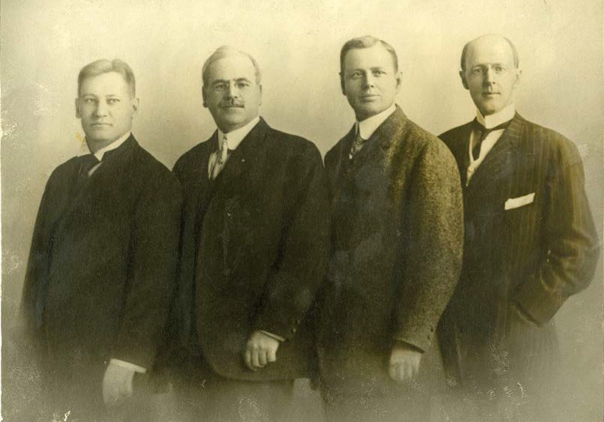
The first four Rotarians: Gustavus Loehr, Silvester Schiele, Hiram Shorey, and Paul P. Harris, circa 1905-12

WHAT WE VALUE
DID YOU KNOW?
Members can earn an Avenues of Service Award by
participating in service
in one of the five Avenues of Service: club, vocational, community,
international, or youth service.

Rotary was founded on principles that we are still committed to today. These principles shaped our core values: integrity, diversity, service, leadership, and fellowship, or friendship.

AVENUES OF SERVICE
We channel our commitment to service through these Avenues of Service, which are the foundation of club activity:
- Club Service focuses on making clubs strong. A thriving club is anchored
by strong relationships and a robust membership development plan. When
members serve their clubs (for example, by sponsoring a new member or serving on a committee or in another leadership role), they help their clubs function successfully.
- Vocational Service calls on all members to work with integrity and contribute their career-related or other expertise to help address the problems and needs of society.
- Community Service encourages every member to find ways to improve the quality of life of people in their communities and to serve the public interest.
- International Service exemplifies our global reach in promoting peace and understanding. We support this avenue by sponsoring or volunteering on international projects, using
local members’ expertise to build long-distance partnerships for sustainable projects, seeking service partners abroad, and more.

  - Youth Service recognizes the importance of empowering youth through leadership development programs such as Interact, Rotary Youth Leadership Awards, and Rotary Youth Exchange.

AREAS OF FOCUS
The causes we concentrate on to maximize our impact are called our areas of focus. Our most successful and sustainable service projects and activities fall within these areas. We help clubs focus their service efforts on:


Peacebuilding and conflict prevention

Disease prevention and treatment

Water, sanitation, and hygiene
Maternal and child health


Basic education and literacy

Community economic development

Environment

These areas of focus are aligned with the 17 Sustainable Development Goals of the United Nations. When our members take action in these areas, they join with others around the world to tackle the major challenges humanity faces today.
Projects that focus on these causes are eligible to apply for global grants and Programs of Scale grant funding from The Rotary Foundation.
Rotary’s motto, Service Above Self, reflects our belief in leading through service.

THE FOUR-WAY TEST
From the beginning, members have emphasized the importance of acting responsibly and ethically and using our professions as an opportunity to serve. Honoring our commitments, however bold
they are, is an ideal characteristic of a Rotary member. In 1932, The Four-Way Test was developed by Herbert Taylor, the 1954-55 RI president. Rotary later adopted The Four-Way Test, and it has long served as an ethical guide for members to live by in their personal and professional relationships.
OF THE THINGS WE THINK, SAY OR DO:
- Is it the TRUTH?
- Is it FAIR to all concerned?
- Will it build GOODWILL and BETTER FRIENDSHIPS?
- Will it be BENEFICIAL to all concerned?

THE OBJECT OF ROTARY
In Rotary’s first decade, members set out guiding principles that evolved into what is now known as the Object of Rotary. They added the advancement of peace in 1921 and updated the language in 1989 and 1995.
The Object of Rotary is to encourage and foster the ideal of service as a basis of worthy enterprise and, in particular, to encourage and foster:
FIRST: The development of acquaintance as an opportunity for service;
SECOND: High ethical standards in business and professions; the recognition of the worthiness of all useful occupations; and the dignifying of each member’s occupation as an opportunity to serve society;
THIRD: The application of the ideal of service in each member’s personal, business, and community life;
FOURTH: The advancement of international understanding, goodwill, and peace through a world fellowship of business and professional persons united in the ideal of service.

Although your club may not emphasize all of these principles, understanding them puts your club experience into perspective and adds meaning to being a part of this organization.

A CULTURE OF BELONGING
At Rotary, we believe that every member should feel a true sense of belonging. As a global organization, we celebrate the richness of our diverse communities, and our goal is to ensure that all members are fully included, respected, and valued.

We are committed to creating environments where people from all backgrounds can contribute, collaborate, and thrive. We embrace differences in culture, experience, identity, and thought, and we recognize the power of these differences in making our communities stronger and more innovative.
We believe that inclusion requires more than simply welcoming others. It means creating an environment where each person feels valued and can be heard and supported. It means cultivating a culture where differences are celebrated.
Rotary encourages clubs to reflect the diversity of the communities they serve by welcoming members from a variety of backgrounds, professions, and perspectives.
Through our commitment to inclusion, we can empower everyone to lead and to contribute to Rotary’s mission. Together, we can ensure that every member has the resources, opportunities, and support they need to succeed. By embracing belonging, we unlock the potential for everyone to act and make lasting change together.

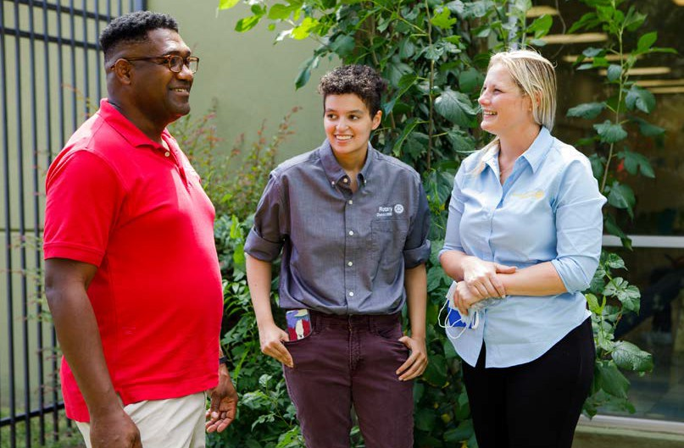
Clubs are most successful when they reflect the communities they serve.

ROTARY INTERNATIONAL OFFICES

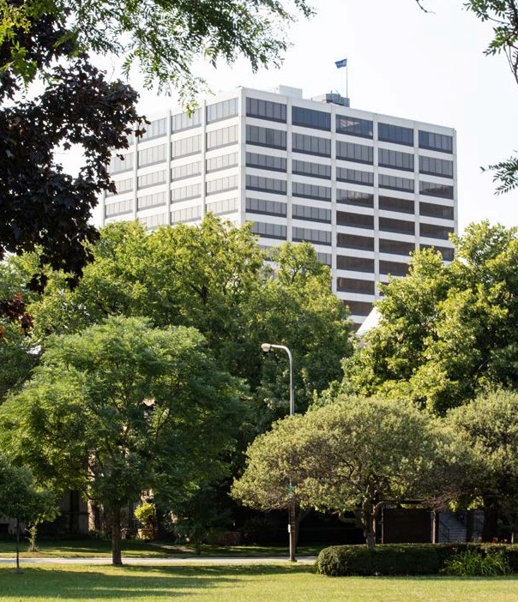
Rotary International World Headquarters in Evanston, Illinois, USA
Rotary’s staff, also known as the Secretariat, supports our members, clubs, districts, program participants, and alumni. There are more
than 800 employees in several offices around the world who work to make Rotary International and The Rotary Foundation run effectively.

Club and District Support (CDS) representatives and regional membership officers provide regionalized expertise to the clubs and districts they work with as well as guidance on Rotary’s policies, procedures, resources, and tools. They often attend club and district meetings to meet with Rotary leaders and prepare them for their roles. Find your club’s CDS representative at rotary.org/cds. You can also contact the Rotary Support Center at +1-866-9ROTARY (+1-866-976-8279) or rotarysupportcenter@rotary.org to ask questions about Rotary and its programs.

Rotary’s world headquarters is in Evanston, Illinois, USA, in a building called One Rotary Center. It has a 190-seat auditorium, Rotary’s archives, and an executive suite with conference rooms for the RI Board of Directors and Rotary Foundation Trustees and the offices of the RI president and other senior officers. It also features exhibits about our history and our vision for the future.
Free guided tours are offered Monday through Friday and should be requested in advance. Learn more and request a tour at rotary.org/visit.

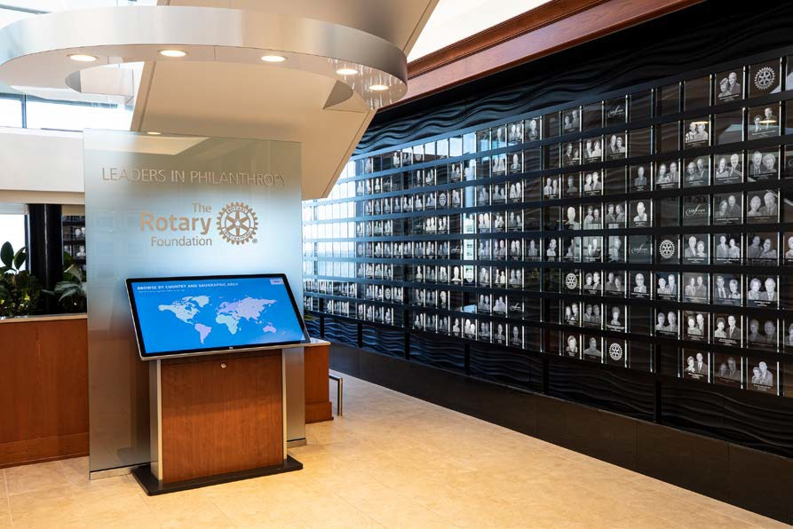
The Arch Klumph Society Gallery on the 17th floor of Rotary International World Headquarters

Rotary International’s offices:
One Rotary Center
Evanston, Illinois, USA
Europe and Africa office
Zurich, Switzerland
South Asia office
New Delhi, India
Brazil office
São Paulo
Japan office
Tokyo
Korea office
Seoul
South Pacific and Philippines office
Norwest (Sydney), Australia
Rotary International in Great Britain and Ireland (Rotary GB&I)
Alcester, England, an office that is independent but affiliated with Rotary
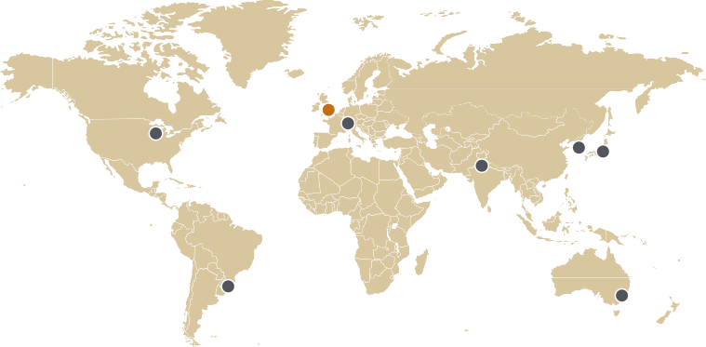

OUR IMPACT

THE ROTARY FOUNDATION
In 1917, Rotary President Arch Klumph voiced his idea for an endowment fund dedicated to “doing good in the world.” With this short statement, Klumph inspired the establishment of The
Rotary Foundation. Today, The Rotary Foundation helps clubs and districts work together to perform meaningful service. Our top-rated, award-winning Foundation has spent more than US$6.5 billion on life-changing, sustainable projects that help people in need around the world get clean water, medical care, literacy classes, and other essentials.
Our members’ and others’ contributions to the Foundation allow us to bring positive, lasting change to communities. Ask your club’s
Rotary Foundation expert or visit rotary.org/donate to learn how you can support our Foundation. To learn more about everything the Foundation does, download The Rotary Foundation Reference Guide or take the Rotary Foundation Essentials course in Rotary’s Learning Center.
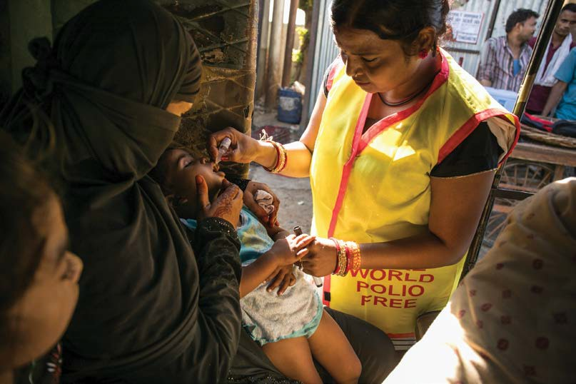
A Rotary member administers the polio vaccine.

ERADICATING POLIO WORLDWIDE
DID YOU KNOW?
Rotary International began its fight against polio in
1979 with a multiyear
immunization project in the Philippines.
Since 1985, Rotary members have served as community-based mobilizers for polio eradication by motivating international
groups, governments, private organizations, communities, and individuals to join the global effort to rid the world of polio, a potentially paralyzing disease that especially affects children.
Rotary is working with partners and governments around the world to achieve this historic public health goal. As part of the effort, members contribute their time and money to the cause. They raise funds,
advocate for governmental support, help immunize children, and raise awareness in their communities. Rotary’s contributions to the global eradication effort have reached nearly US$3 billion. Hundreds of thousands of volunteers have supported massive vaccination campaigns known as National Immunization Days. Since 1988,
3 billion children have received the oral polio vaccine, and we’ve achieved a 99.9% reduction in polio cases.
The effort to eradicate polio is one of the greatest humanitarian service efforts in history, and every Rotary member can take pride in the incredible progress we and our partners have made. To learn how you can support Rotary’s efforts to eradicate polio, visit endpolio.org.

ROTARY PEACE CENTERS
Each year, up to 130 peace and development leaders are selected to become Rotary Peace Fellows. They earn either a master’s
degree or an advanced professional development certificate in disciplines related to peace studies, conflict prevention, and sustainable development at one of the Rotary Peace Centers located at leading universities around the world.
Through the program’s courses, field studies, social change projects, and global networking opportunities, Rotary Peace Fellows develop their capacity to be effective catalysts for peace.
Rotary clubs and districts play a role in all of this by recruiting candidates from their communities to apply for Rotary Peace Fellowships. Rotary Peace Fellows go on to serve as leaders in government, nongovernmental organizations, education and research, military and law enforcement, humanitarian work, media and the arts, and international agencies such as the United Nations and the World Bank.

ROTARY GRANTS
Rotary clubs and districts around the world can apply for grants from The Rotary Foundation to pay for service projects, offer scholarships, and support other initiatives that make a difference in their own communities or far away. These Rotary Foundation grants are funded by voluntary donations from members and friends of Rotary.
- District grants fund smaller-scale, short-term projects that address immediate needs locally or abroad.
- Global grants fund large international projects that have long-term, sustainable, and measurable outcomes and are aligned with Rotary’s areas of focus.
- Disaster response grants support relief and recovery efforts in areas that have been affected by a disaster.
- Programs of Scale grants allow Rotary members to work with experienced partners and expand proven programs that align with an area of focus to make a significant impact.

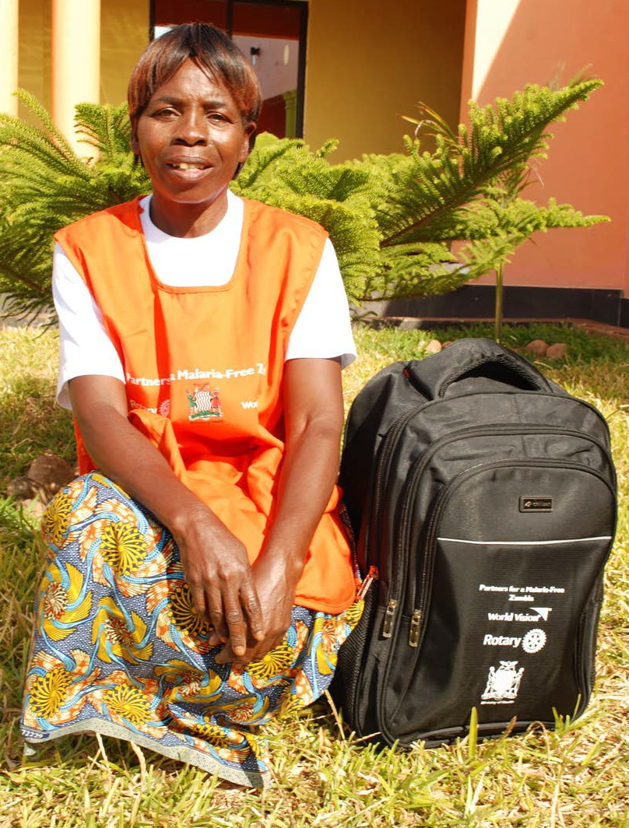
The first Programs of Scale award aimed to reduce severe cases of malaria in Zambia. Through the program, women like this one became volunteer community health workers who can test patients for malaria and offer treatment or refer them to other health care providers.

To learn more, talk to your club or district Rotary Foundation chair or visit rotary.org/grants.

THE CADRE OF TECHNICAL ADVISERS
The Rotary Foundation Cadre of Technical Advisers is a network of Rotary members who volunteer their professional skills and technical expertise in our areas of focus and financial management to increase the impact of Rotary projects. The Cadre helps Rotary members plan projects, submit stronger grant applications, and monitor and evaluate their projects. Cadre advisers play an integral part in The Rotary Foundation’s stewardship efforts by conducting audits and reviewing programs. Learn more at rotary.org/cadre.

ROTARY PARTNERSHIPS
Rotary increases its impact in communities around the world by developing and supporting partnerships. Each partnership is expected to accomplish at least one of the following:
- Align with our strategic plan, the Action Plan
- Relate to one or more of our areas of focus
- Provide opportunities for building our public image
- Attract new members, contributions, or project volunteers Learn more and view a list of our partners at rotary.org/partners.

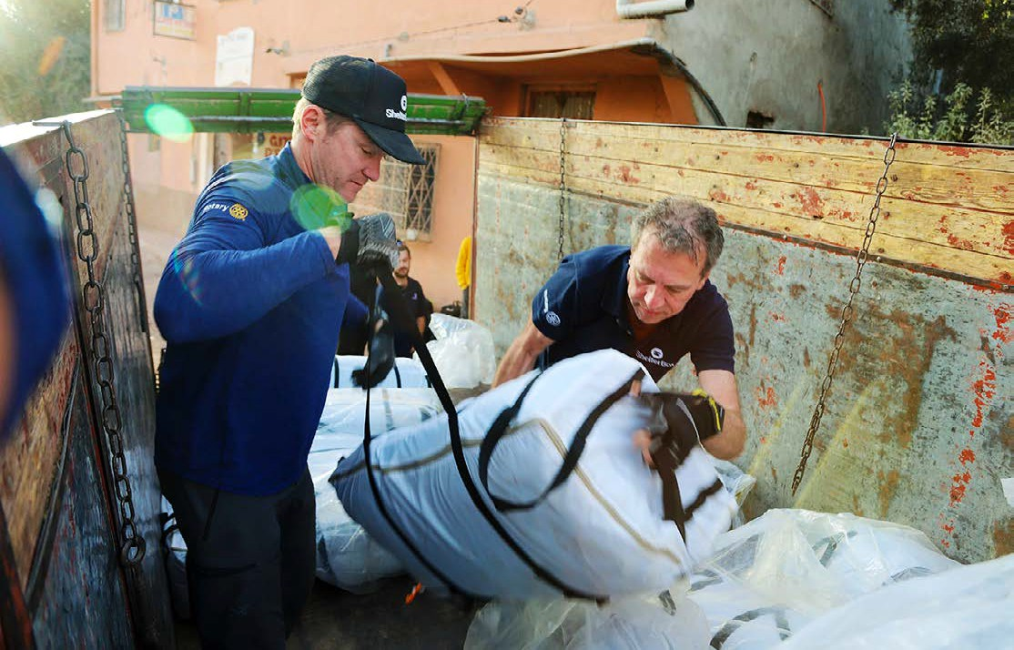
ShelterBox and Rotary members distributed tents and other emergency supplies to people affected by the earthquake in Morocco in 2023.

ROTARY’S IMAGE

Rotary’s image should reflect our vision and values, as well as our unique approach to creating lasting, positive change. People’s perception of Rotary comes from their experiences with our clubs and programs, along with the stories we tell and the images we share. Each of us can improve the public’s understanding of our organization and make sure Rotary is recognized for the important work we do by telling the Rotary story and explaining why we’re proud to be a part of it.


The Rotary and Rotaract logos represent us around the world. Learn more at brandcenter.rotary.org.

ROTARY.ORG AND MY ROTARY
Rotary.org is our website that is primarily for the public, program participants, and other nonmembers. It describes our programs and initiatives. It also includes content of interest to members, like the latest Rotary news and online giving opportunities.
Our official website for members, My Rotary, offers details about Rotary membership, programs, scholarships, and events, as well as stories of Rotary service and other activities. When you register for a My Rotary account, you get access to:
- Announcements — Get important updates from Rotary, such as presidential messages and the latest club and program resources.
- Brand Center — Find resources and guidance along with customizable materials you can use to promote your club, projects, and programs.
- Club Search — Whether you’re traveling across town or around the globe, find a club to visit.
- Grant Center — Apply for and manage your club’s grants.
- Learning Center — Take online courses about Rotary and professional development topics.
- Member Search — Connect with members outside of your club or program.
- Rotary Club Central — See your club’s profile and goals.
- Service Project Center — Explore the good work that members are doing locally and globally, and share these projects through social media.
With a My Rotary account, you can also register for international events and network with other members. To learn how to get one, download How to Create a My Rotary Account.

SOCIAL MEDIA
Rotary posts on social media to share impactful initiatives and stories with a global audience, fostering connections both within and beyond the Rotary community. You can follow Rotary on:
  - Facebook
  - Instagram
  - LinkedIn
  - WhatsApp
  - X
  - YouTube
See a full list of our social media channels to follow specific programs, groups, and leaders.

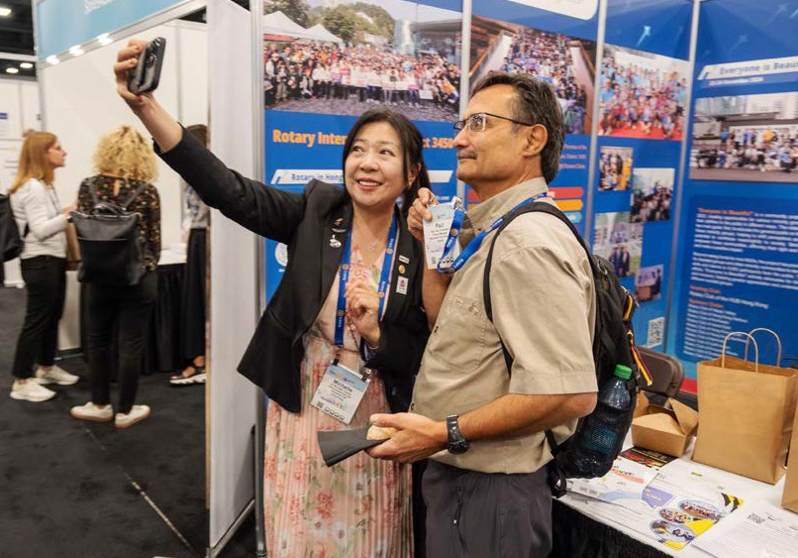
The House of Friendship at the 2025 Rotary International Convention. The hall features about 200 booths.

INTERNATIONAL EXPERIENCES

Being a Rotary member gives you many opportunities to have international experiences and make connections with people around the world. You can host a Rotary Youth Exchange student, attend an international meeting, visit another club while traveling, or partner with a club in another country to do a project.
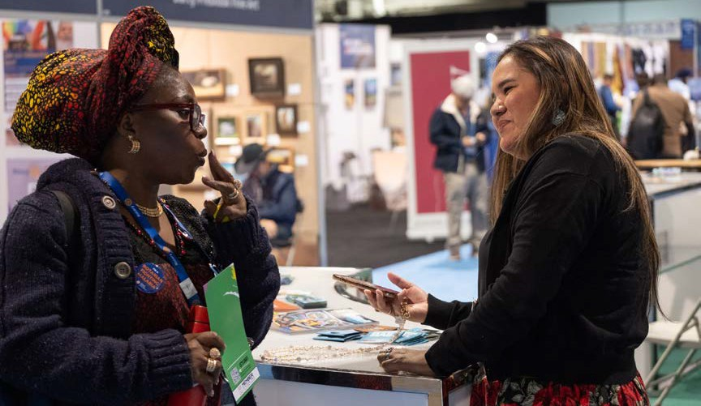
Attendees at the Rotary International Convention in 2025

THE ROTARY INTERNATIONAL CONVENTION
DID YOU KNOW?
Rotary’s
first convention was held
in Chicago, Illinois, USA, in August 1910.
The Rotary International Convention takes place in May or June and welcomes all members, their families, and program
participants and alumni, as well as the public. It’s held in a different city each year and is attended by tens of thousands of people.
At the convention, we network, celebrate Rotary, and connect with members from around the world.

PROJECT FAIRS
Hosted by districts, project fairs invite Rotary members and leaders from different countries to explore potential service collaborations with local clubs that have ideas for projects. These fairs typically
last two to three days and include visits to service project sites and opportunities to experience the host country’s culture. Any club member or representative who is interested in supporting an
international project is welcome to attend. District grants can be used to pay for the costs of travel and participation.

ROTARY FELLOWSHIPS AND ROTARY ACTION GROUPS
Our members have skills, passions, and identities that are as diverse as they are. Two types of international groups offer Rotary members and their friends ways to build community while pursuing common interests with others worldwide. Rotary Fellowships relate to professional or recreational interests, and Rotary Action Groups focus on humanitarian service in specific areas.
Rotary Fellowships represent an abundance of recreational pursuits, including beekeeping, cycling, fishing, gardening, music, bird watching, and professional interests such as graphic design, editing and publishing, leadership development, photography, and public health. They also help build community around shared culture and identities. Their activities are as varied as their interests. Learn more at rotary.org/fellowships.

Rotary Action Groups help Rotary and Rotaract clubs and districts plan and implement large-scale humanitarian projects in their areas of expertise. For example, the experts in the Water, Sanitation, and Hygiene Rotary Action Group advise clubs and districts on how to undertake water projects that make a real impact. The Rotary Action Group for Family Health and AIDS Prevention mobilizes members to help tens of thousands of people in under-resourced communities get low-cost, comprehensive health services and screenings. Learn more at rotary.org/actiongroups.

ROTARY FRIENDSHIP EXCHANGE
Through Rotary Friendship Exchange, participants explore new cultures and discover different perspectives. Participating in an exchange is a wonderful way to make new friends, establish international service partnerships, and strengthen intercultural understanding. Both members and nonmembers are welcome to participate.

ROTARY COMMUNITY CORPS
A Rotary Community Corps (RCC) is a group of non-Rotary members who work in partnership with at least one Rotary club to make positive change through service projects. They bring the knowledge and talents of additional community members into
projects while leveraging Rotary’s network and brand as they plan and implement their projects.
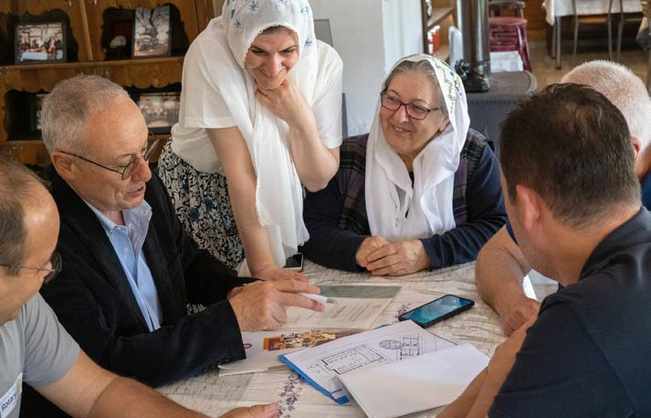
The Rotary Club of Bursa-Uludag, Turkey, established the Rotary Community Corps of Aksu Village in 2011 to support local women in establishing or expanding small businesses.

PROGRAMS FOR YOUNG LEADERS

We believe in investing in our future by empowering young leaders, helping them learn leadership skills, and giving them opportunities to have cross-cultural experiences.

INTERACT
Interact clubs give young people ages 12-18 the chance to work together and have fun while learning about service and promoting international understanding. Each club is required to complete at least two major projects each year, one to serve the community and the other to promote international understanding. Interact clubs are sponsored by nearby Rotary clubs and may be co-sponsored by Rotaract clubs. If you’d like to work with an Interact club, ask your club leaders how you can get involved.

ROTARY YOUTH EXCHANGE
Rotary Youth Exchange promotes international understanding and lifelong friendships by letting young people explore another culture.
Exchanges can be long-term or short-term. Short-term exchanges last from a few days to several months and often take place when school is not in session. Students typically stay with a local family in the host country, but they might also attend a youth camp or tour the country with other foreign students. During a long-term exchange, students spend a year in another country, attending school and living with
host families. Exchanges vary widely among districts, so contact your district’s Rotary Youth Exchange chair to learn what’s available in your area.

ROTARY YOUTH LEADERSHIP AWARDS (RYLA)
Each year, thousands of young people are selected to attend leadership camps or seminars through Rotary Youth Leadership Awards (RYLA). These events can be sponsored by a club, a district, or a group of districts. In an informal environment, participants spend several days in a challenging program, learning about leadership through facilitated discussions, inspirational addresses, and social activities designed to enhance their personal development, communication skills, and good citizenship. Each RYLA program or event is customized to the participants’ age range.
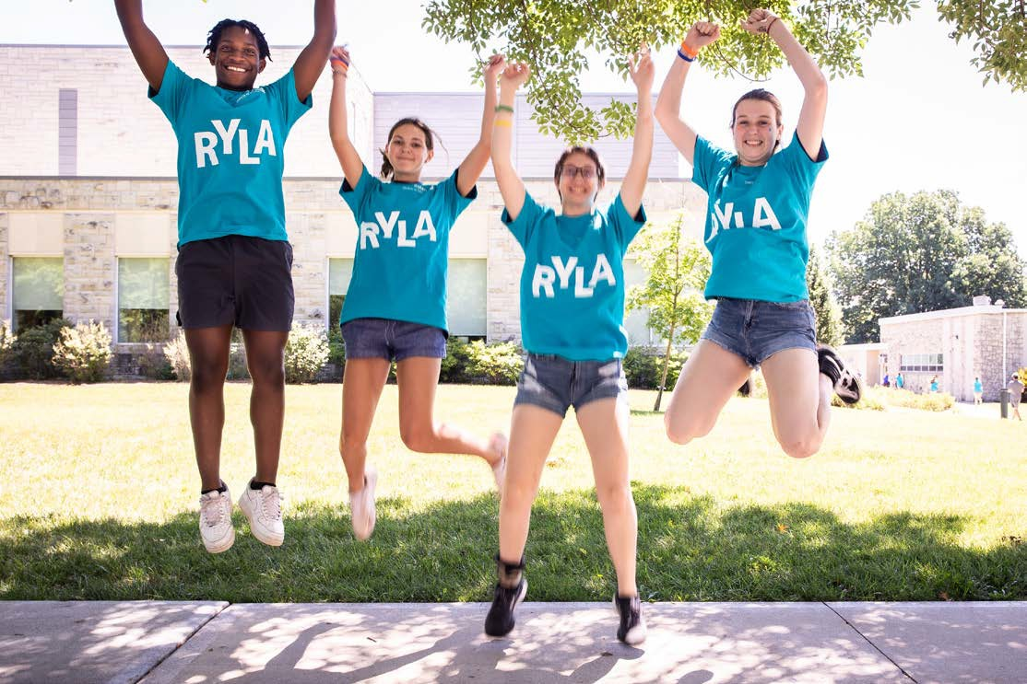
RYLA events instill values of service and leadership.

LEARNING AND SKILL BUILDING
DID YOU KNOW?
You can improve your communi-cation and leadership skills by taking courses from Rotary’s Professional Development catalog in
the Learning Center.

Your club may offer new members a structured orientation to acquaint them with Rotary and the club. As a member, you can also take courses on topics that interest you in the Learning Center, at rotary.org/ learn. Your club may offer other learning opportunities as well. Talk to your mentor, club learning facilitator, or other leaders and find out how you can get involved.
Your district hosts a yearly district vibrant club workshop and grant management seminar for all interested members. Districts may also hold annual conferences to celebrate the year’s accomplishments. These learning events are great places to meet people who share an interest in service and the community.
Districts also hold role-based learning events for incoming club presidents, secretaries, treasurers, and committee chairs, and for district committee chairs and assistant governors. If you take part as
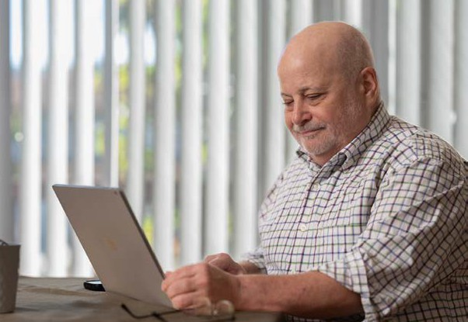
a speaker or learning facilitator, you’ll learn skills, such as project management, public speaking, and event planning, that can help you in your personal and professional life.

Visit the Learning Center to learn new skills that you can practice in your club.

WHAT’S NEXT?

The key to getting the most out of your Rotary or Rotaract club membership is to get involved in ways that suit your interests. The time and energy you invest will yield rich rewards. You can shape your club by talking with club leaders about your ideas, and as a member, you, too, are eligible to become a club leader. Over time, active members find that the connections they make through Rotary and Rotaract become lifelong friendships. For quick ideas on how to get started, go to the appendix, Optimize Your Member Experience. You can also download Designing Your Rotary Experience, an overview of the opportunities available to Rotary and Rotaract club members.

APPENDIX: OPTIMIZE YOUR MEMBER EXPERIENCE

Create a My Rotary account to make the most of your membership.
Attend as many club meetings and events as you can. Get to know different people each time.
Volunteer your skills and take on a role in your club, such as committee member, greeter, or webmaster.
Identify a need in your community and suggest a hands-on project that addresses it.
Take a course in the Learning Center to learn, for example, how to create sustainable service projects.
Develop and practice your leadership skills by taking courses in the Professional Development catalog in Rotary’s Learning Center.
Tell friends and colleagues how your club is giving back to your community.
Explore the unique opportunity Rotary presents for networking with leaders in many professions.
Get involved in your club’s service projects.
Discover Rotary stories from around the world on our blog,
Rotary 360, and on the Rotary Voices podcast.

Follow our Rotary Service in Action blog, where Rotarians, Rotaractors, and RI staff share their experiences, insights, and ideas about programs, service projects, and community and global initiatives.
Stay up-to-date by subscribing to newsletters from Rotary International at rotary.org/newsletters, reading your club and district newsletters, and visiting your club and district websites.
Help your club or district raise funds for polio eradication by
donating to our PolioPlus Fund.
Set a personal contribution goal in support of your club’s Annual Fund giving goal, donate through Rotary Direct, our recurring giving program, or use Raise for Rotary, a peer-to-peer fundraising platform, to encourage others to donate.
Propose a friend or colleague for membership in your club, or
refer a prospective member to another club.
Ask your club’s leaders how you can get involved in Rotary Youth Exchange, Interact, or RYLA.
Talk to club leaders about where your expertise is most needed.
Attend your club’s next assembly, and help plan club activities.
Join a Rotary Fellowship or Rotary Action Group and meet members from other countries who share your interests.
Participate in your district conference and the Rotary International Convention.
Visit another Rotary or Rotaract club’s meeting. If you don’t already know of a club you’d like to visit, use Club Search to find one. Then get its leaders’ contact information from the club’s website or the Official Directory and contact them.

ROTARY GLOSSARY

active member A club member who pays dues and enjoys
the privileges of membership as provided in Rotary’s constitutional documents
areas of focus The causes that Rotary concentrates its
service efforts on: peacebuilding and conflict prevention; disease prevention and treatment; water, sanitation, and hygiene; maternal and child health; basic education and literacy; community economic development; and environment
Cadre The Rotary Foundation Cadre of Technical Advisers, a network of Rotary members who volunteer their professional skills and
technical expertise in Rotary’s areas of focus and financial management to increase the impact of Rotary grant projects

Club and District Support (CDS)
Club Excellence
Award

club leadership learning seminar
Rotary staff members who provide specialized advice and support to club and district leaders
An award that Rotary, Rotaract, and Interact clubs can earn each year by achieving a number of goals that align with Rotary’s Action Plan
An event where incoming club leaders prepare for their roles

codes of policies Documents that detail Rotary International’s
and The Rotary Foundation’s policies and procedures. They are updated after each meeting of the RI Board or The Rotary Foundation Board of Trustees.

constitutional documents

Council on Legislation (COL)

Council on Resolutions

(COR)
district conference

District Designated Funds

(DDF)

district governor

(DG)

district governor-
elect (DGE)
district governor-nominee (DGN)
Rotary International’s governing documents are the RI Constitution, the RI Bylaws, and the Standard Rotary Club Constitution.
They can be amended only by the Council on Legislation.
A meeting where representatives from each district vote on changes to how Rotary and its clubs work that have been proposed by clubs, districts, or the RI Board. It takes place every three years.
A meeting held online every year to vote on proposed resolutions, which express opinions, and make recommendations to the RI Board
A meeting where a district makes decisions and celebrates its accomplishments. It is open to all members in the district.
Funding, generated by Annual Fund-SHARE contributions from all the members in a district, that districts can use to pay for Foundation, club, and district projects.
Contributions are divided between the World Fund and the District Designated Fund, after 5% is deducted for operating expenses.
An officer of RI who works with a district team to run and lead the district, motivating members, providing learning opportunities to clubs, and connecting them with resources
The person chosen to serve as district governor during the coming Rotary year
The person who will serve as governor during the year after the coming Rotary year

district membership chair (DMC)

district Rotary Foundation chair

(DRFC)

End Polio Now coordinator

(EPNC)

endowment/ major gifts
adviser (E/MGA)
The chair of the committee that sets and promotes a district’s membership strategy, manages the district’s membership leads, and nurtures new clubs
The chair of the committee that promotes Foundation grants and programs to clubs and inspires them to support the Foundation. The chair serves a three-year term.
A regional leader who fosters awareness of polio, advocates for its eradication, and
supports fundraising at the district and club levels to achieve the certification of polio eradication
A regional leader who is an expert on major gifts and Endowment Fund matters

family of Rotary Includes, along with members, all
nonmembers who are or have been involved in Rotary’s efforts, including alumni of Rotary programs and those who benefit from Rotary projects
general secretary The head of the Secretariat, who leads staff
at Rotary International World Headquarters and Rotary’s international offices

governance documents
Rotary International and The Rotary Foundation have governance documents that include their codes of policies, the Recommended Rotary Club Bylaws, and the Standard Rotaract Club Constitution. The RI Board and Foundation Trustees can update these documents at their regular meetings.

governors-elect learning seminar

(GELS)
honorary member
An annual regional event where incoming district governors prepare for their role

Also called honorary Rotarians or honorary Rotaractors, these members have the right to visit any club, but they cannot vote or serve as club officers, and they do not pay dues.
Clubs can offer honorary membership to people who have distinguished themselves in humanitarian efforts or who have otherwise exemplified Rotary’s values.

Interact A program with clubs for young people ages 12-18 who want to connect with others in their community or school, carry out service projects, and learn about the world. Interact clubs are sponsored by Rotary and Rotaract clubs.

International Assembly

Manual of Procedure
An annual international event where incoming district governors, known as governors-elect, from all Rotary districts learn together
A collection of Rotary’s constitutional and governance documents, updated every three years after the Council on Legislation

Official Directory An online listing of clubs, districts, and
zones, with links to information about Rotary’s Board, Trustees, and committees. It includes contact information for the more than 36,000 Rotary clubs (for approved uses only).

Paul Harris
Fellow

Paul Harris
Society
Recognition for individuals who contribute US$1,000 to The Rotary Foundation’s Annual Fund, PolioPlus, or approved Foundation grants, or who have such contributions made in their name by someone who wishes to honor them. The Foundation recognizes these fellows with a lapel pin and certificate.
Members of this society commit to give at least US$1,000 each year to the Annual Fund, PolioPlus, or approved Foundation grants.

PolioPlus The program launched by Rotary International in 1985 to achieve global polio eradication through the mass vaccination of children

presidents-elect learning seminar

(PELS)
A district-level seminar that prepares incoming club presidents for their role and responsibilities

project fairs Events that bring together clubs from
different countries to explore potential service partnerships by presenting project ideas from local clubs
quorum The minimum number of participants who must be present when a vote is taken. Rotary’s recommended bylaws leave it to clubs to define a quorum.
regional leaders Regional Rotary Foundation coordinators,
Rotary membership coordinators, Rotary public image coordinators, endowment/ major gifts advisers, and End Polio Now coordinators

regional Rotary Foundation coordinator

(RRFC)
A regional leader who supports and promotes the Foundation’s grants and fundraising for its programs, such as PolioPlus and the Rotary Peace Centers

RI director A Rotarian who serves on the RI Board for a two-year term. Each director is nominated by a Rotary club in their zone and elected at the Rotary International Convention.
RI president A Rotarian who serves as the leader of Rotary International for one year

RI president-
elect
A Rotarian who will serve as the leader of Rotary International during the coming Rotary year

Rotaract clubs Clubs for university students and young
professionals ages 18 and over who take action through community and international service, learn leadership skills, participate
in professional development, and make friends around the world. Members are called Rotaractors. These clubs may be sponsored by a Rotary club or another Rotaract club or may be founded by their own members.
Rotaractor A member of a Rotaract club
Rotarian A member of a Rotary club

Rotary Action
Groups
Independent Rotary-affiliated groups of people from around the world who are experts in a particular humanitarian area, such as economic development, peacebuilding, health, slavery prevention,
or the environment. Action group members use their expertise and global network to support clubs and districts in planning and implementing large-scale and sustainable service projects in that area.

Rotary alumni People who have participated in Rotary
Foundation programs such as Rotary Peace Fellowships and Ambassadorial Scholarships, or who received district- or club-sponsored scholarships funded by Rotary Foundation global grants or district grants. Also included are past participants of youth programs like RYLA, Interact, and Rotary Youth Exchange. Former Rotaract members are also alumni because Rotaract began as a program.

Rotary Community Corps (RCC)

Rotary Fellowships

Rotary Friendship Exchange

Rotary International

(RI)
A group of nonmember volunteers who partner with their sponsor Rotary clubs on service projects to bring positive change to their communities
Independent Rotary-affiliated groups of people from around the world who share a hobby, vocation, identity, or culture. The
main purposes of Rotary Fellowships are to network and to further friendship.
An international exchange program for Rotary members and friends that allows participants to take turns hosting one another in their homes and clubs. Participants may travel as individuals, couples, families,
or groups, and may or may not be Rotary members.
The organization as a whole, not including The Rotary Foundation

Rotary International Convention

Rotary International in Great Britain and Ireland (Rotary GB&I)
Rotary membership coordinator

(RMC)
Rotary public image coordinator

(RPIC)
Rotary senior
leaders
Our largest annual gathering, held in a different city each year. Members, their families, and program participants and alumni attend to celebrate Rotary’s accomplishments, get updates and exchange inspiring stories, and learn more about Rotary and its work.
An independent unit of Rotary International, subject to certain approvals by the RI Constitution

A regional leader who offers support and practical strategies for boosting club membership and keeping members engaged

A regional leader with expertise in public relations, journalism, and communications who advises members on public image matters
Current, incoming, and past RI presidents, RI directors, and Rotary Foundation trustees

Rotary year 1 July to 30 June

Rotary Youth Leadership Awards (RYLA)
A leadership development program for students or young adults that is organized by a club, a district, or multiple districts

Secretariat The staff of Rotary International and The Rotary Foundation, which works at Rotary International World Headquarters and Rotary’s international offices and is led by the general secretary

SHARE The system that transforms contributions to The Rotary Foundation’s Annual Fund into DDF and World Fund, both of which help pay for Foundation grants and programs

The Rotary Foundation

(TRF)
The charitable arm of Rotary, which supports members’ work on humanitarian and educational projects and leads our efforts to end polio and promote peace. It also funds service projects and scholarships through its grants and takes on other global initiatives.
Members and friends of Rotary support the Foundation’s work through voluntary contributions.

Trustee A member of the Board of Trustees of The Rotary Foundation, nominated by the RI president-elect and elected by the Board of Directors to a four-year term

vocational training team
A team of professionals who travel abroad to build their own capacity or the capacity of the community they visit

zone A group of districts, established by the RI Bylaws and defined by the RI Board, for the purposes of nominating directors and electing the committee that nominates the president of Rotary International

“Whatever Rotary may mean to us, to the world it will be known by the results it achieves.”
— Paul Harris, 1914


ROTARY.ORG
699-EN—(925)

