Rotary Club of Castro Valley
Meeting Highlights – September 11, 2018

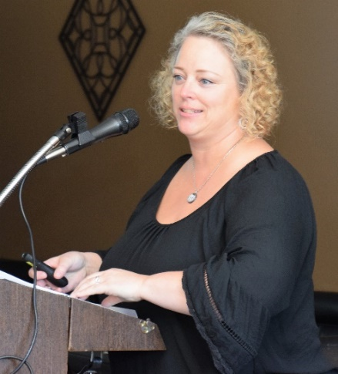
Mary Jo Price, Theater Manager of the Douglas Morrison Theater
Today’s presentation focused on an update on the activities of the Douglas Morrison Theater (DMT), part of H.A.R.D. by Mary Jo Price, the Theater Manager. May Jo joined the Doug Morrison Theater in January 2018 bring a rich history of working with people and theater, including Children’s Creative Museum (2012-15), Administrative Director at the Playwrights Foundation (2015-2016), Operations Manager at Tandem, and Partners in Early Education (2016-17) before coming to the Douglas Morrison Theater.
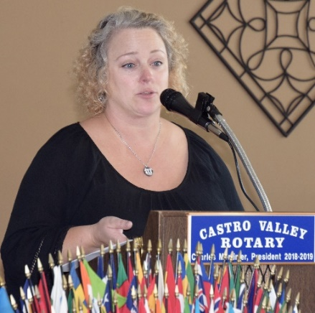
Mary Jo shared some history of the Douglas Morrison Theater, starting with the Players Group (before any building!), then the Little Theatre was built in 1979 and name-change to Douglas Morrison Theater in 2002. The first performance in 1979 was “The King and I,” which has been repeated three more times!

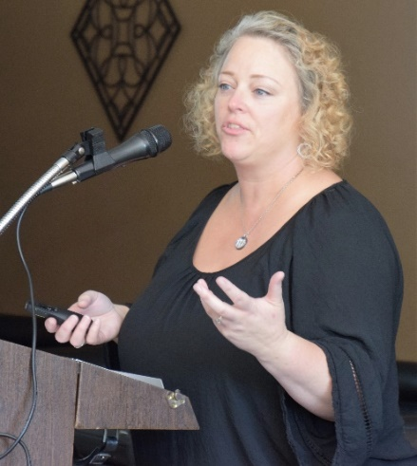
She shared that the H.A.R.D. Board is committed to the DMT and its mission and has adopted a business plan to increase the use and attendance, including using the theater for in-house stage productions, support youth in the district, performance of H.A.R.D. recreation programs, community rental market and have full-service box office (tickets by phone, on-line or in person).

Calendared productions for this season are” Once Upon a Mattress,” “Dracula,” “Ah, Wilderness” and the Douglas Morrison Theatre Chorus. There will be eleven performances of each production.
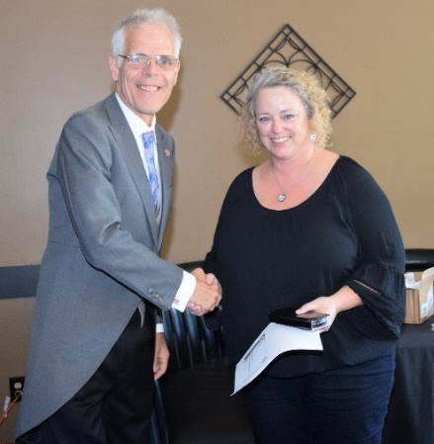
Mary Jo is also working on partnerships to maximize use of the facility, such as with Plethos Productions which will be presenting “Four Men in Paris” by Reg Clay. In addition, she shared her commitment to the Summer Drama Camps for our youth, the “Ruus Shakespearians” (student drama group from Ruus Elementary School), community rentals, and costume and prop rentals (located on West Winton Ave. in a warehouse) for schools, other groups, and individuals for Halloween.

For more information about the Douglas Morrison Theater, go to www.dmtonline.org.

Remembering 9-11

Thought by Bruce Johnson: “Time is passing. Yet, for the United States of America, there will be no forgetting September the 11th. We will remember every rescuer who died in honor. We will remember every family that lives in grief. We will remember the fire and ash, the last phone calls, the funerals of the children.” —former President George W. Bush

Remembering 9/11: Like when we heard President Kennedy was assassinated, we will never forget where we were when we heard of the September 11, 2001, attack on Our Great Country by nineteen militants associated with the Islamic extremist group al-Qaeda hijacked four airplanes and carried out suicide attacks against targets in the United States. Two of the planes were flown into the twin towers of the World Trade Center in New York City, a third plane hit the Pentagon just outside Washington, D.C., and the fourth plane was forced to crash in a field in Pennsylvania by true heroes who sacrificed their lives to prevent it being used to kill more Americans.

A total of 2,996 people were killed in the 9/11 attacks, including the 19 terrorist hijackers aboard the four airplanes. At the World Trade Center, 2,763 died after the two planes slammed into the twin towers, including 343 firefighters and paramedics, 23 New York City police officers, and 37 Port Authority police officers who were struggling to complete an evacuation of the buildings and save the office workers trapped on higher floors. At the Pentagon, 189 people were killed, including 64 on American Airlines Flight 77, the airliner that struck the building. On Flight 93, 44 people died when the plane crash-landed in Pennsylvania.

Todd Beamer lived in San Ramon and was on Flight 93. He will always be remembered for stating “Let’s Roll” to thwart the use of Flight 93 to kill even more Americans on September 11, 2001. Our Club will always be linked to him as his widow, Lisa, and her children were our Grand Marshals of our Rowell Ranch Rodeo Parade in 2002.

Please join me in a moment of silence as we remember that we are here today because of the price many paid before, on and since September 11, 2001. Bruce closed with a prayer of remembrance and thankfulness for our first responders.

From the Meeting
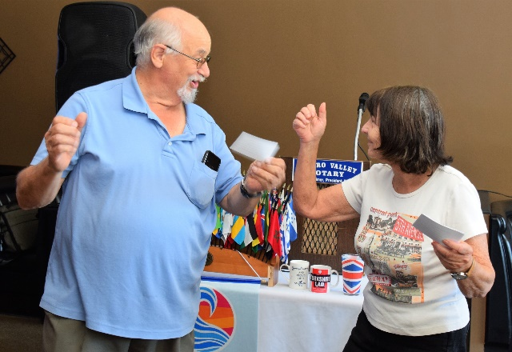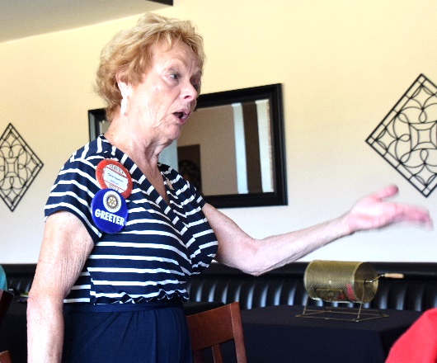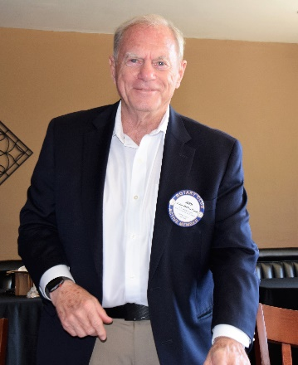

(L-R): Bill Nott and Ceta Dochterman lead the Club in “singing” Give My Regards to Broadway. ***Carol Bigelow leads the Sal Tedesco Memorial Hello Song.***John McPartland Pays It Forward for attending his 55th high school reunion.

Announcements
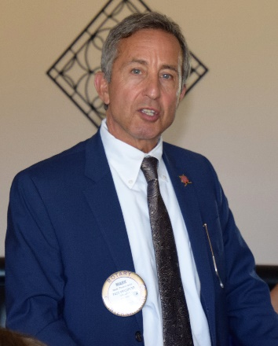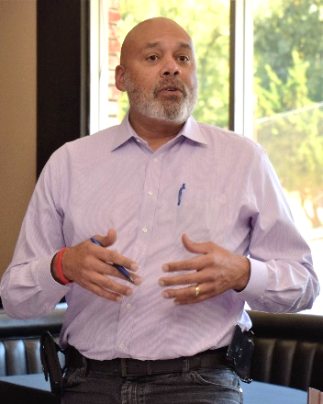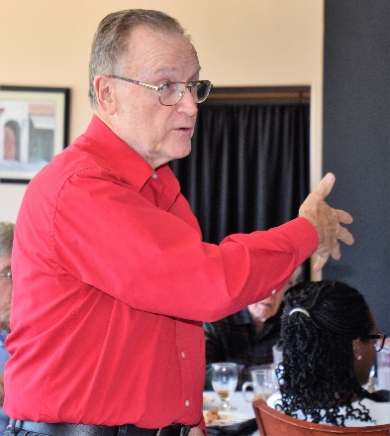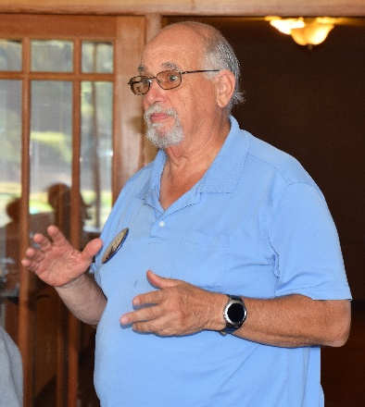

(L-R): Mark Poniatowski announces that the Texas Hold ‘em planning committee meets for the first time on September 12. The goal this year is to increase poker players and dinner guests by 20% each. The Texas Hold ‘em even is the Club’s largest fundraiser ($17,900 in 2018) so every Club is expected to take an active role. The date will be announced shortly. ***Aaron Lewis announced that the Rotary Club of San Leandro is holding its Lobsters for Learning Dinner and Fundraiser on November 9. Tickets are $85 per person. See Aaron for tickets, if Bob Duey hasn’t already hit you up to buy tickets. More information available here.***Bruce Johnson announced the upcoming Day on the Greens golf tournament sponsored by the Castro Valley Sports Foundation and Rowell Ranch Pro Rodeo. More information is available here.***Bill Nott announced an upcoming barbershop quartet show at All Saints Church (Hayward) in which he will be performing. See Bill for details.

Scenes from the Meeting
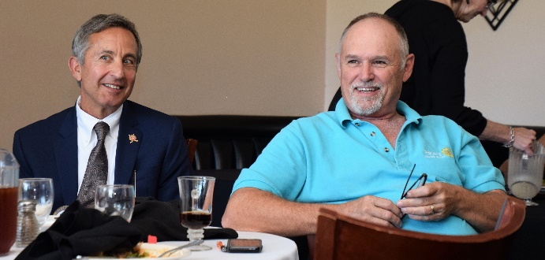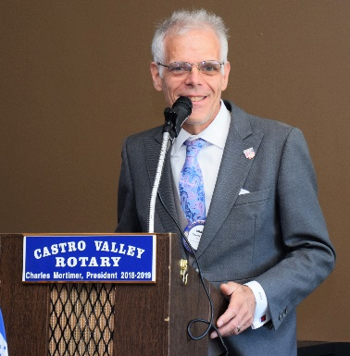

(L-R): After counseling with legal counsel, Mark Poniatowski, Randy Vanderbilt decided that he did not have to purchase a Presidential Pin from President Charles.***Obse Lubo paid it forward for her 3rd wedding anniversary and that she will be a mommy again in December.***President Charles announced the upcoming District 5170 Avenues of Services event on October 4. President Charles encouraged all members to attend. The Club pays for attendance at the event. Please let Charles know by September 18th if you plan to attend. More information available here.

Upcoming Speakers and Events
September 18 – Kathleen Scheidel, Attorney – Update on capital punishment in California
September 20 – Castro Valley Eden Area Chamber of Commerce Mixer at Pete’s Hardware/Vanderbilt Construction
September 25 – Brad Howard, Past Director of Rotary Zones 25-26
September 26 – Rotary Club of Castro Valley Board of Directors Meeting – All members welcome

Make President Charles happy and ease his workload.
Don’t forget to RSVP every week for lunch. Consider bring a guest to share the Rotary experience.

Meeting Highlights
Notes by Bruce Johnson
Photos by Jim Negri
Editor – Jim Negri

