Meeting Highlights – September 20, 2016

New Blue Badge Member
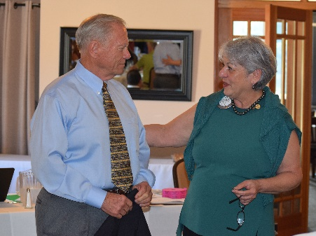
President Carol introduced John McPartland as the newest Blue Badge member of the Club. John’s classification is Elected Official – BART Board of Directors District #5. He was previously a member of the Oakland South Rotary Club. John will be the lunch speaker on September 27.

Recognition
President Carol recognized the Bill Nott for reliability and knowledge of the Club’s tech system and his continued support to keep the technology running.

Breathing for Life Gala – October 22
President Carol reminded everybody to "Save the Date - October 22 at 6:00-10:00 pm" for the Breathing for Life Gala. Tickets, sponsorships and donations are now online on the Club’s website. If you can’t attend the Gala, Carol encouraged you to support the event by donating in any amount. If purchasing tickets or making a donation by check, please note "BREATHING FOR LIFE" on the note section of the check. Please make sure to print your complete full address on the check in order to receive a receipt from the District 5170 501 (c) 3 94-3016176 for the tax deductible part of the ticket or donation.

Volunteers are still needed on October 23 for the takedown after the Gala. The Club is saving 1/3 of the decorating costs by providing volunteers for setup and takedown. Contact Carol to volunteer.

Craft Talk
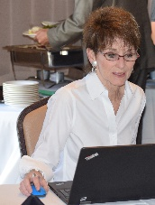
Red Badge member Murline Monat continued the series of craft talks. She discussed her participation in the real estate market.
Murline filling in as Club Secretary.

Paul McCreary, GM of HARD
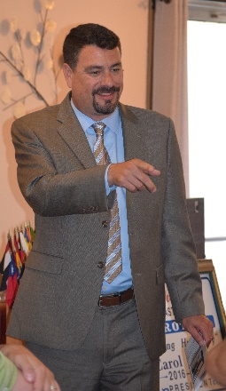
Speaker Chairperson Gary Bosley introduced Paul McCreary, General Manager of the Hayward Area Recreation and Park District, which serves over 275,000 residents. He came to HARD 8 months ago with 25 years of experience in local government having worked with the Cities of Dublin, Pleasanton and Walnut Creek. As the Parks and Community Services Director in Dublin, Paul gained in-depth experience in the city's park system and cultural arts. In addition, he has an extensive experience in cross governmental agencies and programs. Paul hold a Master's degree in Public Administration from the University of San Francisco.

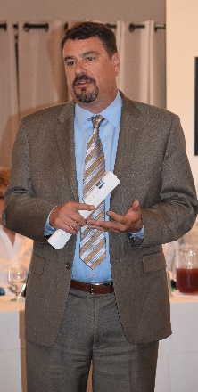
Paul noted that HARD is "Independent Special District" that serves the residents of the City of Hayward and the unincorporated areas of Castro Valley San Lorenzo, Ashland, Cherryland and Fairview. The district encompasses over 100 square miles. Among HARD's signature facilities are the Japanese Gardens, Hayward Shoreline Interpretive Center, Kennedy Park, Meek Estate Park, McConaghy House and Park, Rowell Ranch Rodeo Park, SkyWest and Mission Hills Golf Courses, Sulphur Creek Nature Center, Douglas Morrison Center, Hayward Plunge, and Aldon E. Oliver Sports Park.

He stressed the importance of passing Measure F1-Safe Clean, Local Parks Measure to maintain and renovate the facilities.
Many of the parks and facilities were built decades ago and require upgrading. Measure F1 is necessary for improving the quality and attractiveness of parks, improve park safety and security, rest rooms, water fountains, aging playgrounds, and improve accessibility, and safety of all users. This measure will also help improve park access for seniors by renovating and expanding walking and Bike trails

Future Speakers
September 27 – Incumbent BART Director District #5 John McPartland who is running for re-election.

October 4 – District Governor Jeff Orth on the state of Rotary and District 5170.

Random Photos from lunch

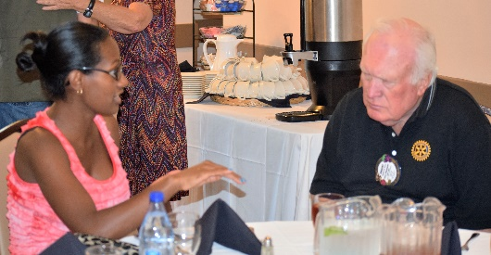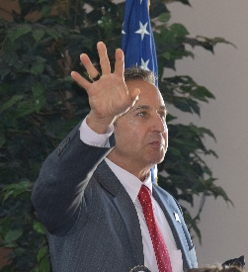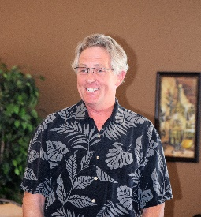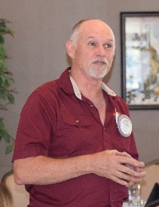

Left to Right: Todd hard at work as Treasurer; Obse and Dwight in a serious conversation; Mark raising a point of order; can you name this Rotarian? (Hint: John); Randy describing an upcoming project with HARD and the Chili Cook-off meeting.

