Meeting Highlights – September 27, 2016

Mark Your Calendar - District Governor Visit on October 4th
President Carol announced that District Governor Jeff Orth will meet with the Board and Chairs at 10:30 a.m. prior to the lunch meeting where he will be the speaker. All Board Members and Committee Chairs are expected to have updates and progress reports ready to present at the meeting with the DG.

Interact Club
Roland Williams announced that Interact will have its largest gathering on October 9th and the Club is donating $100 to cover the cost of transportation to the event. Thank you to Redwood Christian Schools for providing the bus and driver.

Double Sustainer
Dwight Perry asked all members of the club to become a Double Sustainer by donating or pledging $200 (or whatever amount you can) to The Rotary Foundation (TRF) this Rotary year. If possible, please send your checks or pledges to Dwight Perry prior to the October 4th visit by the District Governor. Please make the check to The Rotary Foundation, which is celebrating its 100th anniversary.

October Fest
Mathilda Schmidt reminded members about the upcoming October Fest on October 9th. Contact Mathilda for tickets and/or more information.

Rowell Ranch Rodeo Parade
Bill Nott requested volunteers for Rowell Ranch Parade Parade. The first meeting is scheduled for October 12th at 5:30 p.m. at Direct Sales. The monthly meetings are posted on the Club website and alternate between 5:30 p.m. and 12:00 noon. Please contact Bill for more details. Just a reminder: The Parade and the Chili Cook-off the night before are all-hands-on-deck events for Club members.

Breathing for Life Gala
Save October 22nd at 6:00 – 10:00 p.m. for the Breathing for Life Gala at Redwood Canyon Golf Course. President Carol distributed fliers for the Gala and announced that the flier is now posted on the Club website and Carol’s Facebook page. She requested that all members post the flier on their Facebook pages and other social media. President Carol stressed the importance of participating in the Gala and if you can’t attend to make a donate for the cause.

John McPartland – BART Board of Directors, District #5
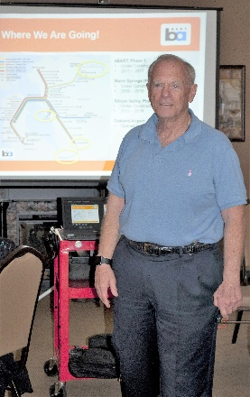
Bernie Kempen introduced Castro Valley Rotarian John McPartland, the incumbent BART Board of Directors - District #5 who is running for re-election, as the lunch speaker.

Mr. McPartland described the history of BART, which started operating in 1972 with a starting ridership of about 20,000 riders per day. BART has a current ridership of 440,000 per day with growth projected to be 500,000 by 2018 and 750,000 by 2030. BART with a fleet of 662 cars is a mass transit system with the oldest train cars in the country. The fleet is currently scheduled for a replacement 10 new Pilot Cars, which are being test during 2016 and will start appearing in 2017. By 2021, there will be 775 cars in the system. The new cars are expected to be quitter, cooler, more comfortable and high tech with 3 exit doors rather than the current 2. The Fleet of the Future will consist of Bombardier cars and 2/3’s will be made in America. The improvements for the future include improved safety during earthquakes and an early warning system, improvements to the Transbay Tube, upgrades to 27 of the 34 stations. Upgrades to 70 of 74 miles elevated tracks are underway and are expected to be completed by 2022. (69% of the tracks are rated as poor to very poor with only 31% rated as fair to good.

BART has 200 assets worth $28 billion, but has an immediate need of $10 billion for upgrades and improvements. Measure RR on the November ballot will go a long way in fulfilling this immediate need, which includes improve parking, security and the reliability of the system.

The next speaker on Oct. 4 will be Jeff Orth , the Rotary club Governor for our district.

