Rotary Club of Castro Valley
Meeting Highlights - September 4, 2018

Ginny Roth – Walk to End Alzheimer’s
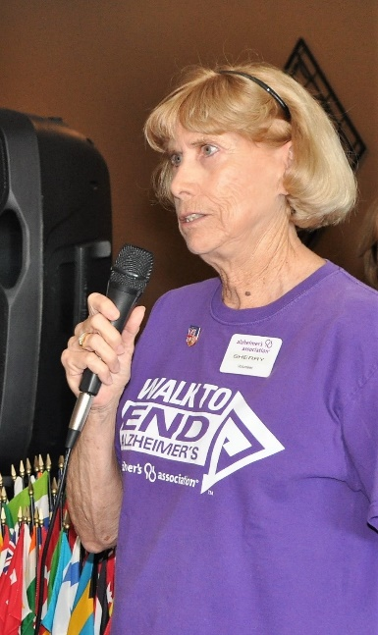
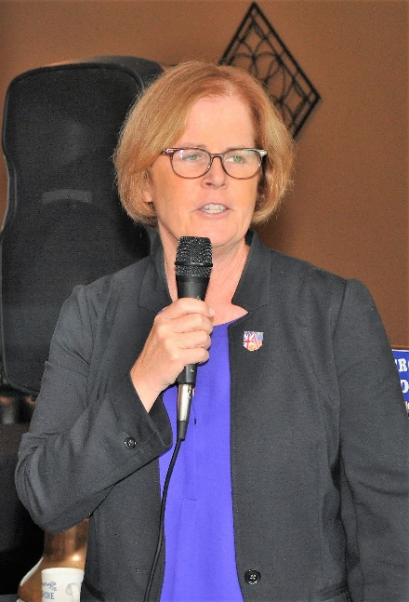
Ginny Roth, Chair of the East Bay Walk to End Alzheimer’s Volunteer Planning Committee, and Sherry Ford, a volunteer with the Alzheimer’s Association of California and Nevada, share their personal stories regarding Alzheimer’s in their families and explained why they are actively involved in the Walk to End Alzheimer, which is scheduled on October 20, 2018, at Heather Farms in Walnut Creek.

In her presentation, Ginny shared the following information about Alzheimer’s:
- Every 65 seconds a new victim of the Alzheimer disease is identified.
- There are 5.7 million cases of identified cases of Alzheimer disease in America and 18.4 million hours of care have been required during 2017.
- There are over 44,000 identified cases of Alzheimer in the East Bay.

The Alzheimer Association help in many ways including the following:
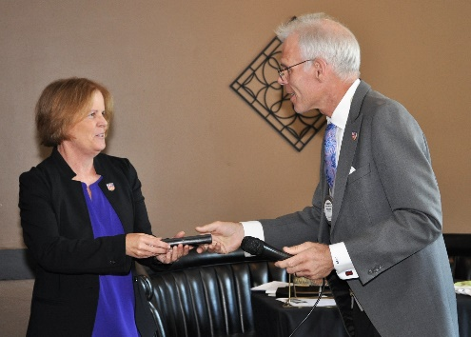
- Provides help line 24/7 and has answered 15,093 calls for help.
- Provides education programs for patients and caregivers.
- Provides a Medicare Alert Safe Return Program.
- Helps coordinate Alzheimer Research programs.
- Provides advocacy at state and federal level, which has been responsible for a $350 million increase in research funds.
- Collects funds for research through sponsors.
- Organizes Walk to End Alzheimer events to raise awareness and funds for research.
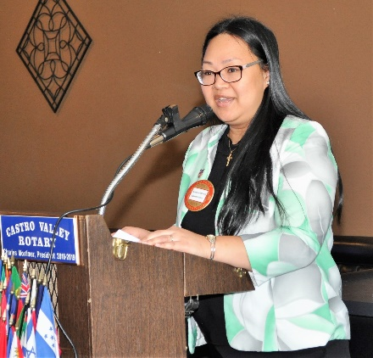
Currently, the East Bay Walk to End Alzheimer has 204 teams and 786 participants signed up and has raised $213,807 of its projected goal of $650,000. For more information about the walk and donating, go to http://act.alz.org/eastbay2018.

Castro Valley Rotarian Roslyn Jones with Edward Jones is sponsoring a team. Edward Jones is a National Presenting sponsor of the Walk to End Alzheimer’s. To see why Edward Jones is a national sponsor, go here. You can support Rosalyn’s team at www.alz.org/edward jones – her team name and number are:

ANTONIO & CASTRO VALLEY TEAM, 480963. For more information, please see the flier attached to the email.

Announcements
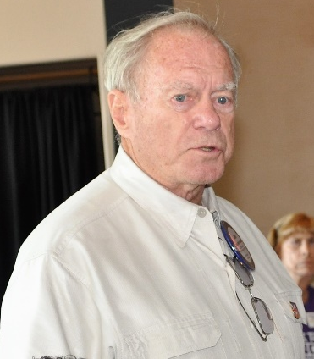
- John McPartland announced that he will be speaking at the 9/11 Memorial Event, which takes places at 9:00 a.m. at the Veterans’ Memorial in Castro Valley where Castro Valley Rotarian and others are honored for service to their country. The 9:00-9:45 a.m. event provides plenty of time to attend and still attend lunch.
- President Charles Mortimer announced that President-Elect Todd Anglin has agreed to be the Chair for the Rodeo Parade on May 11, 2019. Thank you, Todd! A special THANK YOU to Bill Nott who has been the Chair for many years.
- President Charles announced that Rotary Club does not have a booth this year at the Fall Festival, but Club members can participate by volunteering help the Chamber. Lytrel Carter announced that Fremont Bank has a booth at the Fall Festival and offered to share the booth with the Rotary Club. If you go, be sure to wear your Rotary shirt, not flowers in your hair. (If you caught this one, drop Jim Negri an email by September 12, to be entered in a drawing.)
- President Charles announced that he has asked Heidi Hausauer to work with Castro Valley Unified School District and Redwood Christian Schools (Rotarians Parvin Ahmadi and Bruce Johnson) to expand the scope of the Backpack Project to include additional areas where the Club can help students and the schools.
- President Charles asked that the Chairs for the Children’s Christmas Party and the Texas Hold’ em Poker to start planning for the events early.
- Heidi Hausauer announced that the Electric Light Parade will be on November 10 and that she is looking for judges. Please contact Heidi directly.
- Membership Chair Virginia Degner reminded all Club Members that they must complete the Youth Awareness Protection training. A Red Badge Member cannot earn his/her Blue Badge without completing the training that takes 30-45 minutes online. See Virginia for details.

Upcoming Speakers and Events
September 11 – Mary Jo Price, Douglas Morrison Theater – Update on the theater and upcoming productions
September 18 – Kathleen Scheidel, Attorney – Update on capital punishment in California
September 20 – Castro Valley Eden Area Chamber of Commerce Mixer at Pete’s Hardware/Vanderbilt Construction
September 26 – Rotary Club of Castro Valley Board of Directors Meeting – All members welcome
Don’t forget to RSVP every week for lunch. Consider bring a guest to share the Rotary experience.

