Will You Be The Inspiration?
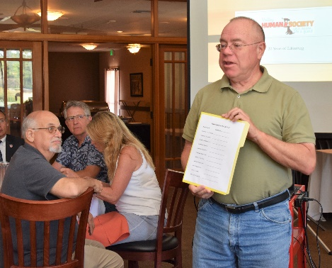
Gary Howard provided the first opportunity to respond to the challenge from President Charles to be the inspiration and step up to the plate. Gary Howard will be the 2018-2019 Speaker Chair, but for the program to maintain its excellence, Monthly Speaker Chairs are necessary. Gary circulated a sign-up sheet for 2018-2019. Former Speaker Chair Gary Bosley has developed a step-by-step, easy-to-follow template. If you did not sign up at the meeting, please contact Gary and volunteer for a month this year.

