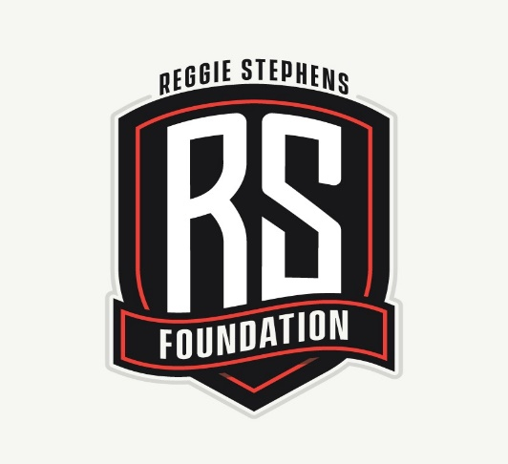
Reggie Stephens Foundation
640 14th Avenue Santa Cruz, Ca 95062

www.reggiestephensfoundation.org
reggiestephensfoundation@gmail.com
Reggie Stephens, President 831.239.3403

The Reggie Stephens Foundation (RSF)’s aim is to provide opportunities for our youth to showcase their skills in the arts and in the athletic arena. Our vision for how we provide these opportunities is based on our mantra to Seek, Believe, and Achieve.

Seek-We believe our youth can only reach their potential by first understanding what it is they are passionate about; exposing them to options in the world is the first step in that process.

Believe-We provide our youth with mentors and role models who will instill the importance of confidence and high self-esteem, and who can talk to them about their own experiences in the worlds of athletics and the arts---their successes, their setbacks, and how they handled each in order to grow and find themselves.

Achieve-We promise to give our youth the tools they need to see and reach their own highest ground; to understand the importance of goal-setting, and the paths to achieving those goals.

Your generous donations to the Reggie Stephens Foundation will go to help artists and student athletes in Santa Cruz County and the Central Coast area

RSF 2019 Schedule:

- February 23rd & 24th, 2019 – RSF AAU Basketball Try-Outs at SCHS
- Sunday March 17th, 2019 – 7th Annual 8th Grade & Senior Central Coast All Star Basketball Game at Cabrillo College
- Friday, June 21st, 2019 – RSF 2nd Annual Golf Tourney at DeLaveaga Golf Course

Coming Soon (dates to TBA)…

- Tutoring by The Learning Center
- Art Workshops with Jason Williams (artbywillz) – sponsored by Palace Arts & Supplies
- RSF Scholarships - Santa Cruz & Central Coast Areas
- RSF AAU Flag Football
- RSF Central Coast Senior All Star Baseball Game
- Red Hat, Inc. / Annie Rooke – Young Women Empowerment in the SC & Central Coast Areas

Any RSF Donation is tax deductible as a charitable contribution to a 501(c)3 – Tax ID # 82-3969806

