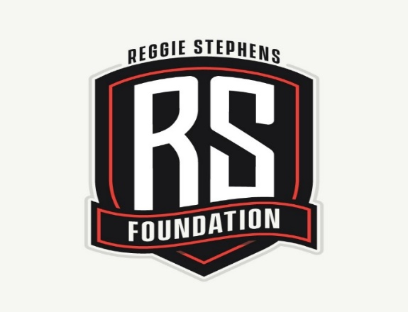
Second Annual
Reggie Stephens Foundation
Golf Tournament

Friday, June 21st, 2019 * DeLaveaga Golf Course

12pm Shotgun Start * 4 Person Scramble * $150 Per
(Lunch & Dinner Provided)

Name:__________________________ Email:______________________________ Shirt Size:_____

Name:__________________________ Email:______________________________ Shirt Size:_____

Name:__________________________ Email:______________________________ Shirt Size:_____

Name:__________________________ Email:______________________________ Shirt Size:_____

Hole Sponsorship Information

Platinum Package $2,500.00 (Includes Tee Box, Booth & 3 RSF Events)

Gold Package $400.00 (Sign on Tee Box & Booth Set Up)

Silver Package $200.00 (Sign on Tee Box)

Company Name: ________________________________ Email: ____________________________

For Golf Info: Paul Quilici 831.234.5575 / John Saggau 831.320.6063

For Sponsorship Info: Kristy A. Netto 831.818.0423
Reggie Stephens 831.239.3403 / reggiestephensfoundation@gmail.com

Please Make Checks Payable to: Reggie Stephens Foundation
Tax Deductible Donation – Tax ID # 82-3969806

