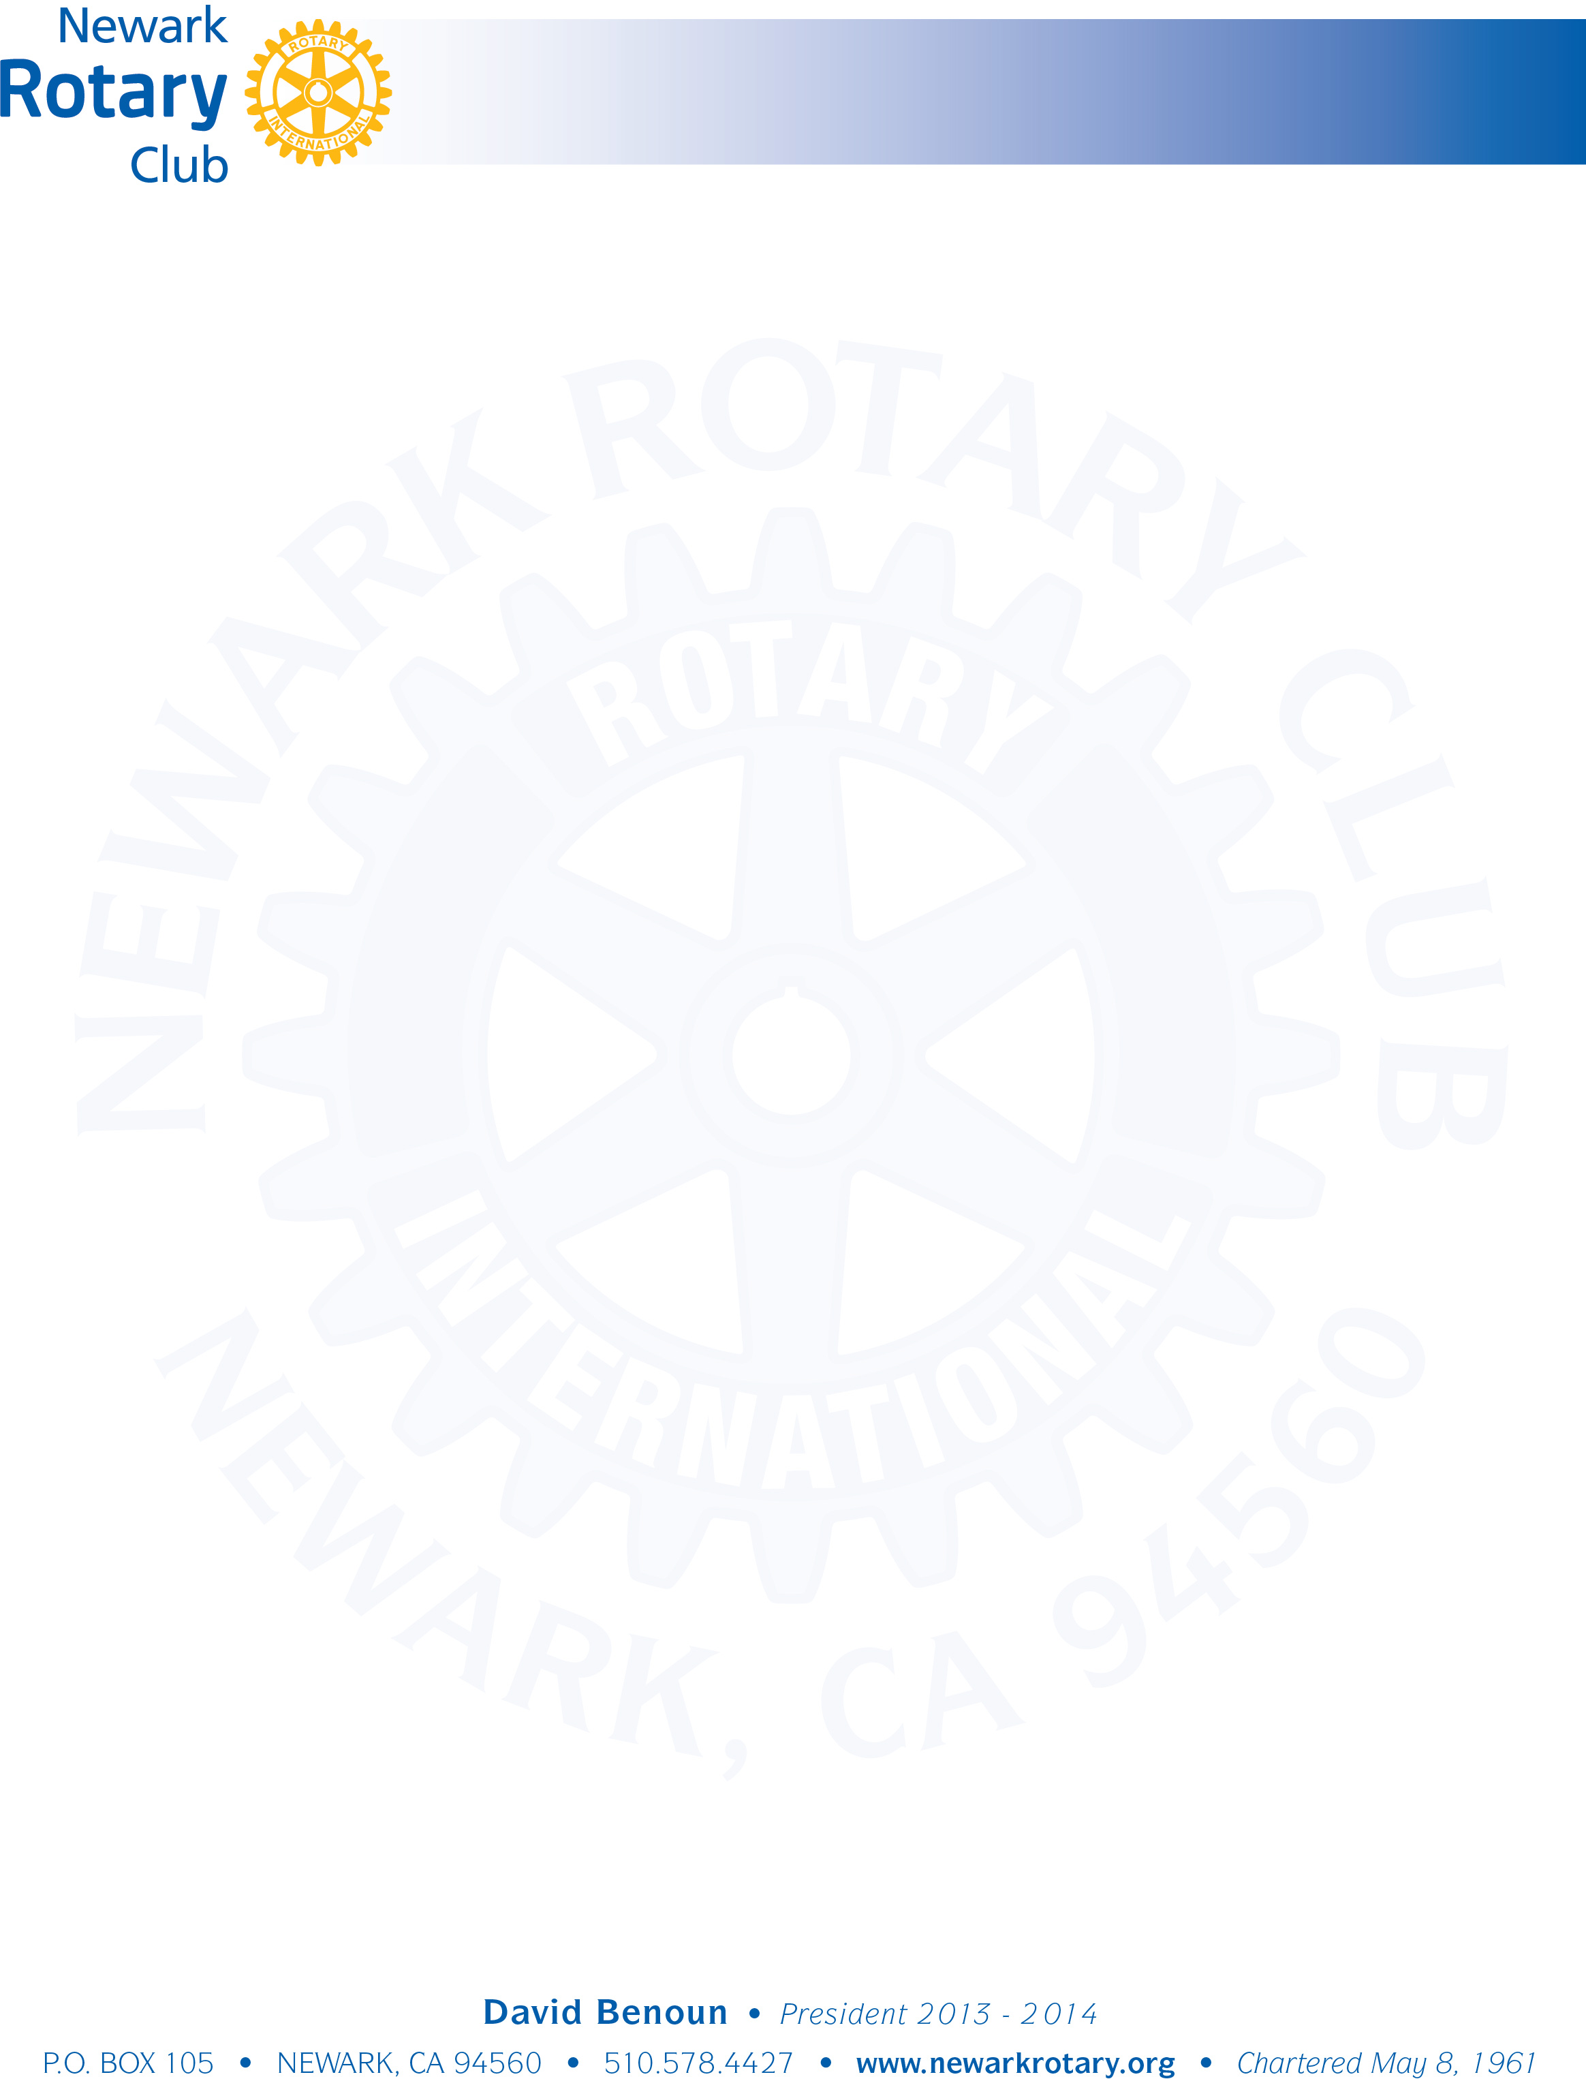

“Red Badge” Expectations

Congratulations on joining the Newark Rotary Club! We welcome you to our organization and we look forward to working with you as we serve our community.

Newly inducted club members are considered “Red Badgers”. The Club expects that Red Badgers participate in a few ways in order to earn a “Blue Badge”, which is the final step to become a Newark Rotarian. The following are the requirements that you must complete in order to obtain your Blue Badge:

_____ Maintain a minimum of fifty percent (50%) attendance at Club meetings (including makeups at other clubs)

_____ Give a two minute introductory talk to our club at a regular club meeting so that you can familiarize yourself with club members ("Who Am I Talk”)

_____ Participate in a club volunteer event – e.g., participate in the chili cook-off, feed the homeless lunch, yard clean-up, Viola Blythe can sorting, etc.

_____ “Make up” a meeting at another Rotary Club meeting. (The following are other clubs in the area that meet for lunch: Fremont Rotary at Spin-A-Yarn on Wednesdays, Niles at Washington Hospital on Thursdays, and Mission San Jose at Papillon’s on Friday. Please check with your sponsor for breakfast and nighttime clubs.)

______ Attend a Newark Rotary Board of Directors meeting (generally the third Tuesday of the month at 11:00 a.m. at Sinodino’s, but please check with Clubrunner to verify).

______ Attend a District or Area 3 event. Please check with your sponsor, the Club President, the Membership Chair, or Clubrunnner for information regarding upcoming district or Area 3 events.

______ Participate in hosting the Newark Rotary Annual Crab Feed in November.

As always, please do not hesitate to contact your sponsor, the Membership Chair, or the Club President if you have any questions or concerns. We welcome you to our club!