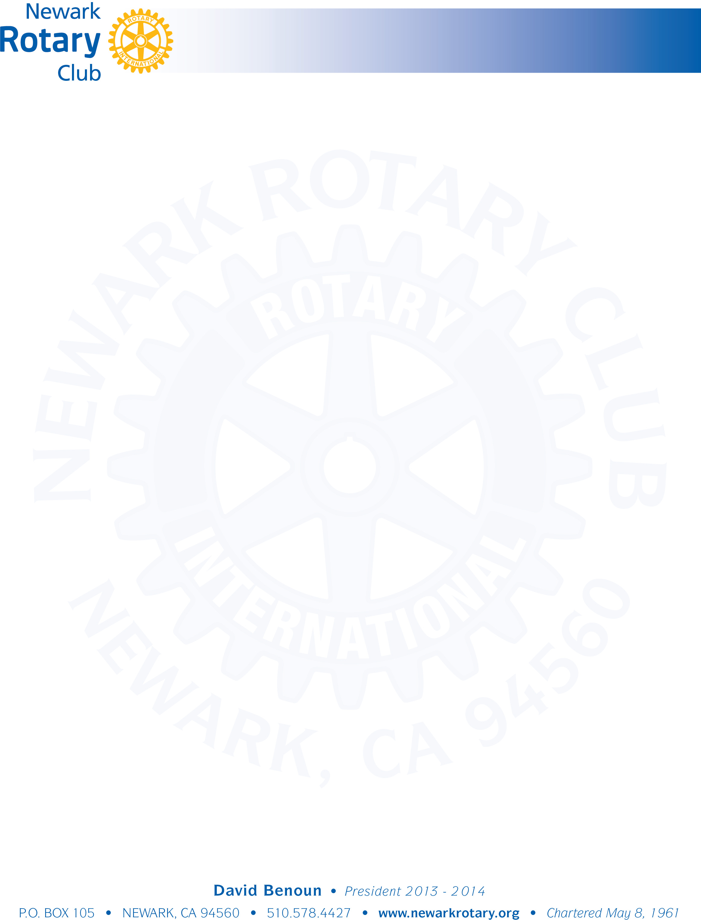

**Newark Rotary Club Speaker Information**

Each Club Member is scheduled to arrange for a luncheon speaker. Speakers should be invited who will discuss topics of interest to the club relating to beneficial public/private programs, that address activities consistent with the goals and programs of Rotary, and/or local programs or events of interest or benefit to the community.

It is your obligation to advise the speaker that:

* Meetings are at Sinodino’s Restaurant located at 36665 Cedar Boulevard, Newark.
* Meetings start at 12:15 and the speaker is typically scheduled to begin a few minutes after 1:00 p.m.
* The speaker needs to conclude their presentation no later than 1:25, including any time for questions.
* The meeting room layout and typical attendance should be explained to the speaker.
* A brief bio of the speaker needs to be sent to you and the Club President by the Thursday prior to the meeting.
* You will make the introduction at the meeting.
* If the speaker intends to include a visual presentation (Power Point, video, etc) they need to provide a computer and also bring their presentation on a flash drive as a back-up Standard USB connections can be made to the monitor. It is recommended that the speaker arrive a few minutes early if bringing a Power Point presentation or video.
* There should be sufficient handouts (if desired) for all members in attendance (typically 20-25 attendees).
* The club will pay for the speaker’s meal.
* Direct solicitation of donations should not be made at the meeting but can be forwarded to the Board of Directors for consideration as part of the annual grant process. See Clubrunner website for more information.

Please contact the Club Services Director if you have any questions or concerns.