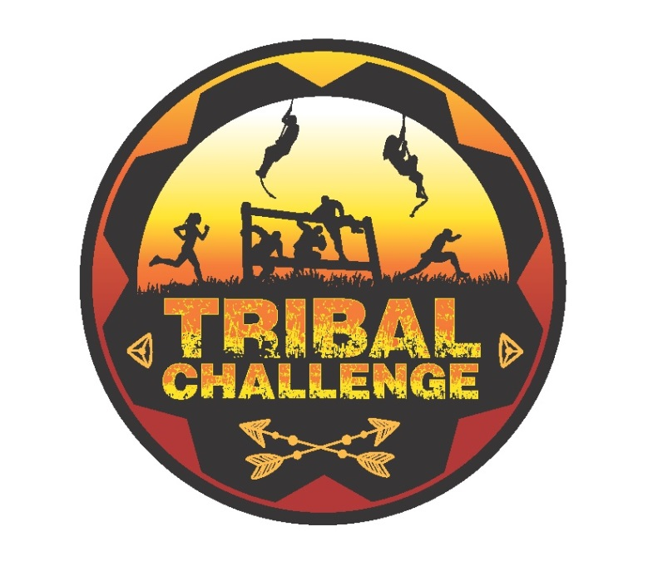
Presented by: The Rotary Club of Hatboro
A Team Obstacle Course Race on the Horsham Power Line Trail
3 miles of physical and fun challenges
Prepare to get wet and dirty!

Wednesday, July 11, 2018
Start times between 6pm and 7pm

Teams of four – coed, female or male
Team name, theme, and costume encouraged
(Sports team, TV show, corporate, etc.)

Additional Event Details
- Course starts and finishes at the Hatboro- Horsham High School Stadium, 411 Babylon Rd, Horsham, PA 19044, and the course is along the Horsham Power Line Trail.
- Teams of four, aged 15 years old and over.
- Prizes awarded to the three teams judged to have the best combination of team name, theme, and costume.
- Waves of up to 30 teams will be sent out every 10 minutes between 6pm and 7pm, select your start time when registering. Competitive teams are encouraged to register for a 6pm start.
- All team members must complete the course and finish together; last team member across finish line is the teams finishing position
- Scoring is a point system based on finishing position from your start time and points awarded for completion of challenges. Prizes awarded to the top three teams.
- All team members receive a Tribal Challenge event shirt.
- Post Event Celebration between 8-10pm, at Magerk's Horsham
- Outdoor shower system and changing tents are provided at the event.
- Course map and challenge details will be emailed a few days prior to the event.
- Register on-line at Run The Day

Facebook.com/TribalChallenge

