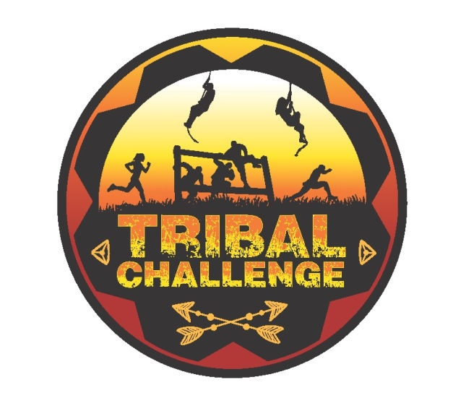
Sponsorship Opportunities

Sponsor Level | Benefits
Conqueror  $2,500  To  $5,000 | - Two complimentary team entries  - Logo displayed on results page of registration website  - Your Facebook page liked by Tribal Challenge Facebook page  - Company name and website recognized on Tribal Challenge Facebook page  - Company banner displayed at race finish  - Sponsor table at event for information, product, coupons, etc.
Warrior  $1,000  To  $2,499 | - One complimentary team entry  - Logo displayed on results page of registration website  - Your Facebook page liked by Tribal Challenge Facebook page  - Company name and website recognized on Tribal Challenge Facebook page  - Company banner displayed at race finish  - Sponsor table at event for information, product, coupons, etc.
Gladiator  $500 | - One complimentary team entry  - Sponsor table at event for information, product, coupons, etc.
Fighter  $250 | - Two complimentary individual entries  - Sponsor table at event for information, product, coupons, etc.

----------------------------------------------------------------------------------------------------------------------------
Please complete this Sponsor Form and return with payment.
Sponsorships of $1,000 or more include a company logo displayed on results website.
Email logo to gchamberlain@philaymca.org in PDF or JPG format.

Contact Name: ___________________________________________________________________________Company Name: _______________________________________________________________
Phone Number: ___________________________________________________________________________Email Address: ________________________________________________________________
Sponsorship Levels: Conqueror $_____________ □   Warrior $____________ □ Gladiator $500 □   Fighter $250 □
Checks payable to: Hatboro Rotary
Mail to: Gary Chamberlain
Hatboro Area YMCA
440 S. York Road
Hatboro
PA 19040

