WIN $1,000
What are you PASSIONATE about?

Could you persuade others while answering these questions?

1. Is it the Truth?

2. Is it Fair to all concerned?

3. Will it build goodwill and better friendships?

4. Will it be beneficial to all concerned?
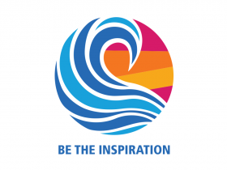
Freshman through Seniors Are Eligible For Cash Prizes!

The Clubs of Rotary District 7430 are holding speech contests at the local Club level in March and early April of 2019. The winners will compete in regional level contests on April 13, 2019. The Finals will take place on May 4, 2019 at Renaissance Allentown Hotel, Allentown, PA. Prizes of $1,000 (1st), $500 (2nd), $350 (3rd), $250 (4th), and $150 (5th) will be awarded at the Finals while local and regional contests also pay cash prizes. Contact Terri Pfennig tpfennig1@comcast.net for details.

