Presents The Sixteenth Annual

Habitat For Humanity 5K
Volunteers & facilities provided by
The Quakertown Rotary Club
&
Quakertown United Methodist Church
Join us for the Sixteenth Annual Habitat For Humanity 5K. Co-sponsored by the Quakertown Rotary Club and the Quakertown United Methodist Church, all proceeds benefit Habitat for Humanity of Bucks County. Since its founding in 1990, Habitat for Humanity of Bucks County has built over 100 homes housing more than 400 people. Home building projects are underway throughout Bucks County, in addition to A Brush with Kindness projects throughout the County. To learn more visit

Founded in 1905, Rotary International is a service club dedicated to the ideal of “Service Before Self.” The Quakertown Rotary Club has been performing community service work since 1924. In addition to Habitat Bucks, the club supports a variety of youth initiatives in the Quakertown and Palisades school districts, the Upper Bucks YMCA, Children’s Development Program, Quakertown Food Bank and others. More information about Quakertown Rotary can be found at www.quakertownrotary.org

Quakertown United Methodist Church welcomes all community members to join us for worship on Sunday Mornings. Traditional Worship Services are at 8:00AM and 11:00AM with a Contemporary Worship Service at 9:00AM and Sunday School at 10:00AM For more information, contact the church at 215-536-4992 or visit us at www.QUMC.com.

Habitat for Humanity of Bucks County
c/o Bill Tuszynski
27 S. Vassar Drive
Quakertown PA 18951

Quakertown United Methodist Church
1875 Freier Rd.
Quakertown PA 18951
Registration: 8:00-9:30 AM
Fun Run: 9:30 AM

5K Race: 10:00 AM

Awards: 11:00 AM

Presented by the
Quakertown Rotary Club

Quakertown United Methodist Church

Directions:

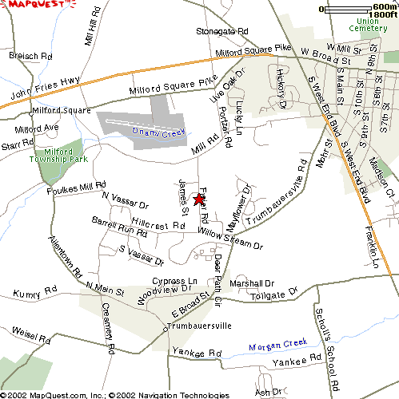

From Route 309 (West End Blvd.):
Turn west (right from southbound 309) at Park Avenue Turn right at Mill Rd. Continue to Freier Rd. Turn left on Freier. The Church is on your left.

From PA TPKE/Rte. 663:
From the PA Turnpike, head east (left) on Rte. 663 (John Fries Highway) to the third light at Portzer Rd. Turn right and Mill St. Turn right and go 0.2 miles. Turn left on Freier. The Church is on your left.

From Route 313:
Go west on Rt. 313 to Rt. 309. Turn left at Rt. 309 and right at the next light (Park Ave.) Follow as above.

On-line registration is available at https://runsignup.com/Race/PA/Quakertown/QuakertownRotaryHabitat5K

http://www.active.com/quakertown-pa/running/distance-running-races/16th-annual-habitat-5k-2017?int=

Quakertown United Methodist Church
1875 Freier Rd.
Quakertown PA 18951
Saturday, November 25, 2017
Registration: 8:00-9:30 AM
Fun Run: 9:30 AM

5K Race: 10:00 AM

Awards: 11:00 AM

Course Records:
M: 15:59 (Steve Gourley, 2007)
F: 18:14 (Andrea Luebbe, 2005)

Results will be posted at www.coolrunning.com and www.quakertownrotary.org .

Awards (Male & Female)
Overall 1-3 M/F
Age Group: (3 Each) M: 9 & Under, 10-14, 15-19, 20-24, 25-29, 30-34, 35-39, 40-44, 45-49, 50-54, 55-59, 60-64, 65-69, 70+ (3 Each); F: 9 & Under, 10-14, 15-19, 20-24, 25-29, 30-34, 35-39, 40-44, 45-49, 50-54,
55-59, 60-64, 65-69, 70+ (3 each)

Quality long sleeve cotton shirts for all pre-registered runners and while supplies last on race day.

Race organizer:
Bill Tuszynski, 267-374-1631 (before 10PM please); wtuszynski@verizon.net

Name

Age on 11/25/17 M F

T-shirt size: S M L XL None

Address

City State Zip

E-Mail

$25 Postmarked Before 11/19 *
$30 After 11/19; Race Day* Bill Tuszynski
$5 Kid’s Fun Run (no shirt)
Optional Donation:
Total Enclosed: Quakertown PA 18951
* Deduct $5 for no shirt

MAKE CHECK PAYABLE TO:
Habitat for Humanity of Bucks County
MAIL TO:
Bill Tuszynski
27 S. Vassar Dr.
Quakertown PA 18951

I know that participating in a race is a potentially hazardous activity. I should not enter unless I am medically able to participate. I also assume any and all risks associated with participating in this event, including but not limited to falls, contact with other participants, the effects of the weather, traffic and the condition of the roads. In considering of accepting this entry, I hereby waive for myself and my heirs all rights and claims for damages I may have against Habitat for Humanity of Bucks County, Quakertown Rotary Club, Quakertown United Methodist Church, and all other sponsors, volunteers, their agents or representatives arising out of, or in the course of, my participation in the Habitat for Humanity 5K. I also give permission for the free use of my name and picture in any broadcast, telecast or print media account of this event.

Signature
(parent/guardian if under 18 years)

Date

