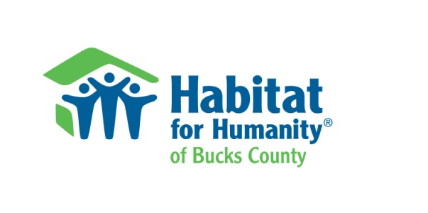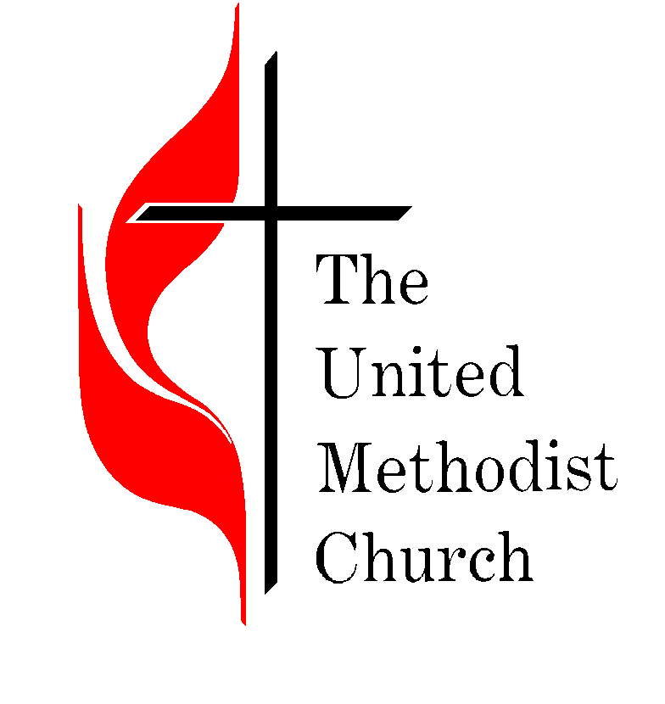
Habitat for Humanity of Bucks County Presents The

Habitat For Humanity 5K

Sponsorship Opportunities

The Event: A charity 5K road race and kids’ fun run, all proceeds supporting Habitat for Humanity of Bucks County

When: Saturday November 30, 2019. Race time - 10:00 AM

Where: Quakertown United Methodist Church,
1875 Freier Road, Quakertown PA 18951

Organized By: Quakertown Rotary Club
Quakertown United Methodist Church

Race Organizer: Bill Tuszynski, 267-374-1631; wtuszynski@verizon.net

Sponsors Receive: On-site recognition
Logo on race shirt
Recognition on the Habitat (www.habitatbucks.org) and Quakertown Rotary (www.quakertownrotary.org) websites
Recognition in press release materials
Two complimentary shirts

Sponsor: Contact:

Address City State Zip

Phone: Fax: E-Mail:

Sponsor Level: Platinum ($1,000) : Gold ($500) Silver ($250) Bronze ($100) Other ( )

In-Kind: Food . Beverages: Other: Volunteers:

MAKE CHECK PAYABLE TO: Habitat for Humanity of Bucks County

MAIL TO: Kimberly Morales
Habitat for Humanity of Bucks County
31 Oak Ave., Suite 100
Chalfont PA 18914
k.morales@habitatbucks.org

Signature ______ _ Date

