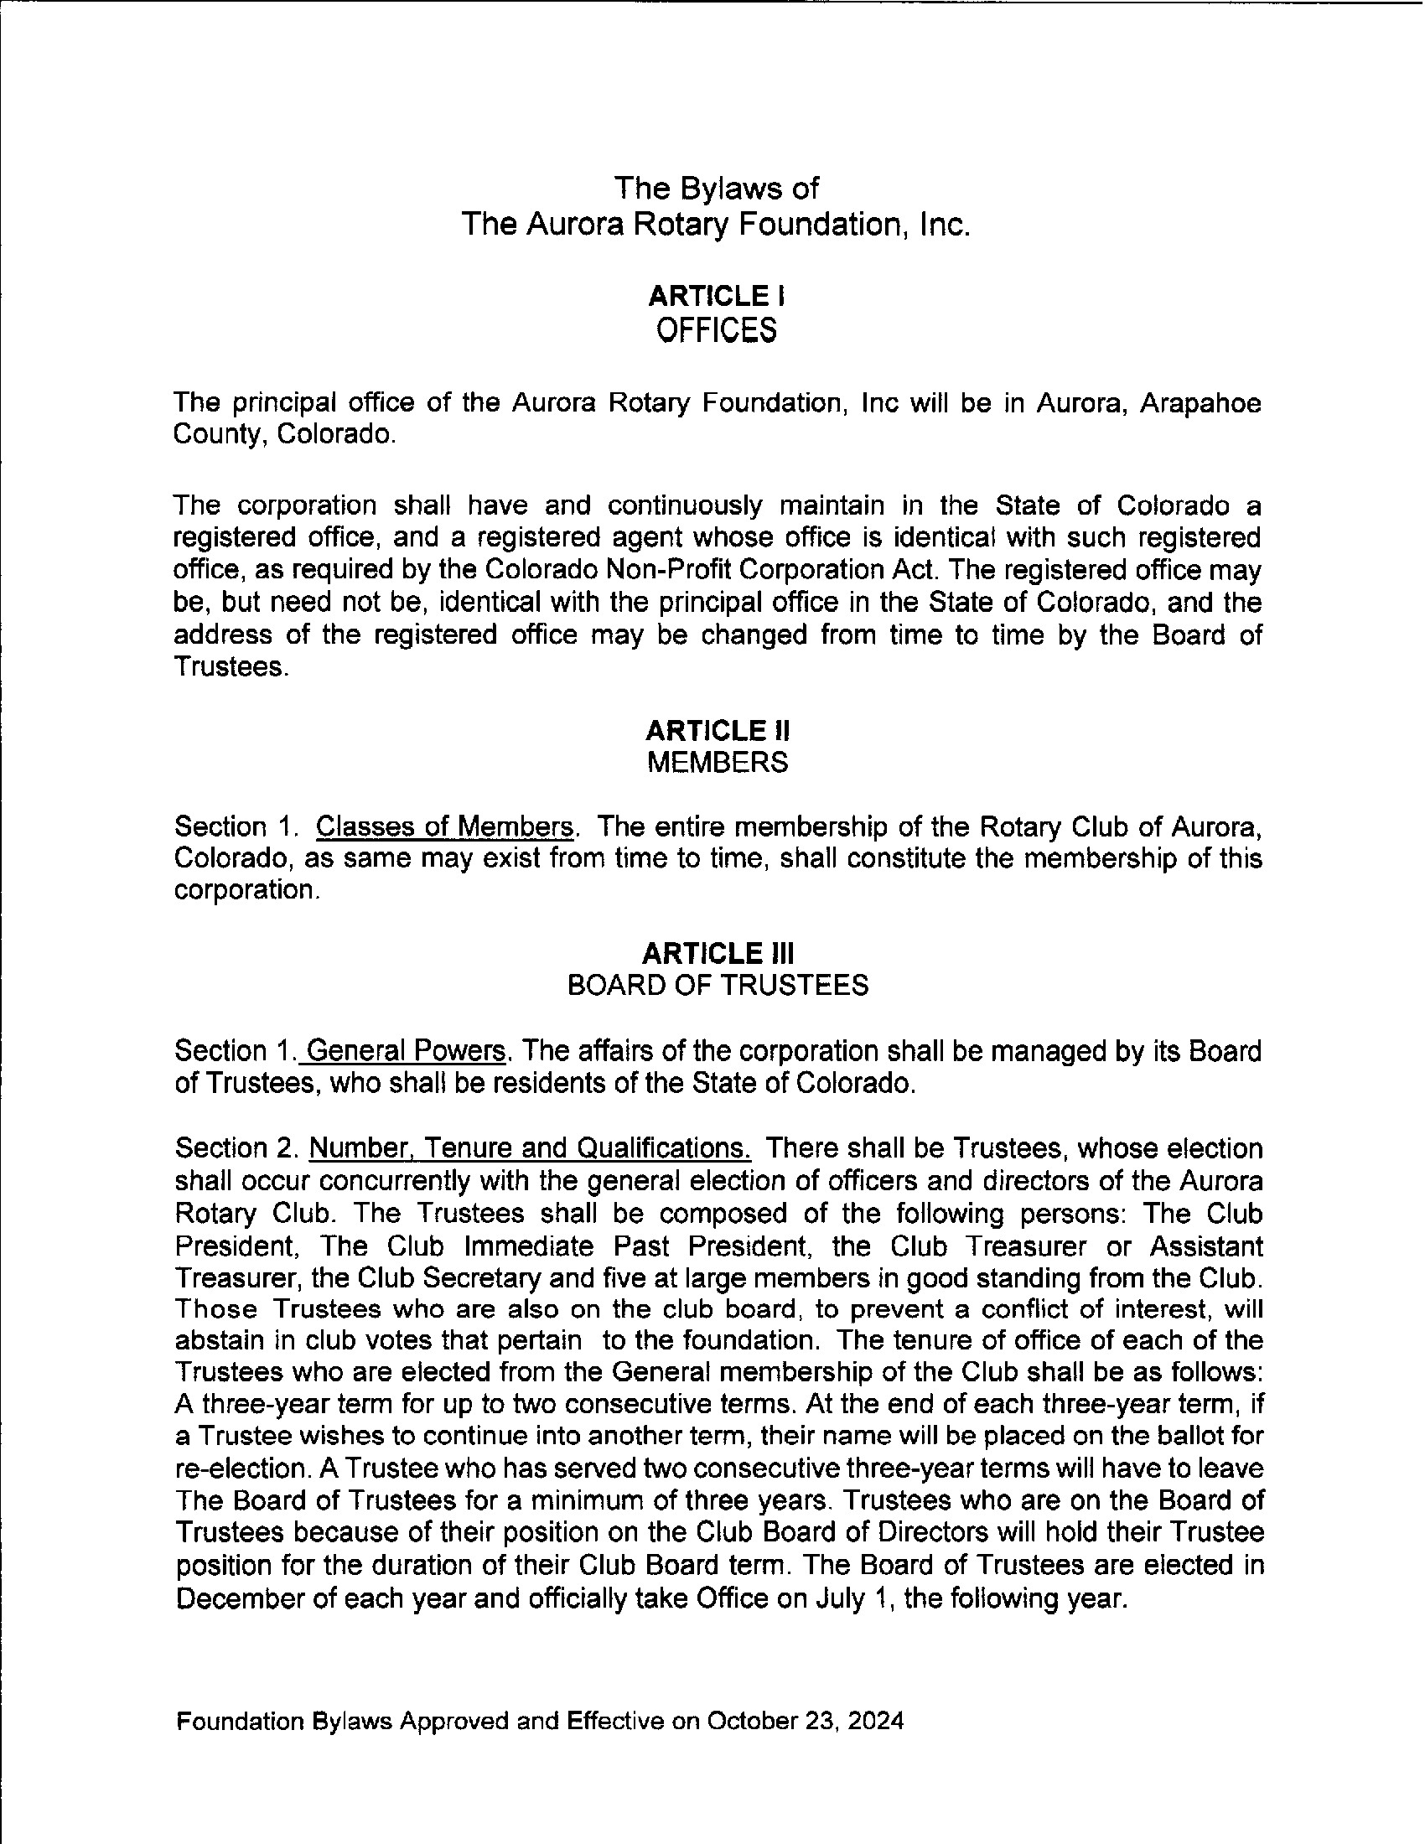
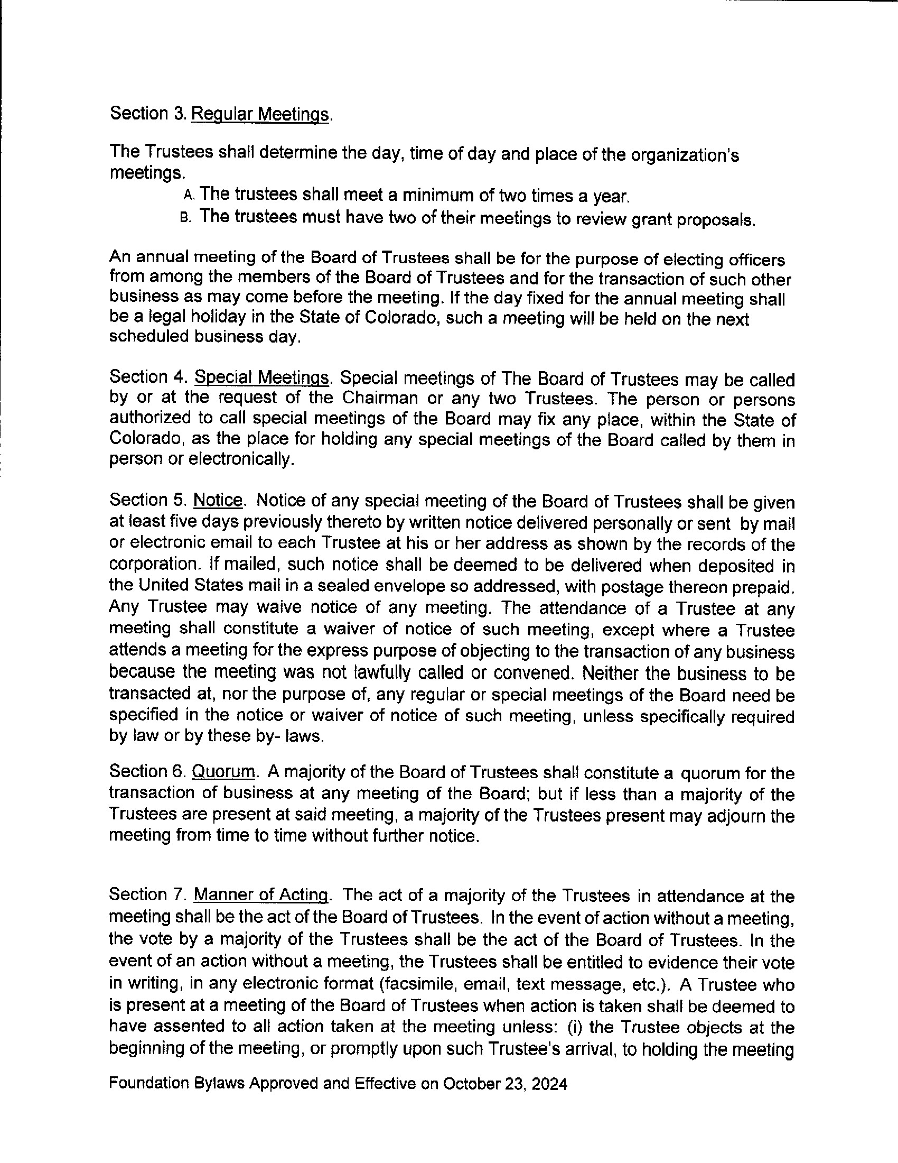
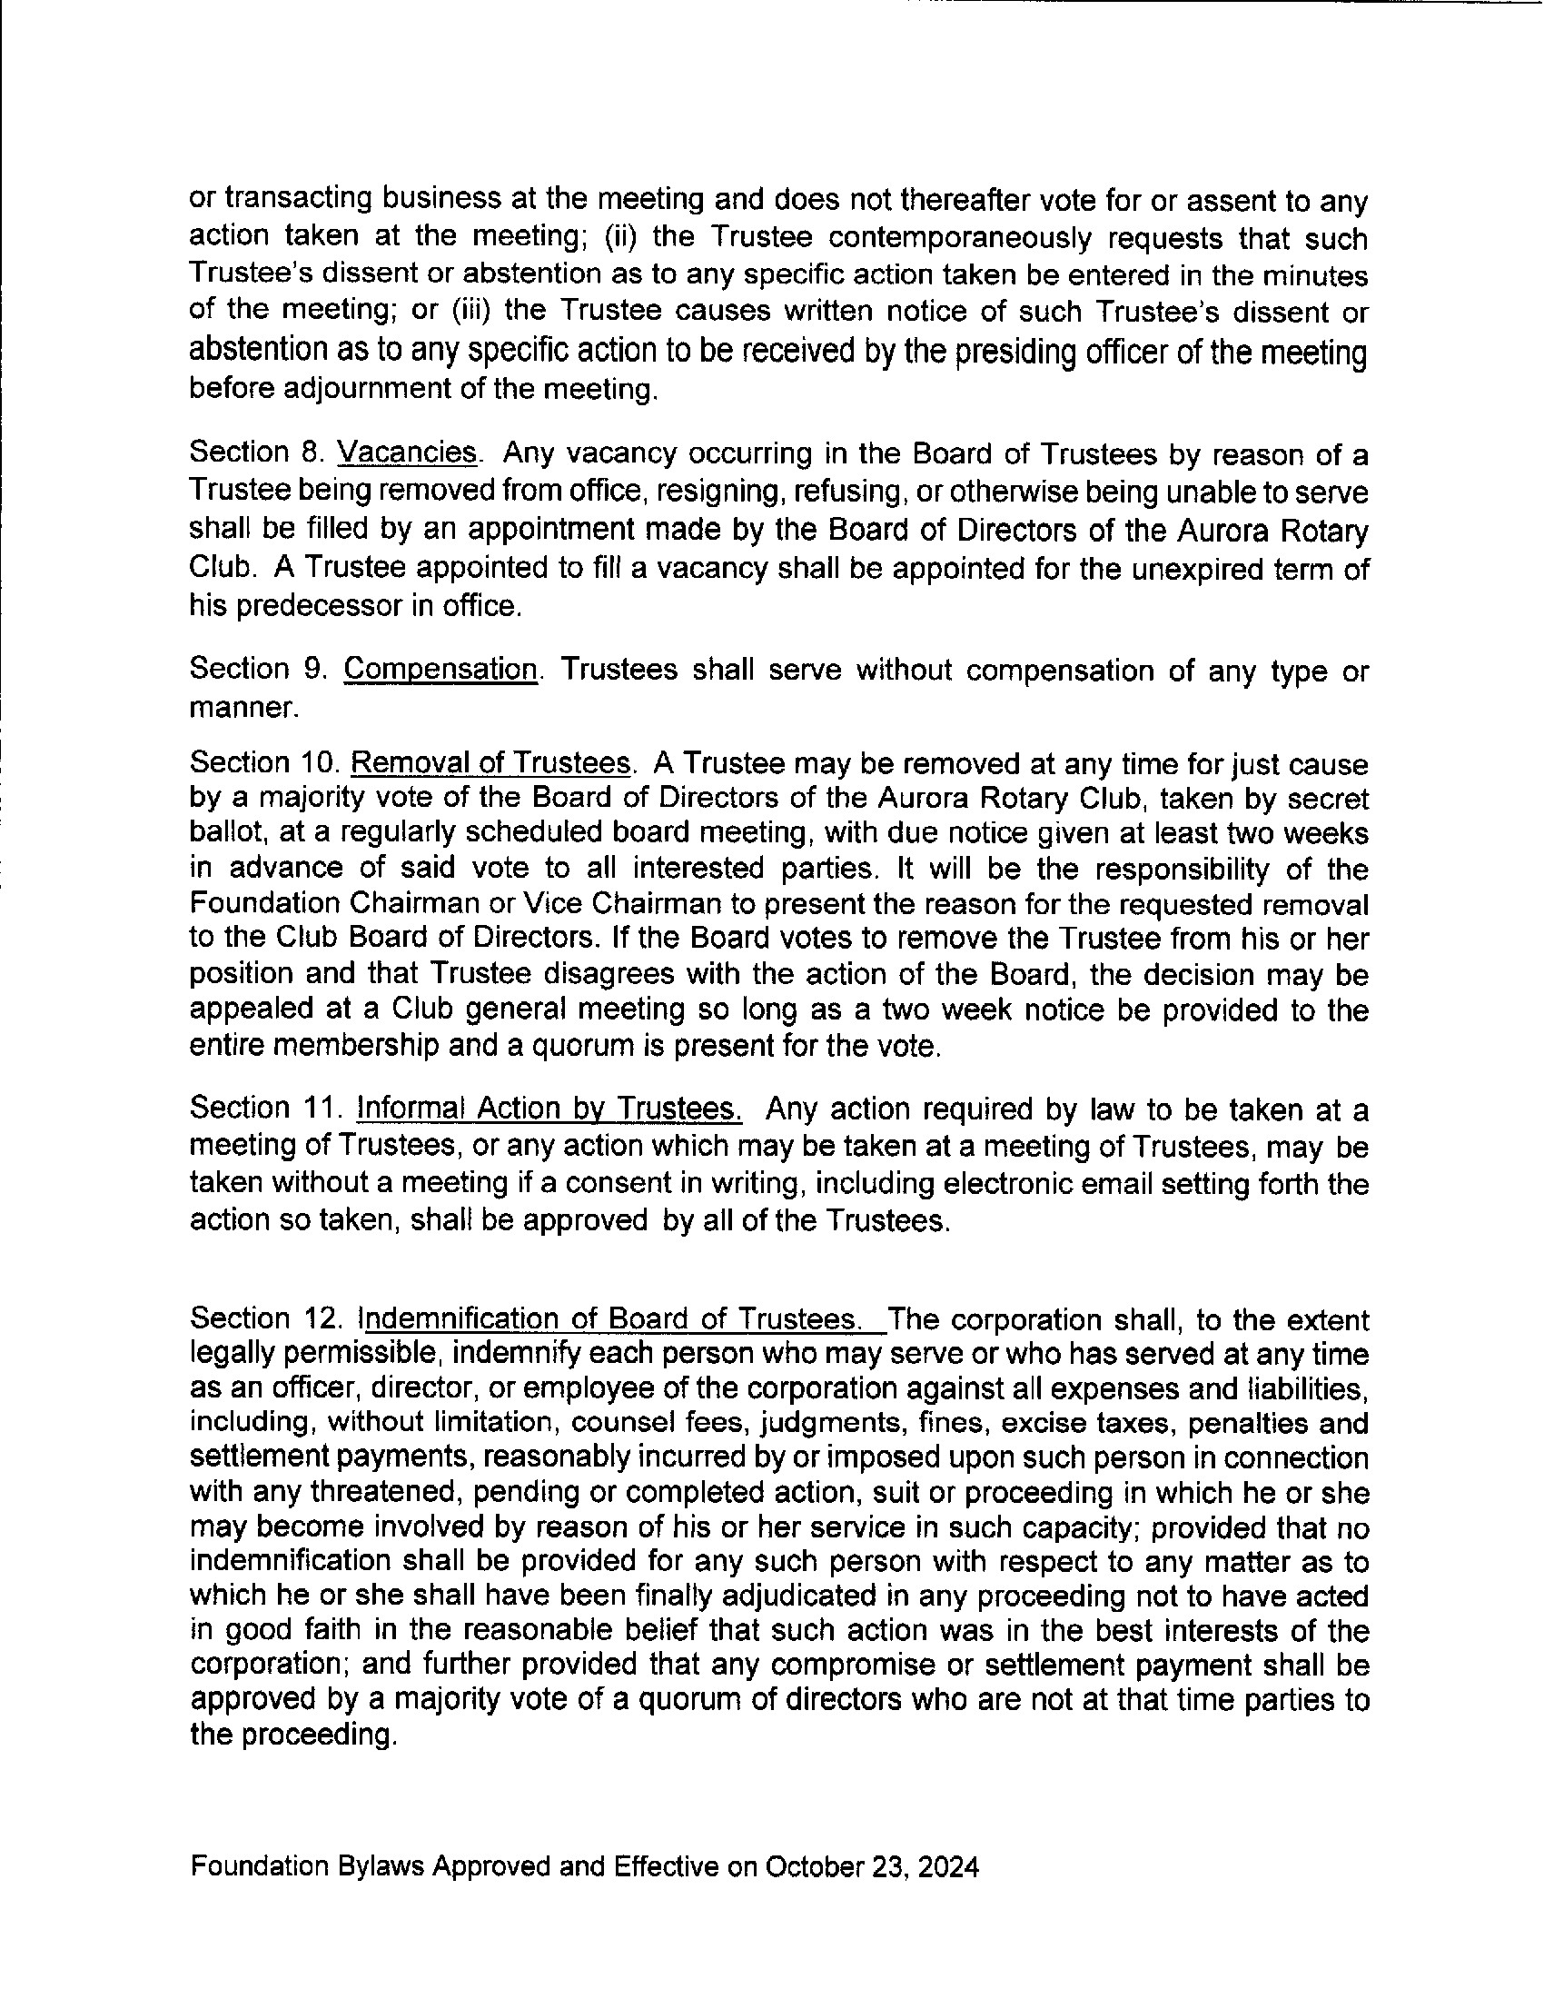
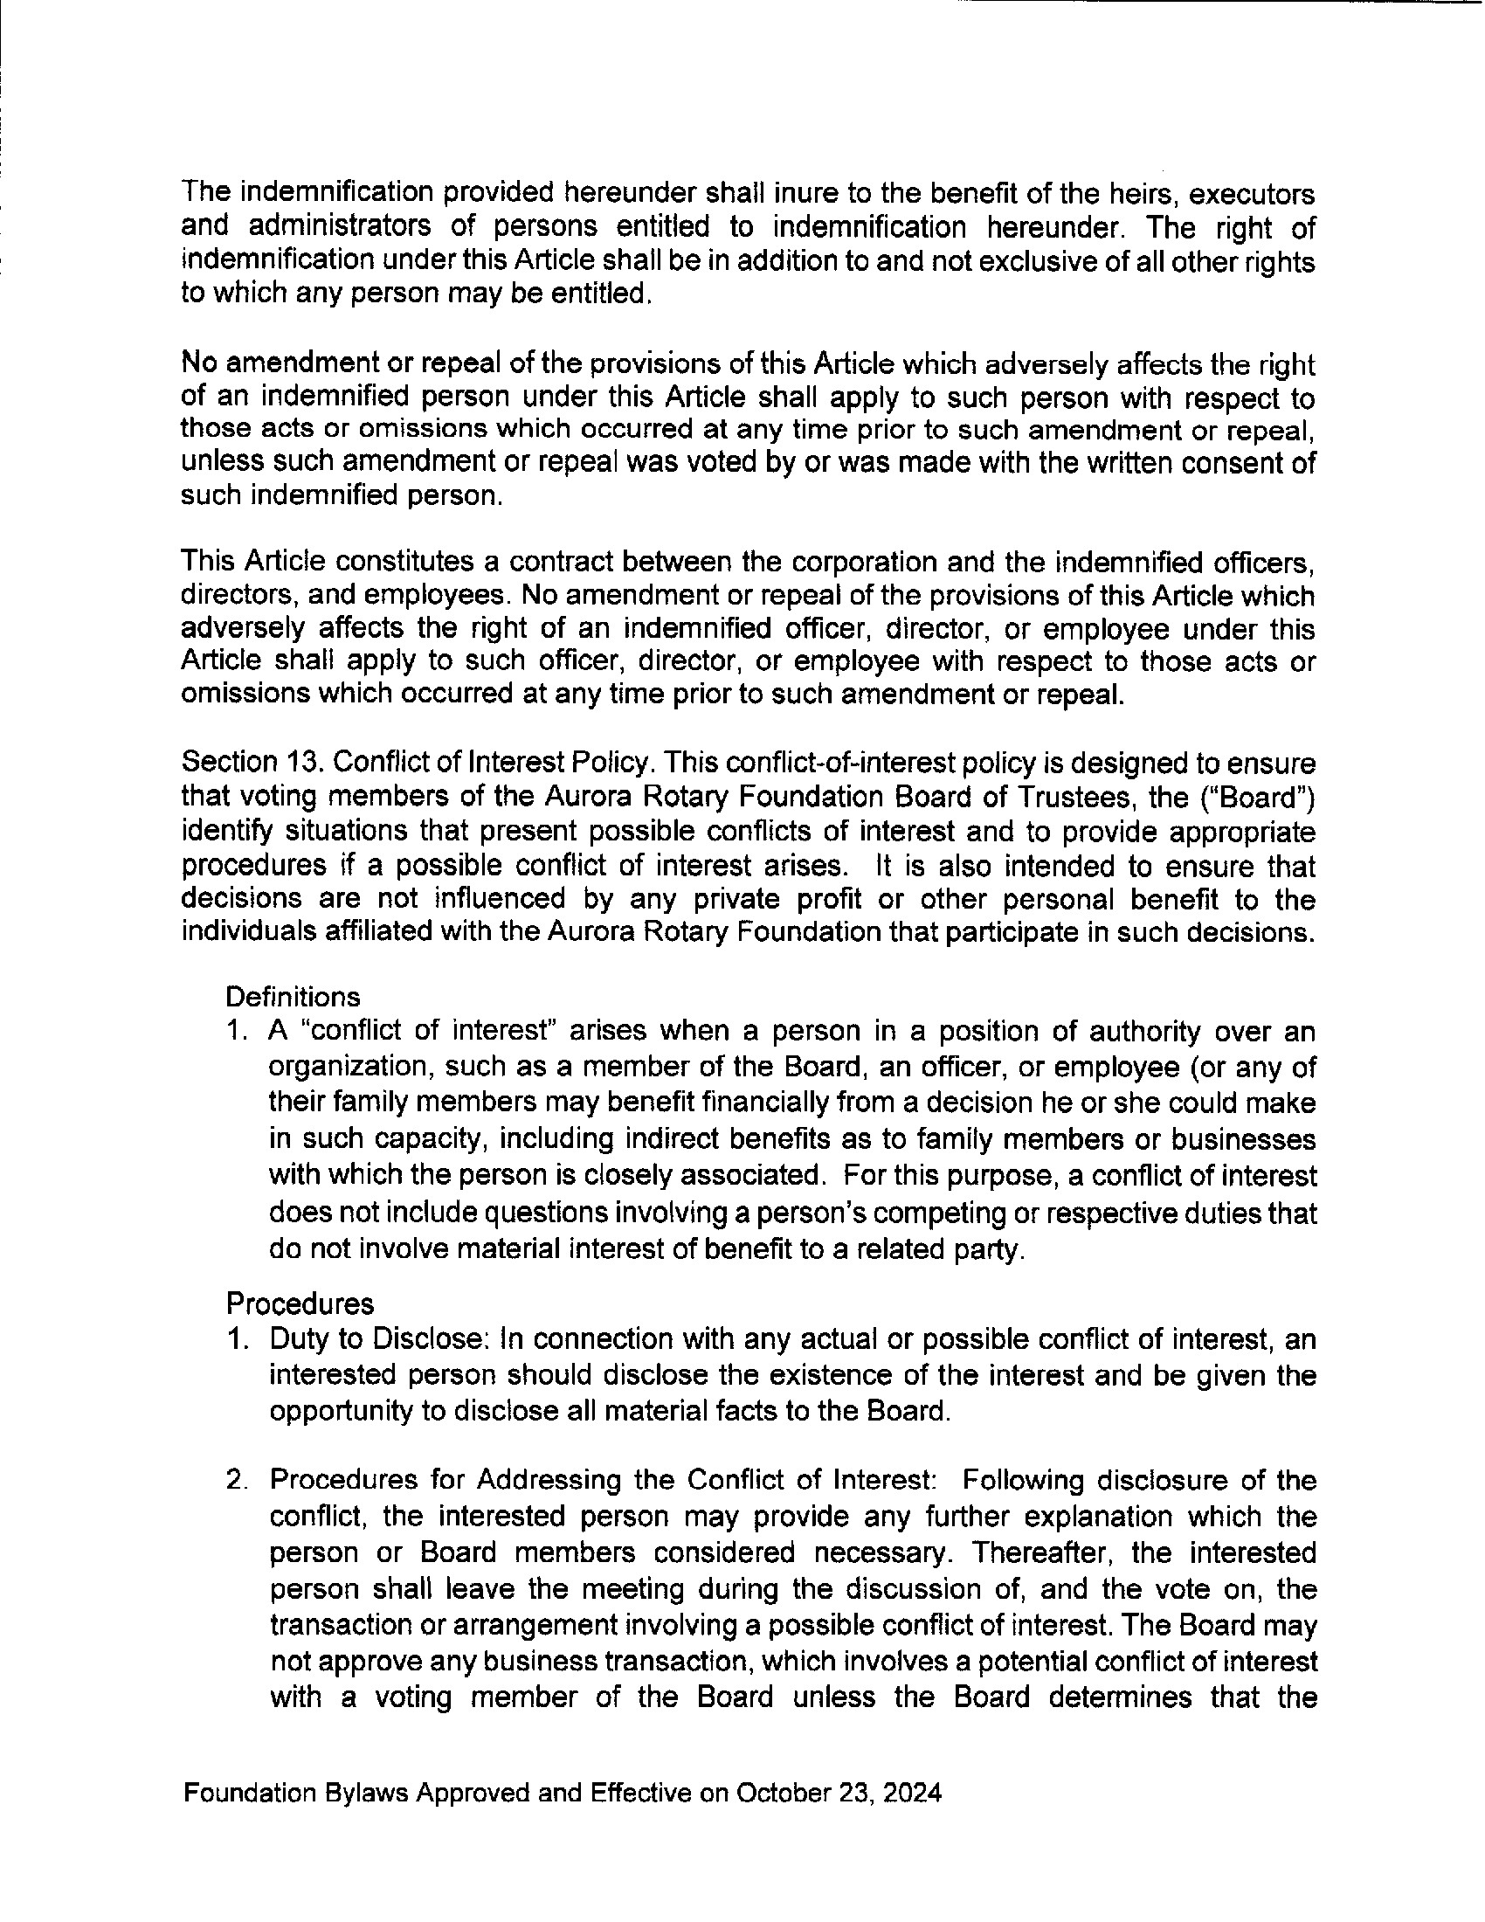
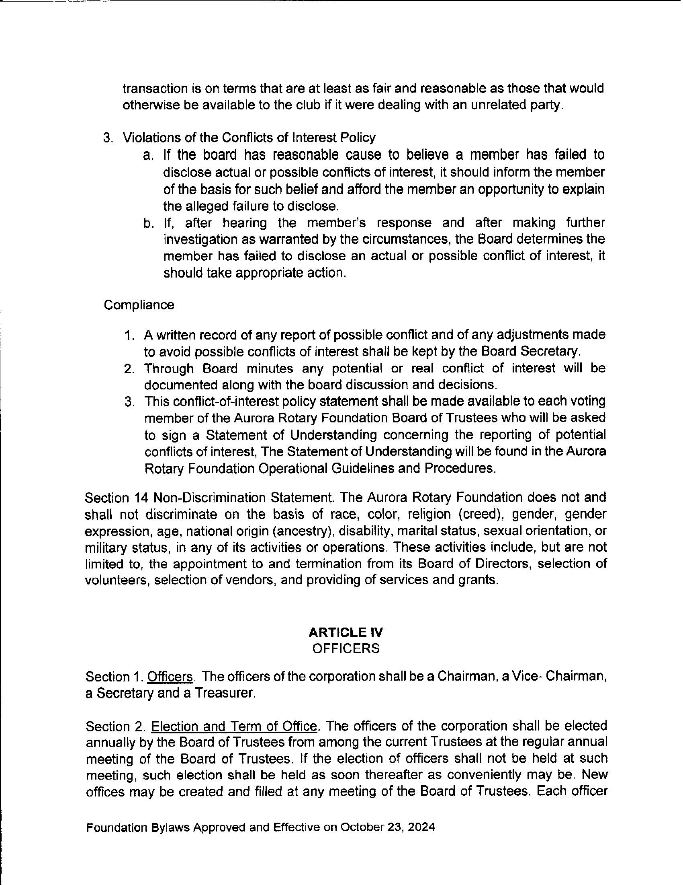
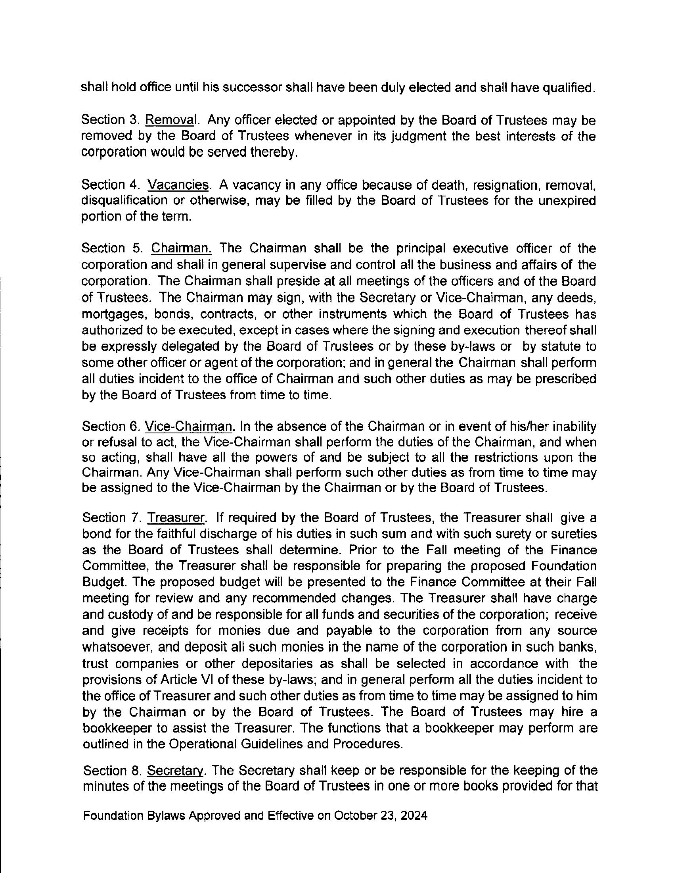
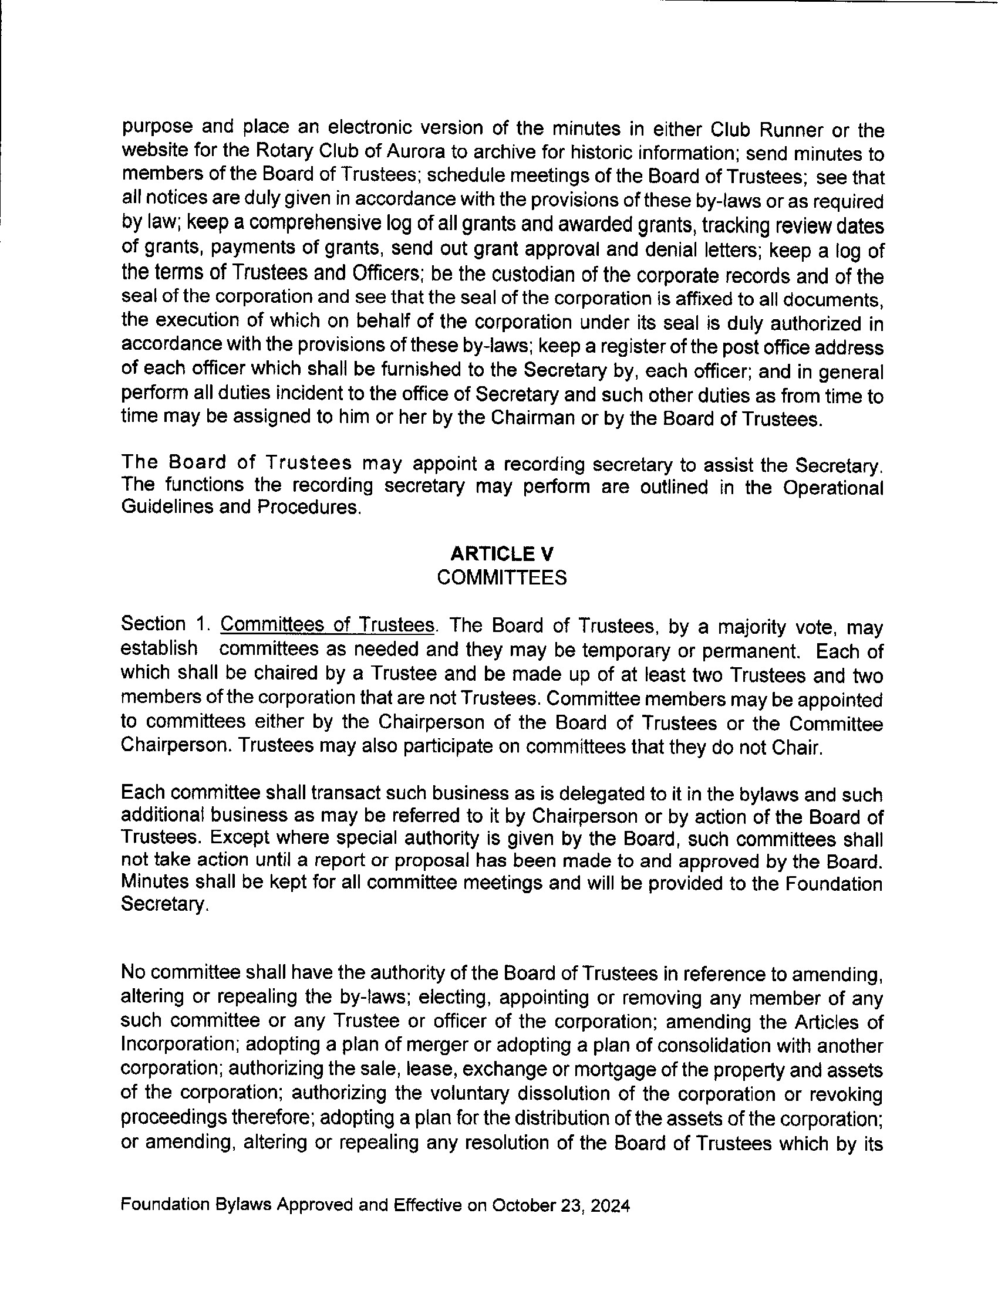
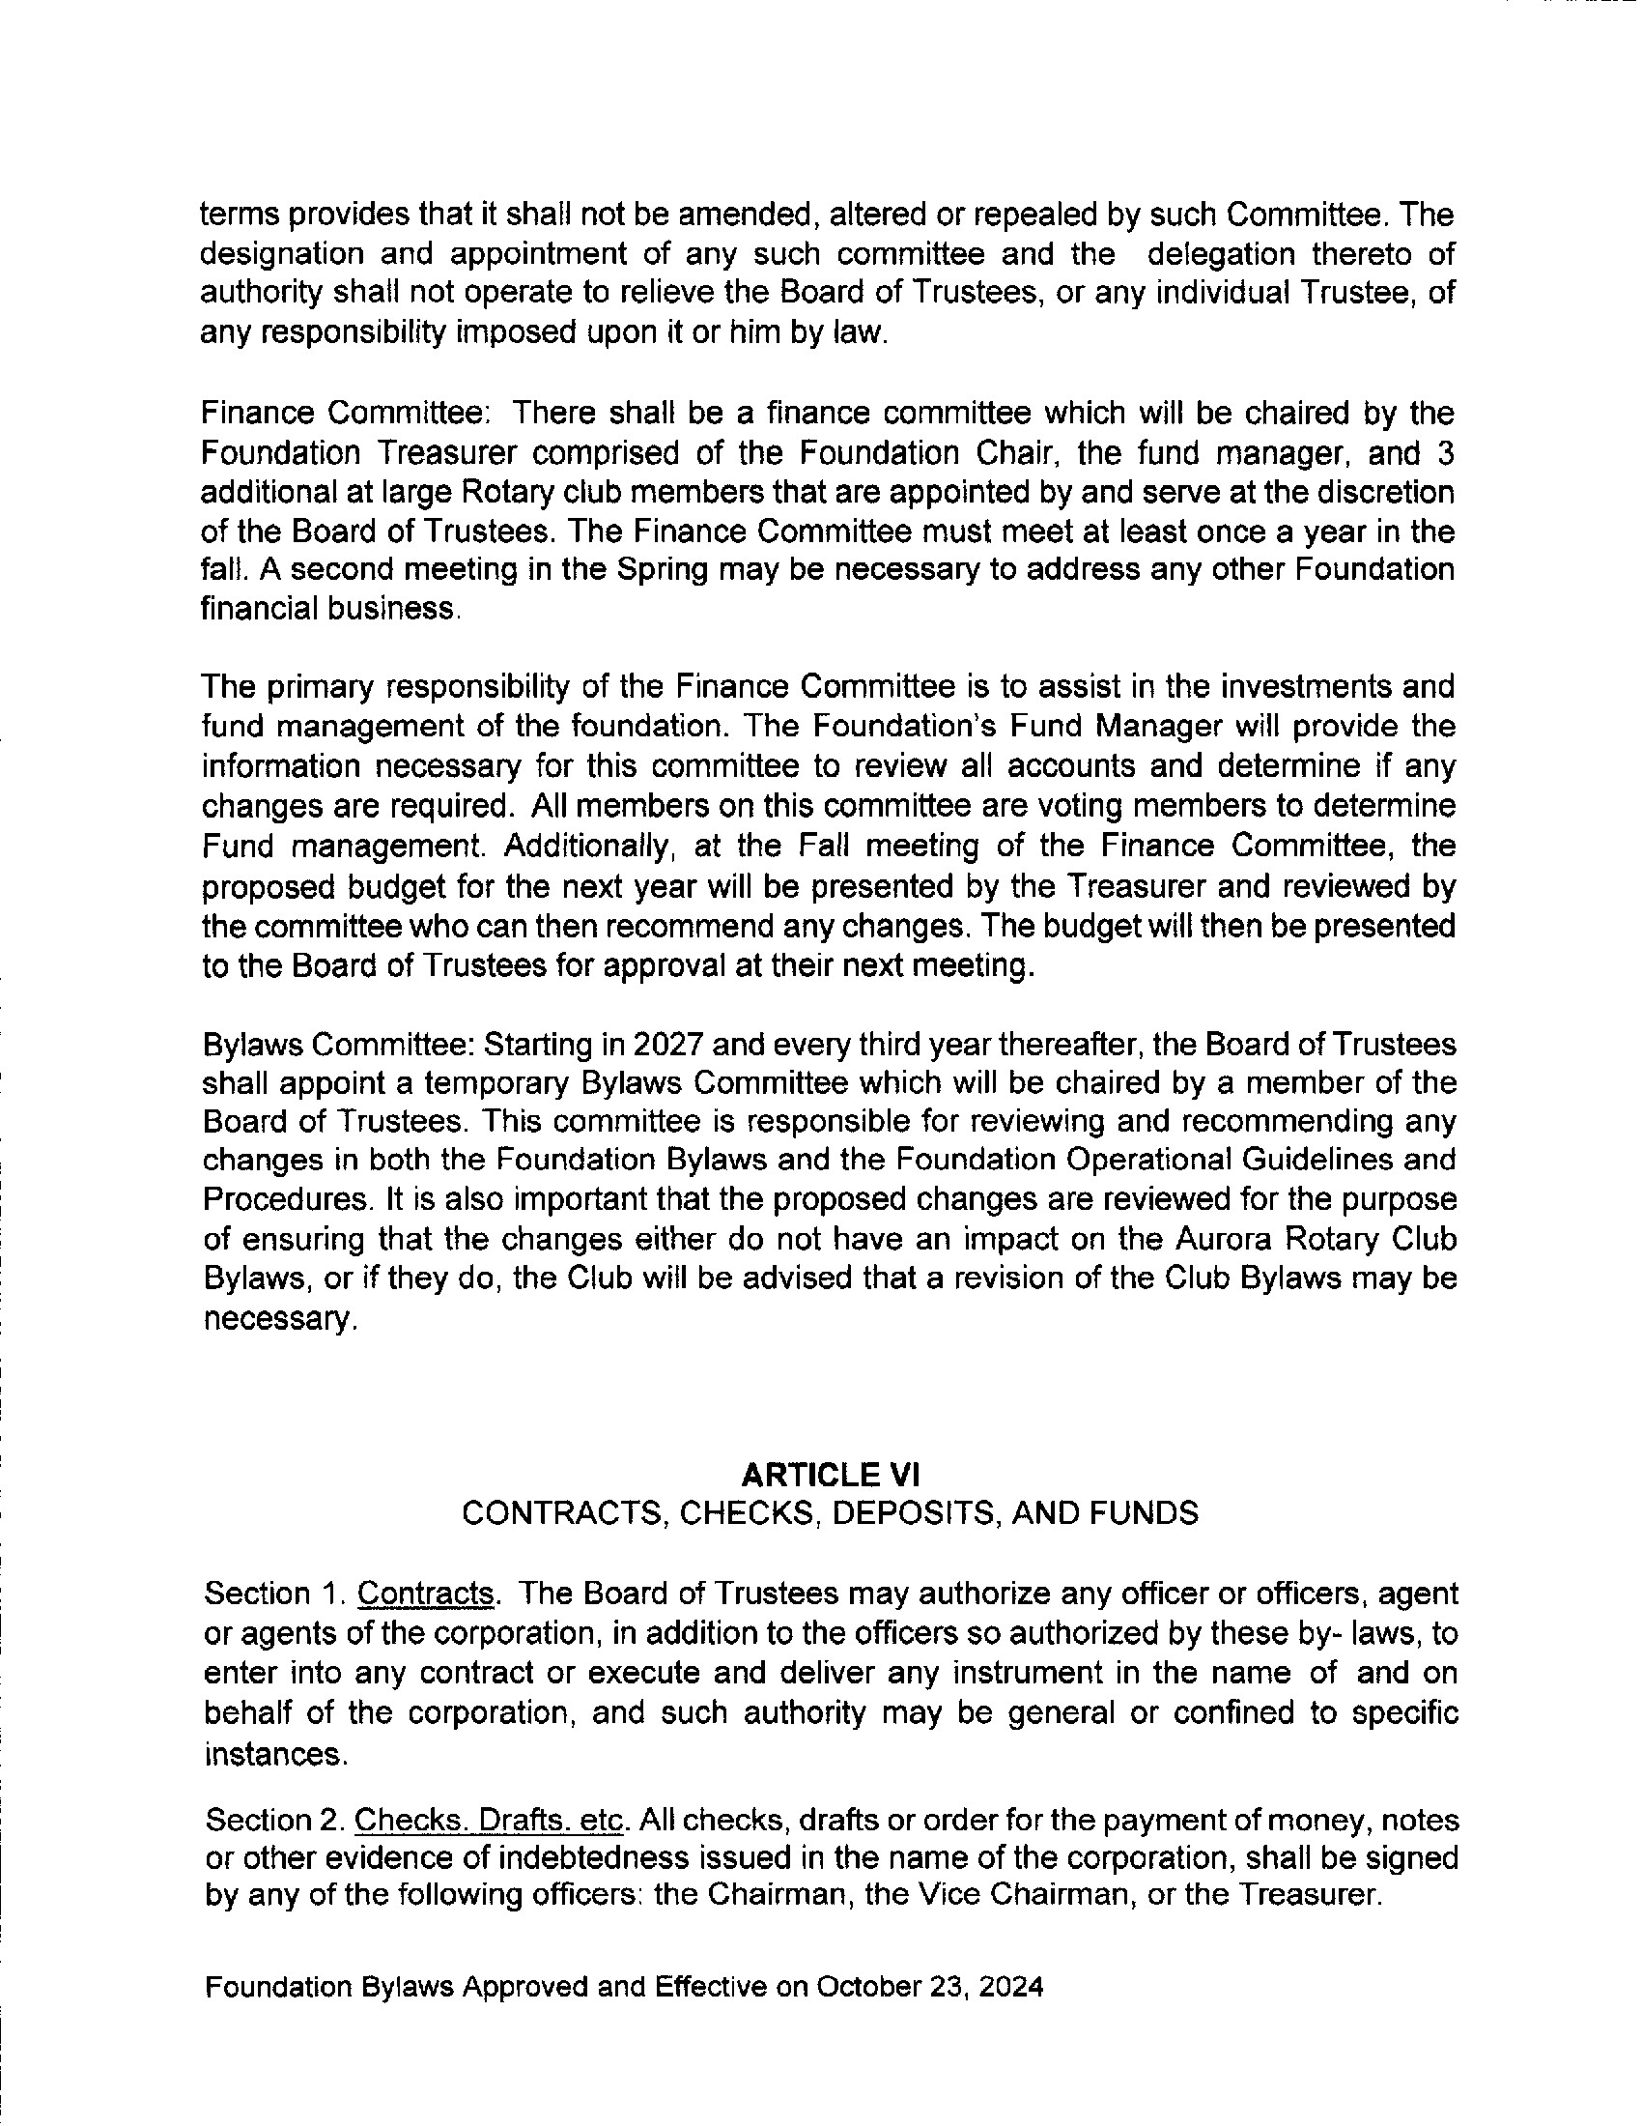
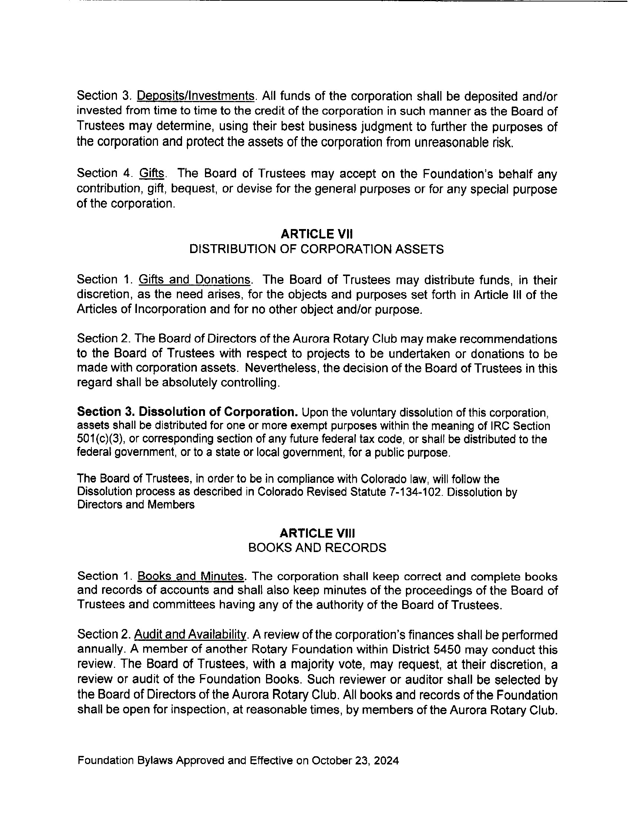

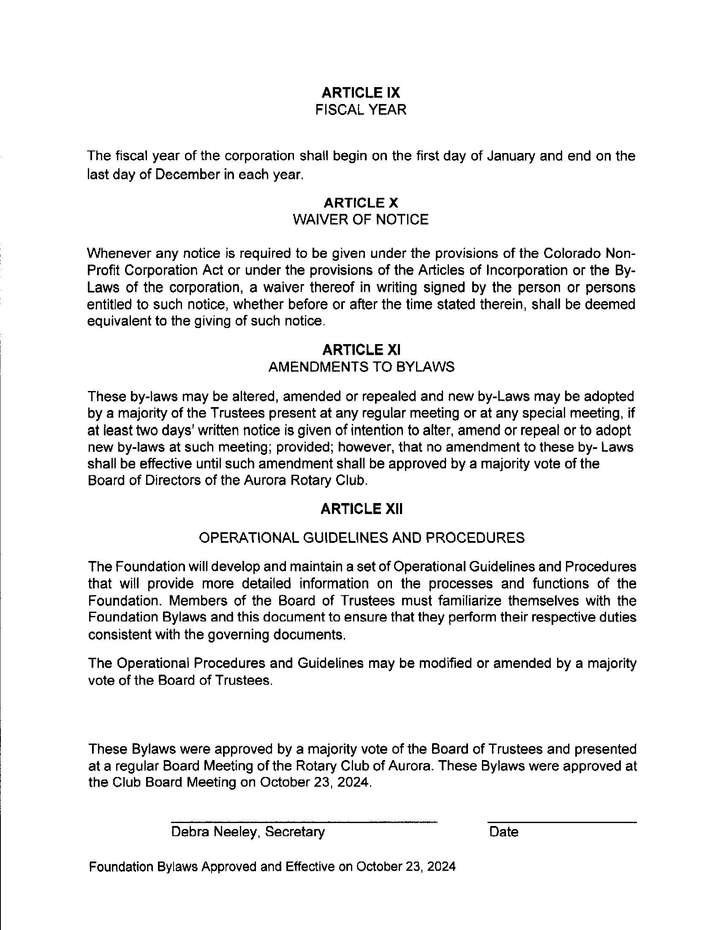
Debra Neeley (Oct 25, 2024 12:20 MDT
)
Debra Neele
y
10/24/2024

ARF bylaws Oct 2024
Final Audit Report 2024-10-25
Created: | 2024-10-24
By: | Arthur Arms (skiparms@comcast.net)
Status: | Signed
Transaction ID: | CBJCHBCAABAA7AT4fQ8r_xWCZqfhGkMg6B9w_fu8k9Gq
"ARF bylaws Oct 2024" History
Document created by Arthur Arms (skiparms@comcast.net)
2024-10-24 - 10:20:33 PM GMT
Document emailed to Debra Neeley (debneeley@msn.com) for signature
2024-10-24 - 10:20:37 PM GMT
Email viewed by Debra Neeley (debneeley@msn.com)
2024-10-24 - 11:01:07 PM GMT
Document e-signed by Debra Neeley (debneeley@msn.com)
Signature Date: 2024-10-25 - 6:20:57 PM GMT - Time Source: server
Agreement completed.
2024-10-25 - 6:20:57 PM GMT
