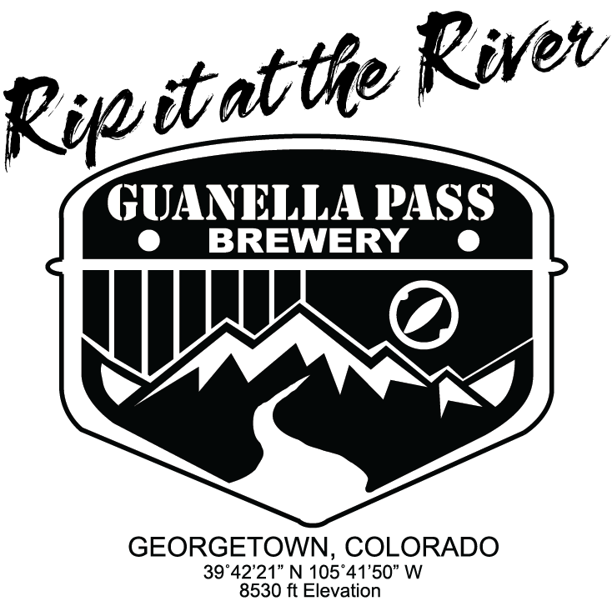
The Guanella Pass Open
“RIP IT at the RIVER”
CHARITY GOLF TOURNAMENT
Friday June 9, 2023

KEYSTONE RIVER GOLF RESORT
155 River Course Dr., Keystone, CO 970-496-4444
(4-PERSON SCRAMBLE, modified scoring – 60+ HANDICAP PER FOURSOME)
7:30a.m. – 8:30a.m. REGISTRATION
8:00a.m. – RANGE OPENS, Complementary COFFEE, JUICE & ROLLS
9:00a.m. - SHOTGUN START
2:00p.m. – 5:00p.m. – DELICIOUS LUNCH & AWARDS
Guanella Pass Brewery, 501 Rose St., Georgetown
GOLD SPONSOR - $1,000 (Goodie bag with fleece vest, hat, beer glass, YOUR SIGN
on a TEE BOX & a 4-Person team entry)

COMPANY NAME:_______________________________________

SILVER SPONSOR - $800 (YOUR SIGN on a TEE BOX, 4 Free Entries)

COMPANY NAME:__________________________________________________

BRONZE SPONSOR - $200 (YOUR SIGN on a TEE BOX)

COMPANY NAME:__________________________________________________

TEAM SIGN UP - $125 PER PERSON (includes breakfast, cart, practice range, snack bag, prizes, awards, delicious lunch @ Guanella Pass Brewery)
1. CAPTAIN:_________________________________________________
e-mail______________________________Phone_________________

2. Player___________________________________________________

e-mail______________________________Phone___________

3. Player____________________________________________
e-mail______________________________Phone__________

4. Player_____________________________________________
e-mail____________________________Phone___________

Send ck & sign up to: Bob Pagano 303-489-5987
Peak One Realty
POB 413
Georgetown CO 80444

Call for information: Diane Lee 303-921-9096
dlee@clearcreeksheriff.us

Make ck payable to G.T. Community Center

Proceeds to Benefit: Georgetown Community Center & Rotary Youth Scholarships

