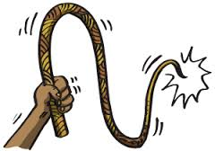**The Whipping Post**

Rotary meetings held 12/4/14 and 12/18/14

C:\Users\budny\AppData\Local\Microsoft\Windows\Temporary Internet Files\Content.IE5\Y9YWZYD5\MC900053611[1].wmf

**Breaking News!!!**

Sad news: our very own Commander in Chief, Lynne Alexander has announced her decision to resign her position as the President of our Rotary Club. Due to an increase in her business and the complex matters that she is taking care of, she no longer has the time to give the Presidency the attention it deserves. Lynne, we applaud you for your service! Sue Voghel will be stepping up as President effective 1-14-15!

**Reminders:**

Due to the holidays, we will only be having one meeting in January on the 15th and we will be at Forman as usual.

Stop and Shop cards that help support the Litchfield Education Fund are still available … Please see Dave Pavlick. These make a great donation to the Morris Food Pantry!



The Golf Tournament’s new date is 05/22/15 – less than 5 months away!! (when did that happen?!?!)

**Annoucing…. Drum roll please!!**

We have a new Rotarian! Welcome, welcome to Fred Colson. Fred has a long list of accomplishments – (I wrote as fast as I could, but I know I missed some!!) He was formerly the Director of a Catholic Youth Center, CFO of a Family Service Center, Consultant for non-profits, CFO of a boarding school in Troy NY, CFO of Forman School, but now he is here to stay in Litchfield and we are very happy to have him join us!!!

C:\Users\budny\AppData\Local\Microsoft\Windows\Temporary Internet Files\Content.IE5\M1ZW4U7S\MC900022950[1].wmfAnd a laughing “thank you” goes out to Bob Kluge for his thougtful gifts! Now I will never run out of ink when I am frantically scribbling notes! Ted no longer has an excuse to be late with his new watch, Lynne will continue to light up the place with her new candle, Sue will enjoy her vintage FNBL candy dish and as we all already know – Bob Doyle is worth a million bucks and now he has a million dollar bill to prove it!!

Holiday Party: a big thank you to Dan Ferrara and Lynn Cossette for all of their hard work on the Holiday Party!

A big **Thank You** goes out to Rob VanWyck, Bob Doyle, Ileana Santore and Ted Murphy for their help setting up and breaking down the Blood Mobile site!

Our Seargeant at Arms is at it again! Fines were doled out over the last two meetings for such items as:

*Pinless Wonders

*Having to run back to your car to get your pin

*forgot that Bob Kluge was collecting food at the meetings

*coin, coin, who has the coin?

*And the always wonderful happy dollars!

**Our Illustrious Guest Speakers**

I could write a book about each of our guest speakers from these two meetings but will try to keep it manageable!

Our first Guest Speaker was our own Jonathan Costa who is the Director of School and Program Services at Education Connection besides that he is also a “good guy with a wonderful golf swing”. (remember that for golf tournament time – we may have a ringer!!)

John filled us in on the declining enrollment issues in our schools and the question of regionalizing. According to John, the bulk of the debate is over what we will lose and there is no compelling voice telling what will be gained. The average per pupil expense in the state is $11,900 while in Litchfield county that number climbs to $15,000-$17,000. Savings can be generated by closing buildings and laying off staff; however once a school is closed, to reopen it, it must meet today’s building codes and ADA requirements. Ted pointed out that decisions are being made by adults for kids for political reasons. You will never get administrators to give up their jobs. To change the status quo, we are going to need a grassroots movement by the parents or possibly the state.

This is a topic we could have discussed for hours! This is just a small taste of the discussion.

Our second speaker was also one I could have listened to for hours! “Reg” Harrison from

Connecticut AMVETS Posst 24 which is based in Litchfield County. Reg’s list of

accomplishments is another one I couldn’t write fast enough to get it all down! He is a

Vietnam veteran, was the AMAVET CT Commander 2012-2013, earned the Distinguished

Flying Cross and the Republic of Vietnam Cross. He is the Colonel and Commander of the 1st Artilary, a life member of disabled American Veterans and was the 1978 Litchfield Lions President. According to Reg, he sent Ted Murphy’s dad over to Rotary to help us out ;)

Currently Reg and the AMVETS are working with the American Warrior Project. The American Warrior project takes 100 WW II vets twice a year to Washington to see the monument. AMVETS was able to collect wheelchairs so our veterans could make this trip.

Our own Bob Doyle connected AMVETS with Doyle’s Medical Equipment to refurbish and power medical equipment for the vets.

AMVETS funds scholarships for the children of veterans and helps Paws for a Cause and Pets on Wheels and ECAD (Educated Canines Assisting Disabled) where they help with the aquirement, care and feeding of service dogs for our wounded heroes.

He also brought to our attention that the Afganistan and Iraq vets are unique in that so many have lost body parts. AMVETS helps them with gift cards so they can purchase items at military stores to maintain a quality of life.

Bob Kluge requested a list of items that they need to see if Rotary can help!

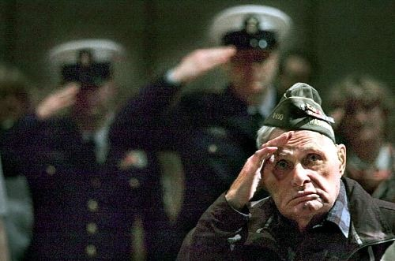Reg Harrison and the AMVETS are doing amazing work and we are greatful for their service and for taking the time to open our eyes about CT AMVETS!

That is the end of the Holiday Recap edition of the Whipping Post!

Remember: Our next meeting is 1/15/15 and our Guest Speaker will

be Catherine Wocko and she will enlighten us about bee keeping!