**The Whipping Post**

Rotary meeting held 02/05/2015

C:\Users\budny\AppData\Local\Microsoft\Windows\Temporary Internet Files\Content.IE5\Y9YWZYD5\MC900053611[1].wmf

**Breaking News!!! Club Assembly meeting!**



We are renegade Rotarians!! Who knew?! We were members of a pilot program that was “test driving” bi-monthly meetings rather than weekly. The program is over, but we, as a club,

have decided we like being rebels and will stay with our bi-monthly meetings!

The Short Term Rotary Youth Exchange: 3/1/15 is the deadline for entries.

Committee Updates:

The Golf Tournament: The first meeting was held. The committee will be reaching out for help in targeted areas. We need golfers!! **And don’t forget the new date – MAY 25, 2015!!**

Litchfieldopoly: We still have approximately 80-100 games left. Games can be purchased at

Webster, Union and the Historical Society to name a few.

Upcoming Speakers and Topics: Tina Reardon is coming 02/19/15 to speak with us about the Japanese Internment. Upcoming topics include managing multiple housing situations, college funding and Montessori.

Public Relations/Website: Currently we are primarily in the newspapers but will be working to enhance our website. Timetable on enhancements will be in the next 2-3 months.

Career Day: Litchfield High School is not doing a Career Day this year but has expressed interest in having students job shadow and touring facilities. More info to follow…

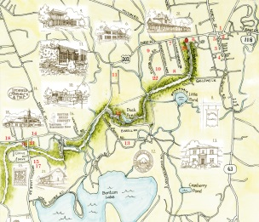

The Greenway: Appeals letters have been sent for funding and were well received. Follow up is coming up. You can now donate online at litchfieldcommunitygreenway.org! The possibility of trying for a Rotary Grant was discussed as well.

Remember: Our next meeting is 02/19/15 and our guest speaker will be Tina Reardon to speak to us about the Japanese Internment.