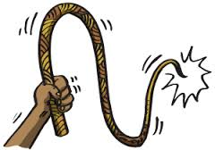**The Whipping Post**

It’s another Whip-a-palooza!!!! Fourth Quarter and Year End 2015

C:\Users\budny\AppData\Local\Microsoft\Windows\Temporary Internet Files\Content.IE5\Y9YWZYD5\MC900053611[1].wmf

**The News!!!**

Bob Doyle is amazing and on October 1, 2015 we celebrated Bob! Bob received Proclamations from the Town of Litchfield presented by Leo Paul, The town of Morris presented by Bob Kluge and Rotary. Bob was presented an award for all he has done for the Rotary Club of Litchfield-Morris: a founding member, past president, Paul Harris award winner and always there to volunteer. Some of his other accolades and gifts:

A fancy 4 color pen from Dan Ferrara so he can color code to his heart’s content

The Quiet Rotarian award since he is sometimes caught napping (we won’t tell Bob Kluge!!)

Dessert – Bob can take home the dessert without sneaking it!

Stories about Bob were shared by many and one thing became very clear – Bob Doyle is a wonderful man who quietly and without fanfare is constantly giving of himself in hundreds of different ways. He is also one smart cookie as he listened to his wife about joining Rotary!

So…. From here on out, October 1st is hereby declared

Annual Bob Doyle day!! In honor of Bob, make sure to do something

special for someone else, take a nap, and eat an extra dessert!

**The Greenway**

It’s happening people!!! Very exciting! Our grant request was approved and we are moving ahead with Rotary Park! Benches, bollards and the bike rack have been ordered, received and awaiting a spring installation. Ground has been broken and we are moving ahead. By this time next year, we will all be enjoying a beautiful part of the Greenway sponsored by the Rotary Club of Litchfield-Morris!

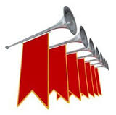

Comings and goings:

New Rotarians: Barbara Rodenbach

Peter Moritz

Resignations since June 2015: Dani Thibodeau, John Costa, Raj Patel, Margret Warner (joined Watertown Rotary), John Wages, John Creedon and Adam Sobek. We wish them all well and they will be missed!

**Salvation Army**: Bells were rung and a record amount of funds were collected this year!! A big **THANK YOU** to everyone that helped with the bell ringing!

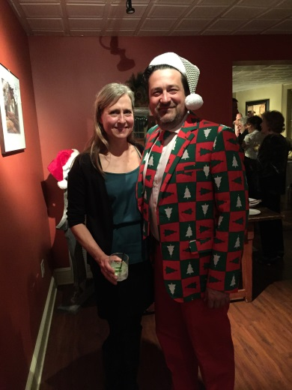

**Our Holiday Party**!! Another successful event! It was a wonderful evening with friends enjoying the holiday season and some wonderful food!!



The award for most “festive” outfit would have to go to **Ron Swanson**! No one can sport a suit like that better than Ron!

**The Golf Tournament**: It may seem like it is a LOOOOOOOOONNNNNNGGGGG time away, but it isn’t! It will be May 20, 2016 before you know it! The Golf Committee will hold their first meeting 01/14/16 at Leo Paul’s office at 8 am for any who would like to join!

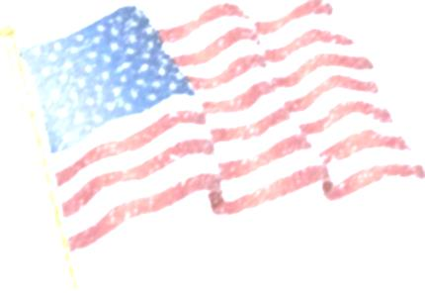

**Patriotism Project**: Spearheaded by our very own Bob Kluge, we will be selling U.S. made

Flag kits in late spring. All funds we raise will go to benefit our local first responders. Anyone who can help with this project with sales, advertising, product placement, etc., your help would be greatly appreciated!

**Food Drive:** Bob Kluge is once again coordinating our food drive to benefit the Morris Food Bank. Don’t forget, you can donate gift cards and Dave Pavlick is still selling Stop and Shop Gift Cards – a total win/win with both the Litchfield Education Association and the Morris Food Bank benefiting. Food Drop off points will be at all the local banks, EJ Murphy Real Estate and others!

**Alumni Basketball Game**: Ted Murphy is coordinating the annual Alumni Basketball Game which will be 12/26/15. Please let him know if you can volunteer to help out at this fun event!

**Rotary Foundation**: It is time to start thinking about your Rotary Foundation donation. To be eligible for the grant program, we need to have 100% participation in donating to the Rotary Foundation. Donations for as little as $1 count!! Every dollar helps! Please see Bob Doyle about making your donation today!!

**Membership:** Kudos to Barbara Rodenbach for stepping up and chairing this committee! 2016 will be the year we will be looking to increase our visibility in the community and to gain new members! Bring those guests to lunch so they can see what we are all about!! Any leads, please be sure to pass them on to Barbara!

**Guest Speakers**: Last year Sky Post did a phenomenal job of bringing in speakers. If you know of anyone who would like to speak to Rotary, please give their contact information to Sky so he can arrange a time for them to come and visit with us. It is very important that Sky does the booking so we don’t cross book!



**Donations Committee**: Teresa is currently compiling donation requests to be submitted to the committee.

**Interact**- Fred Colson has met with the high school advisor about Interact and the Youth Exchange. He has spoken with a group of students to help increase the awareness of both Interact and the Youth Exchange.

**Earth Day:** Rob Vanwyck has agreed to be the Chair of this committee and fill the vacancy left by John Wages. The tentative date for the 2016 cleanup will be 04/23/2016.

And what Whip-a-palooza would be complete without our **Sargent at Arms**!

 Bob Kluge does not take his duties lightly people!! You had better be reading your *Rotarian* magazine, sporting your sassy pins, and don’t forget to duck when you see John McKenna! New for this year is the **Pass The Fine** card to be awarded at Bob’s discretion. I am sure that brown-nosing the Sergeant might be called for to obtain one of these sought after treasures!! And if your name happens to be Ted Murphy….look out!