**The Whipping Post**

Time to get back to business!

C:\Users\budny\AppData\Local\Microsoft\Windows\Temporary Internet Files\Content.IE5\Y9YWZYD5\MC900053611[1].wmf

**The News!!!**

Our summer ‘Walkabout’ has taken us to Brandywine Senior Center for our August 4, 2016 meeting!



Mark your calendars:

8/18/16 meeting at Saltwater Grille with the executive board meeting to follow immediately after.

9/1/16 we are finally back at Forman School with a visit from the District Governor.

9/15/16 we are at Forman School and Benjamin from BR Mortgage will be speaking to us about Reverse

Mortgages

10/1/16 Annual Bob Doyle day!! Everyone is allowed to have extra dessert on Bob Doyle Day!

10/6/16 we are meeting at Forman for our Quarterly Club Assembly

10/20/16 we are meeting at Forman and Captain Leo Lloyd from the Salvation Army will be speaking

C:\Program Files\Microsoft Office\MEDIA\OFFICE14\Lines\BD14800_.gif



About our Host:

Felicia Saraceno, Director of Community Relations at Brandywine brought us up to speed on the happenings and offerings at the center. Brandywine has completed a 30 room addition and renovated all of the community spaces as well as expanding the Memory Care unit. Brandywine offers assisted living, memory care and Serenade. Serenade is anything, anytime. It is upscale living that includes a concierge butler. You can get room service, custom dinners and supply transportation. They have their own private dining room and lounge available.

The Memory care unit has Neuropsychologist on staff. He makes sure the residents are still learning and he does brain exercises with them. The Neuropsychologist works with both the residents and their families. He also can assess someone who will soon need to transition to memory care.

Rooms available include studios, one bedroom and 2 bedroom units.

Life is good at Brandywine – The Escapades program takes residents to events and activities out in the community. There is also daily entertainment in the pub for happy hour and karaoke. Chefs are all from the culinary institute. They can provide anything from normal diets to chopped diets to liquid diets.

Also offer Respite care – you can stay for a weekend or a winter vacation. Can use respite care for a week as a transition from hospital to home. Brandywine in Litchfield has the highest level of 4,5,6s in the Brandywine network which stretches from CT to Virginia. Level ranges start at 1 being fully self-sufficient and not needing assistance to a level 6 which is the highest level they cover. Level 6 is the level prior to requiring full nursing home care.

In the future: memory care will be expanded beyond 38 beds. They are considering “step down” units that helps those that are independent during the day but need extra help in the evening and overnight. This would entail taking room away from assisted living rather than expanding the footprint of the building.

C:\Program Files\Microsoft Office\MEDIA\OFFICE14\Lines\BD14711_.gif

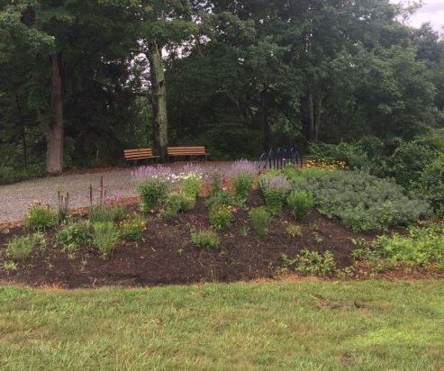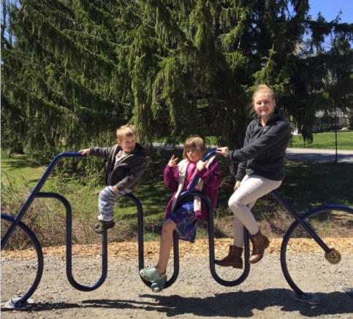

**The Rotary Park**

It's getting a lot of attention and is being enjoyed by families in the area. Bob Kluge’s bicycle bike rack is a huge hit. Recently the plantings that had been done had been stolen but have been replaced. Discussion is being held on the plaque. Once we come up with the wording the plaque will be ordered. There are two more benches to be placed: One to be in honor of our own Col. William Rodenbach and the second in honor of Joseph Italiander.

C:\Program Files\Microsoft Office\MEDIA\OFFICE14\Lines\BD14710_.gif

**Interact:** Peter Aziz met with the Forman School about forming an Interact Club. Peter gave them all the information they need to get started. School at Forman resumes in another month or so, we will follow up with Terry Walsh from Forman at that time.

**Membership:** Sue Voghel is now the membership chair with Barbara Rodenbach continuing as a committee member.

We may try to have a Fall Social/Harvest Social since we were unable to get enough attendance to move forward with our Summer Social at the Bantam Yacht Club. The Party Committee will revisit. Please stay tuned for more info!

**In the News:** Our Rotary club sponsors a student at Razia’s Ray of Hope School and Razia’s had a person interviewed on the Ellen DeGeneres Show! For more info – check out the email that Teresa Spring, our intrepid President sent out!

**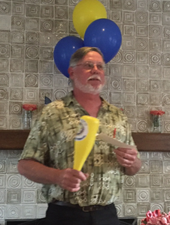The Sergeant at Arms** was his usual enthusiastic and overly dedicated self! Fines were levied for being late, not reading the *Rotarian* magazine, traveling, for sassing the SAA, anniversary dollars and ‘It Could Only Happen to Me’ stories. The bat did not make an appearance today!!

**A note from the Secretary**: If you have any photos from any of our events or

Service projects please send them to me at [budny@litchfieldbancorp.com](mailto:budny@litchfieldbancorp.com)

I have created photo albums in ClubRunner so we can all share in the

memories!

Please make sure to check ClubRunner for meeting dates and locations, speakers, events and service project announcements. If you are having issues signing into ClubRunner, please let Mickie know.