Rotary Club of Gros Islet/Flow Charity Golf Tournament 2017/2018
Sponsors
Title - FLOW | 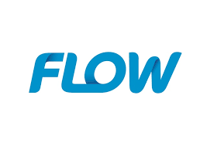
Diamond:
Courts | 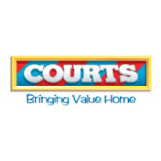
J.Q. Motors | 
Sandals Golf Club | 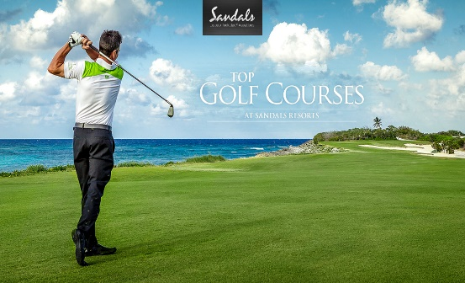
Gold:
CIBC First Caribbean International Bank | 
Diamonds International | 
Heineken | 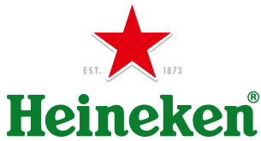
Yamaha Saint Lucia | 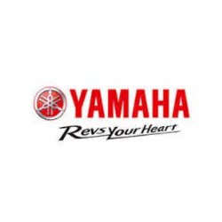
Silver:
ADCO
BOSLIL Bank
Concept Holdings
Embassy of the Republic of China (Tiawan)
Massy Stores
Rider Livett Bucknall (Saint Lucia) Ltd.
Spinnakers | 
Secure World
Endless Summer Cruises | 
Theobalds Consulting
Saint Lucia International Financial Services | 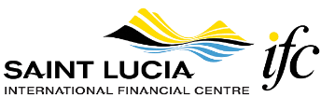
RCGI Youth Team | 
SIXT Car Rentals | 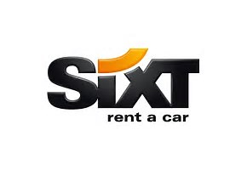
St. Lucia Helicopters
Royal Saint Lucian Hotel
LUCELEC
Ernst & Young | 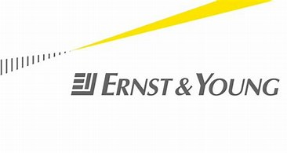
Bay Gardens Hotel | Prize
Cap Maison | Prize
Courts / Unicomer | Prize
Glitter Nails | Prize
Harmony Suites | Prize
Harris Paints Ltd. | Prize
J Q Motors Ltd. | Prize
La Cantina Wines | Prize
Razmataz | Prize
Rendezvous | Prize
RJB Hotel Supplies | Prize
Royal St. Lucia Resort & Spa | Prize
Strandz Hair Studio | Prize
Windjammer Landing Resort | Prize
Yamaha St. Lucia | Prize
Blue Waters St. Lucia Ltd. | Other
Mannee's Bakery | Other
St. Lucia Distillers Ltd. / Barbay Ltd | Other
The Voice Publishing (1993) Ltd. | Other

