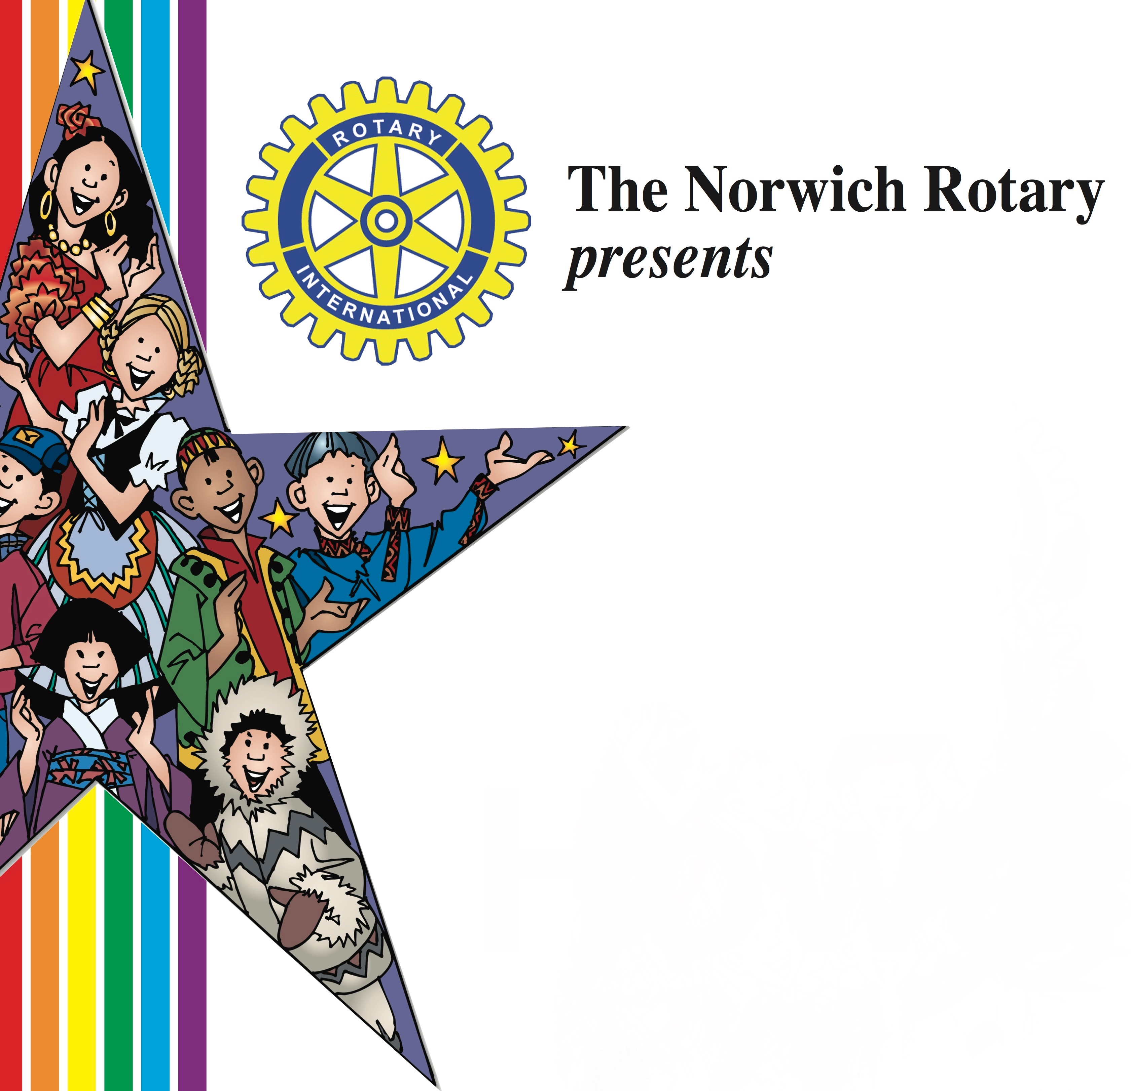
CELEBRATE CULTURAL DIVERSITY

On Tuesday, September 19, 2017, from 5:00 p.m. to 8:00 p.m. at Howard T. Brown Park, Chelsea Harbor Drive, Norwich with Ethnic Foods, Music, Dance and Entertainment that reflects the cultures of Norwich.

We invite you to participate: We provide the advertising, and The Bulletin will add your logo to provide a “click-thru” to your Website or Facebook page. We will provide $200.00 to help with your food costs. An additional $50.00 will be provided to any restaurant that decorates their table and the best decorated table will be awarded a $100.00 prize. We handle your Temporary Food Permit; provide the table and electricity if needed.

What you will provide: Small sample servings (Approximately 2 oz. servings) of the foods that will highlight the cultural flavor of your restaurant. You can pass out your menus, or any materials to promote your restaurant. DECORATE YOUR TABLE and showcase your cultural pride!!

Trophy will be given for the restaurant with the best food!! The Trophy will be yours to display for one year. In addition, you will be named the DIVERSITY RESTAURANT/BAKERY for 2017-2018.

The MC this year is FRANCO in the morning… star of K-Hits Radio. There will be a media blitz on both Radio and The Bulletin on this year’s event.

We require a copy of your SERVSAFE Certificate at the time you sign up, along with the completed Application so that we can get your Temporary food license for the event. Also, please provide us with the name of the food/dessert that you plan on serving at the event. We hope that you will join us!

YES, WE WILL PARTICIPATE! Signed:______________________________
SORRY, WE WILL NEED TO DECLINE. Restaurant:__________________________

DEADLINE FOR INCLUSION IN PROMOTIONAL MATERIALS - AUGUST 15

