Polio Plus Cards Available
Looking for the perfect gift for that special someone who has everything?
We have the answer!! Purchase an originally designed card and all also support Polio Plus. Our cards feature a striking photograph of the seacoast of New Hampshire and can be used for birthdays, graduations, anniversaries or “just because” and the best part, is that every card lets your special someone know that a donation to Polio Plus was made in their honor.
Help us create lasting change in communities around the world. Rotary is committed to eradicate polio in our lifetime and we are only two countries away from achieving that goal. In the first half of 2015, there were fewer than 40 new polio cases worldwide.
Despite such impressive gains, the job is not yet finished around the world. Polio is stubbornly hanging on in Pakistan and Afghanistan.
One hundred percent of your donation goes to Polio Plus. A $10 donation per card is suggested however any amount will be cheerfully accepted.
To order:
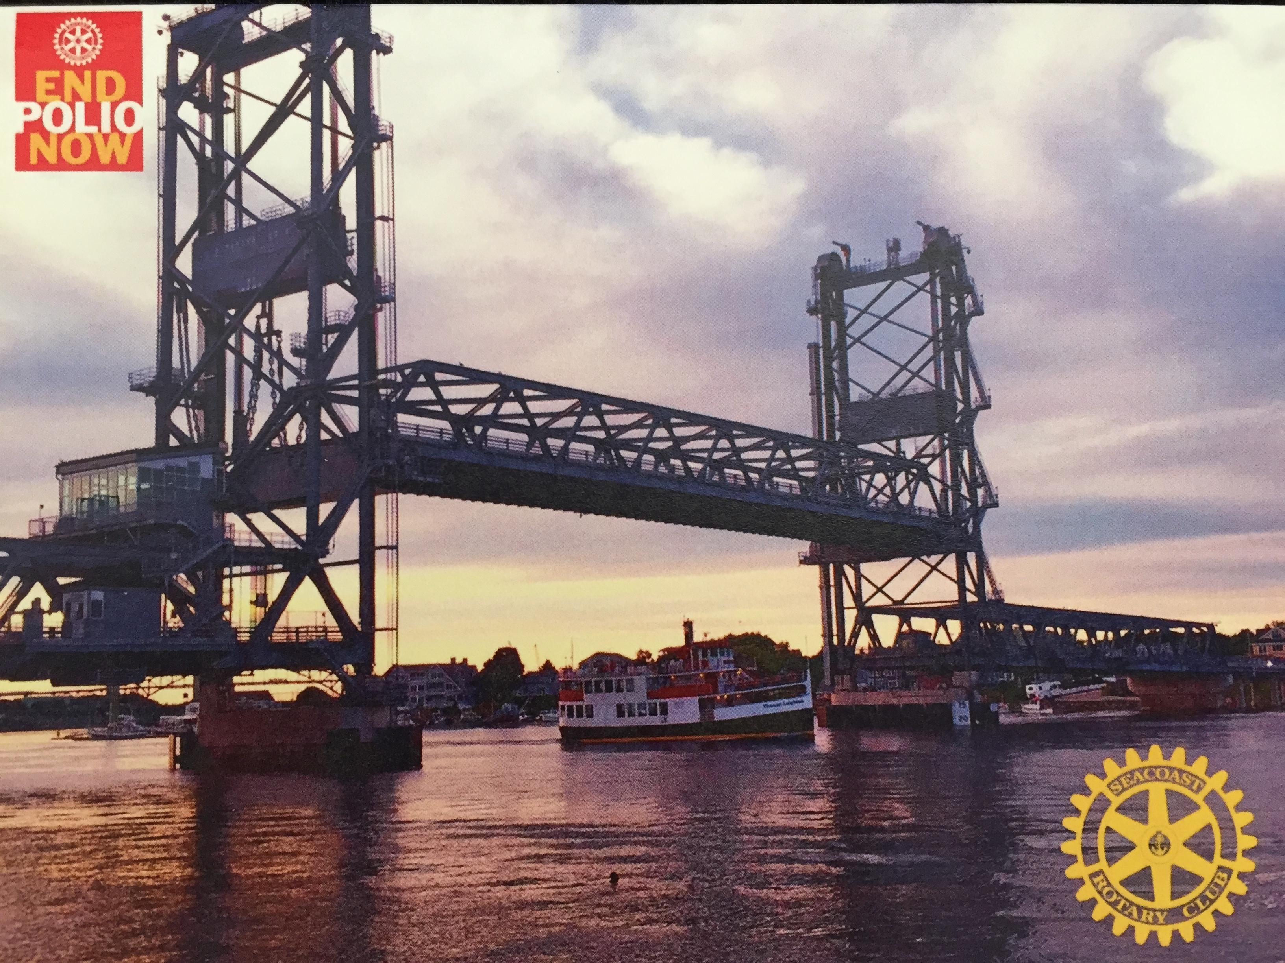
Send check payable, along with your return address, to Rotary International Polio Plus and mail to:
Seacoast Rotary
P.O. Box 6674
Portsmouth, NH 03801

NAME_______________________________________________________

ADDRESS_____________________________________________________

CITY_________________________________________________________

NUMBER OF CARDS REQUESTED___________NUMBER SENT___________

DONATION AMOUNT__________ROTARY CLUB______________________

DATE______________ORDER FILLED BY_____________________________

