ROTANEWS

DISTRICT 7030
CLUB#6798
Chartered March 07, 1962

R.I. OFFICERS

President

Francesco Arezzo

President Elect
TBA

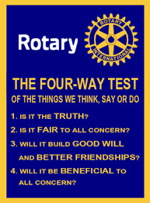

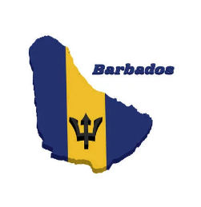

PATRON

HE The Most Honorable Dame

Sandra Mason, FB, GCMG, DA, SC.

President of Barbados

DISTRICT OFFICERS

District Governor
Soraya Warner-Gustave

District Governor Elect
Maurice Saad

District Governor Nominee

Steven Tjin A Djie

Assistant Governor
Paul Ashby

District Secretary
Leathon Khan

District Treasurer
Charlie Serieux

Council of Governors Chair
Debbie Roopchand

District Rotary Foundation Chair
PDG Waddy Sowma

District Disaster Relief Chair
PDG David Edwards

District TRF Fundraising Chair

Elwin Atmodimedjo

District Conference Chair

Konrad Wagner



August 14th, 2025

CLUB OFFICERS & DIRECTORS
Website: www.rotarybarbados.org
Email: rotarybarbados@gmail.com

President

Jeff Evelyn

President Elect

Jamella Forde

Vice President

Ron Davis

Secretary

Davina Layne

Treasurer

Meryl Stoute

Club Administration

Tamara Allman

Membership/Youth Service

Danielle Donowa-Spencer

Public Image

Dawn Greaves

Community Service

Katrina Alkins

International Service

David Antrobus

Immediate Past President

Arlene Ross

Sergeant–at–Arms

Peter Arender

***************************************

Club Weekly Meetings
Thursdays at 12.30 pm
Hilton Barbados
Needham’s Point, Aquatic Gap,
St. Michael

Mailing Address:
P.O. Box 148B, Brittons Hill,
St. Michael, Barbados
The Rotary Club of Barbados welcomes visiting Rotarians and Guests.


Our next meeting will be on August 21st, 2025, this will be a Fellowship Meeting, which will commence at 12:30pm at the Hilton hotel.

,
Meeting Details – August 7th, 2025

Guests
Andre Holder – PP Tracey Knight Lloyd
Kemar Saffrey -Rtn. Wayne Tasker
Jeffon Botters – Rtn. Diana Doughlin
Suzanne Davis – VP Ron Daavis

Rotarians, Rotaractors and Interactors
Rtn. Janelle Jordan – Satellite Club ‘Rise Up’

Honorary Rotarians
None
Fines: BBD 120.00
Raffle: BBD 156.50

Today August 14th, 2025, will be a Business Meeting, which commences at 12:30pm on the Zoom Platform.
Meeting ID: 890 9064 9358 Passcode: 673723

l



Summary Minutes of the RCOB Meeting Held on August 7th, 2025

President Jeff opened the 5th meeting of the Rotary year at 12:32pm.

The theme for the month of August is Membership and New Club Development.

SSA Peter welcomed all visiting guests.
Lunch was served.

President Jeff invited Assistant Gov Paul Ashby to present the Club Excellence award to IPP Arlene Ross.

A very interested afternoon unfolded, where Rotarians were invited to share why they joined Rotary. Director Tamara was the first Rotarian to share!
PP Fiona spoke about Rotary Ann’s from which was born what we currently know as 'Partner in Service'.
PDG David spoke about how he was asked to join Rotary and hasn’t stopped some 47 years later.
Pres Jeff expressed how moving it was to hear the heartwarming stories from other Rotarians.
This initiative was fantastic as Rotarians got to learn a bit more about each other.
The meeting was adjourned at 13:29pm

Sangkoo Yun resigns as 2026-2027 Rotary International President

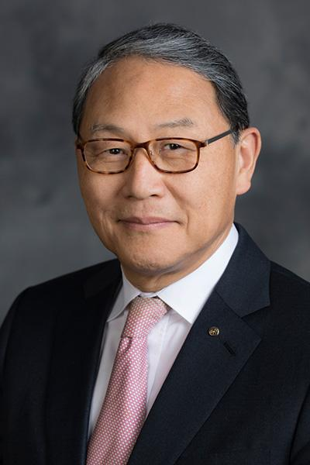

https://my.rotary.org/en/sangkoo-yun-resigns-as-2026-27-rotary-international-president?fbclid=IwQ0xDSwMHgv1leHRuA2FlbQIxMQABHgJHZ0m6IcbgHItpvO-rayD7KJwRzI5Czb51fXAay8xvv28lMyCAHiI0xlSr_aem_wMnA245Bh-2grtWsPweXzw&utm_campaign=PANTHEON_STRIPPED&utm_medium=PANTHEON_STRIPPED&utm_profile=PANTHEON_STRIPPED&utm_source=PANTHEON_STRIPPED
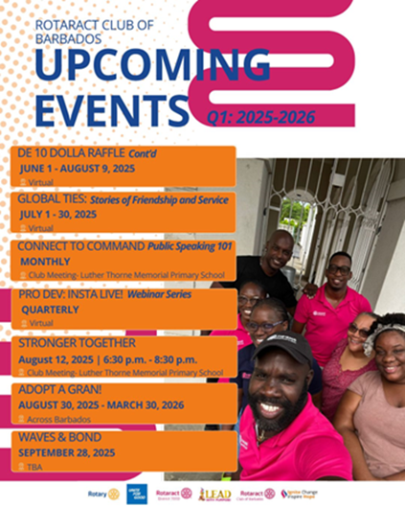

UPCOMING EVENTS
August 21st – Fellowship Meeting
August 28th Fellowship Meeting
September 13th – School Signs Painting
October 24th – World Polio Day
October 24th – Project Amai
December 2nd – Giving Tuesday
December 14th – Carols by Candlelight

RaCOB/Satellite Club/EarlyAct
August 30th – Adopt a Gran!
September 28th – Waves & Bonds

DISTRICT 7030 EVENTS
14th-16th November - RYLA
22nd - 25th April 2026 - District Conference
ANNOUNCEMENTS

Birthdays Rotarians
None

Birthdays – Partners-in-Service
Wanda – Rtn. Neal Griffith – August 17th

Wedding Anniversaries
None

Join Date Anniversary
None

