2018 – 19 Club Budget

Our 2018-19 budget is a multi-page document. Page one is displayed below as a sample.
If you would like to look at the entire document, please click on the below object to open the PDF view. Paper or electronic copies can be obtained from the treasurer.

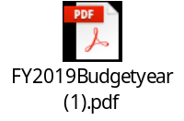

Budget Page One Sample:


