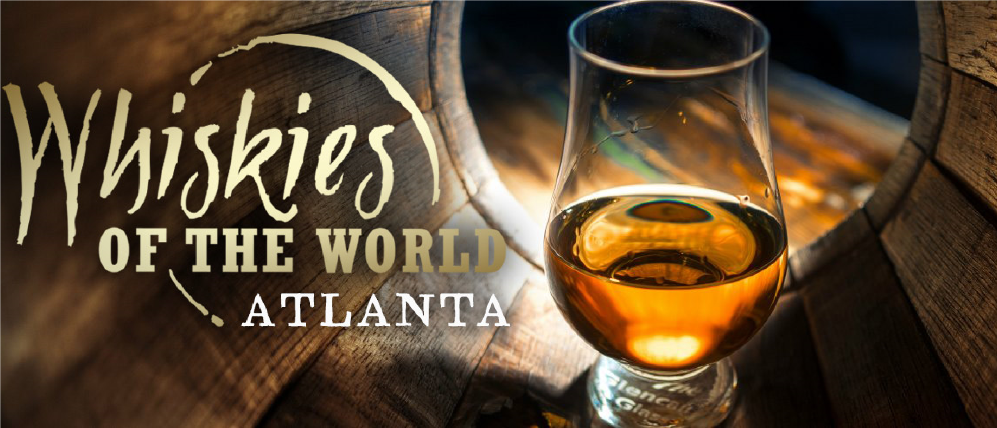

Whiskies of the World Atlanta

Saturday November 4, 2017
5:00 – 9:00 PM

Westin Buckhead
3391 Peachtree Road NE
Atlanta, GA 30326

For Tickets Go To:
www.northatlantarotary.org to get your link to the Family and Friends of Rotary Discount Code

Friends of Rotary Discount Code Link:
https://www.xorbia.com/e/whiskiesoftheworld/whiskies-of-the-world-atlanta/?promocode=ROTARYA

For More Info on the Event Go To:
http://whiskiesoftheworld.com/atlanta/

Discover the world of whisky like you’ve never seen it before. Over 200 of the most fascinating distilled spirits from around the globe, along with their makers and ambassadors, creating an unforgettable tasting experience.

