September 30, 2022
General Manager

Dear Community Supporter,

With the COVID-19 pandemic issues slowly (and thankfully) becoming a thing of the past, the Rotary Club of Healdsburg is excited to announce that the annual Crab Feast and Auction will be returning as an in-person event this year! We are looking forward to joining once again with our friends to celebrate our wonderful community and enjoy our favorite crustacean!

The Rotary Club of Healdsburg’s 43rd Annual Crab Feast and Auction will be held in its usual location, The Villa Chanticleer, on Saturday, December 10th. We hope that this event will continue to ensure our ability to serve those local organizations and individuals who need us most – sheltered seniors, deserving students, and families with food insecurities. We are celebrating 74 years of serving the Healdsburg and Geyserville area and traditionally, this festive occasion has been our largest fund-raising event. In addition to helping support programs like the Healdsburg Senior Center, Sonoma Family Meals, Corazon Healdsburg and Reach for Home, Rotary Club of Healdsburg provides over $60,000 annually in scholarship awards to Healdsburg and Geyserville High School graduates.

We realize that our local businesses are just beginning to recover from the last two challenging years and some of you may not be able to help us out with a silent auction donation. If, however, you would like to donate an item to help support our community, we would welcome your contribution. Please contact either Fred Roberts at fhrhealdsburg@gmail.com (707-494-2622) or Grady Wann at gradywann@comcast.net (707-975-5053), so we can answer any questions and/or arrange for someone to pick up your donation. Would you consider being a sponsor of the event or joining us at the Villa in December? More information can be found on our website below and a “Save the Date” mailing was mailed out recently.

Thank you for considering a donation to Rotary Club of Healdsburg and our incredible community! Please contact us now if you can help make our 43rd event the greatest ever!

Sincerely,
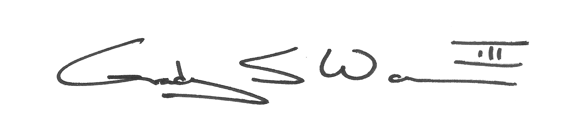
Fred Roberts (Silent Auction Co-Chair) Grady Wann (Silent Auction Co-Chair)

