Jarrell High School
Thursday, January 26, 2017
9:30AM – 10:30AM
Location TBD

"CAREER OPPORTUNITIES IN FBI - CYBERSECURITY"

Cyber attacks are all around us. The Russians allegedly hacking the DNC and making sensitive information available to Americans trying to influence the 2016 U.S. Presidential election. Yahoo for the second time had their member data hacked. This time taking a billion names with all of their personal information.
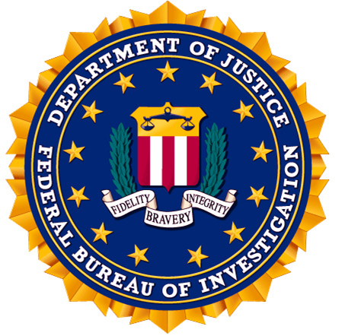

There is no better time to launch a career in cybersecurity. Cybersecurity specialists are some of the most highly sought after and in-demand professionals in today’s job market. These days, as more and more Government agencies, corporations, and even small businesses owners are turning to the Internet to conduct business, the need for cybersecurity professionals has also increased exponentially. According to the Ponemon Institute, the average cost of a cyber breach has reached highs of $3.8 million in 2015, which was a 23% increase from the last two years. With so much sensitive and personally identifiable information floating online, hackers are targeting online resources to exploit this private data. However, as hacking sophistication and innovation continues to grow, this can negatively affect many Government agencies and businesses monetarily. This is why the need for more competent and highly trained cyber professionals is the most sought after job and this does not seem to show any signs of slowing down anytime soon. At the end of 2015 there were 209,000 cybersecurity jobs left unfilled in the United States. The demand will continue to increase along with the salaries in this field.

No organization in the U.S. has been any busier and more involved in the increasing number of cyber attacks than the Federal Bureau of Investigation.

Our Distinguished Speaker for This Program:
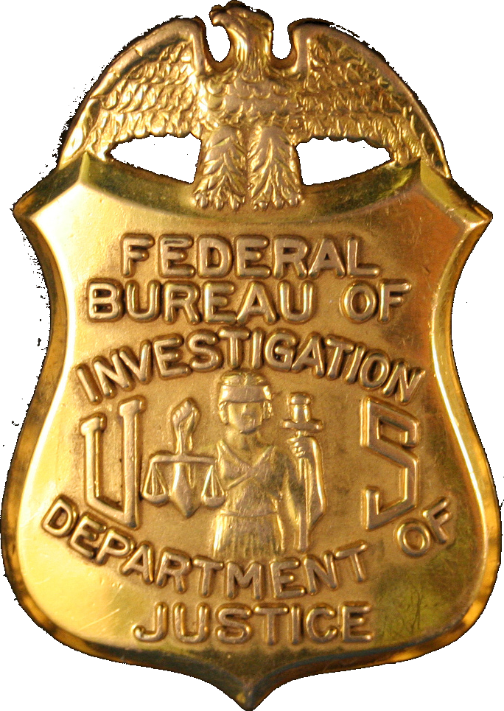

FBI Special Agent Scott is a cyber agent positioned on a counterintelligence squad in Austin, Texas. SA Scott works both criminal and national security computer intrusion matters. Prior to the FBI, Special Agent Scott worked for several U.S. universities in the areas of IT and data management.

Students interested in these fields should consider attending this presentation: IT, Technology, Electronics Engineering, Software Engineering, Business Admin, Computer Science, Cybersecurity, Criminal Justice and Law Enforcement.

DID YOU KNOW? The FBI normally requires a 4-year college degree plus some experience working in the outside world after college. An exception to this requirement is that the FBI will hire Cybersecurity Majors right out of college.

