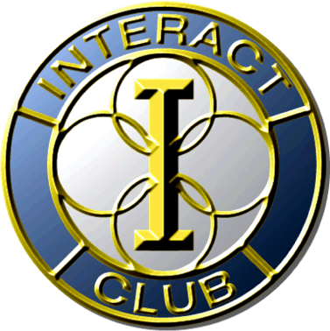

Jarrell High School
Wednesday, January 11, 2017
9:30AM to 10:30AM
Career Guidance Program – School Cafeteria

"CAREER OPPORTUNITIES IN VETERINARY MEDICINE"

Kristin Dodson, DVM, will talk about what it takes to become a Veterinarian and the different steps you will need to take to make this your profession. She will explain a “typical” day in the life of a Veterinarian and she will present several interesting cases to the students who attend.

Biography
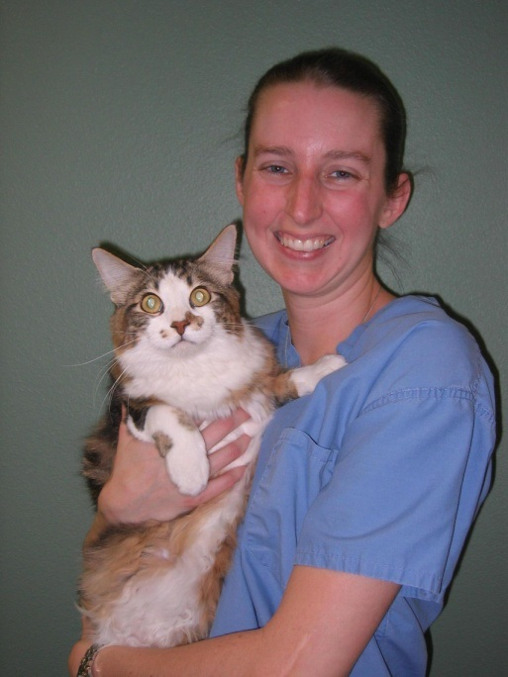
Kristin Dodson did her undergraduate work at Baylor University and attended Veterinary school at Texas A&M. After graduating, Dr. Dodson did her medical and surgical internship at two different hospitals in Chicago.

Kristin returned to Texas and worked at Hewitt Veterinary Hospital near Waco. Ms. Dodson liked the hospital so much that she recently purchased it! There are 21 employees at the hospital including doctors, technicians and administrative staff. The hospital was founded in 1983 to proudly serve the community with a vision to provide compassionate and high quality veterinary medical care and services for patients and their families.

Dr. Dodson practices small animal medicine primarily with dogs and cats. Services that Hewitt Veterinary Hospital offers includes routine elective surgery; soft tissue surgery; orthopedic surgery; dental therapy; pain management; prescriptive diet planning and much more.
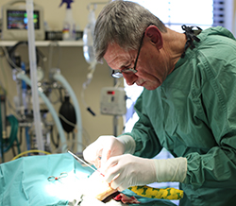

There is some really good information on the Hewitt Veterinary Hospital website if you’d like to review before Kristin Dodson visits Jarrell High School. It may trigger some questions you might want to have answered on January 11th about this profession. Their website is http://hewittveterinary.com.

This will be a worthwhile and informative presentation for any students seeking a career in the Veterinary field.

