We had hoped that everyone would be eating pancakes and sausage and getting their picture taken with Santa this year on Saturday, December 11. However, we have decided to continue exercising caution in 2021 for the BREAKFAST component of “Breakfast with Santa.” A free, physically distanced (no hot meal and no direct Santa contact or Santa photos) drive-by event in San Gabriel Park will be conducted again this year to handout “goodie bags” to all the children (very similar to what we safely did in 2020).

What remains unchanged this year is the primary objective of our annual “Breakfast with Santa” project which is helping kids and families in our community and area during the Christmas-season. For twenty years, local business sponsorships, contributions from individual Rotarians, friends, families, and neighbors have funded the distribution of gifts and food to help make Christmas a lot brighter for those in need. “Breakfast with Santa” has also provided financial support to the Jarrell UMC’s annual “Out-Reach Project” and purchased clothing, restaurant and entertainment gift cards for GISD teenagers served by The Georgetown Project’s “NEST” (a day shelter providing supportive services for “homeless” teenagers).

This year’s goal is to focus again on providing food-related assistance for as many kids and families as possible rather than shopping for “gifts,” as in previous years, as well as continuing support for Jarrell UMC and the “NEST.” All (100%) of the sponsorships and donations from the business community and other individual donors go directly to helping kids and families. “Breakfast with Santa” administrative expenses are covered by contributions from members of our Club. The enclosed “Breakfast with Santa” Sponsor Instruction Sheet has additional details about the project and information for donating. A copy of last year’s “Thank You” ad published in the ‘Williamson County Sun’ is also enclosed and explains how “Breakfast with Santa” is much, much more than just a breakfast. We will cautiously conduct activities that can be done safely in 2021, but look forward to resuming to a more “normal” BWS in 2022!
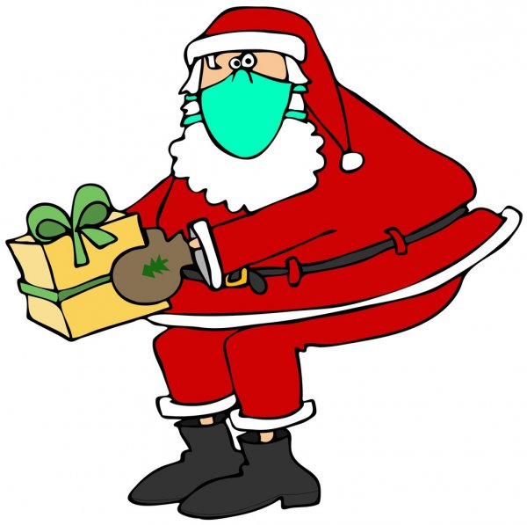
Thank you in advance for supporting our communities.

Sincerely,

• Sun City Rotary Club

• Georgetown Fire Department

• Georgetown Independent
School District
BWS Partners

2021 “Breakfast with Santa”
Rotary Club of Georgetown – Sun City
For more information: info@sctrotary.com

