
Rich-Mar Rotary Membership Information

Your Pathway to Membership
Thank you for your interest in Rotary membership. Here is some Frequently Asked Questions (FAQs) about the global organization and about our local club.

What is Rotary?
Rotary is an organization of business and professional leaders united worldwide who provide humanitarian service, encourage high ethical standards in all vocations, and help build goodwill and peace in the world.

In more than 190 countries worldwide, approximately 1.25 million Rotarians belong to more than 31,500 Rotary clubs. Rotary club membership represents a cross-section of the community's business and professional men and women. The world's Rotary clubs meet weekly and are nonpolitical, nonreligious, and open to all cultures, races, and creeds.

More information is available at the Rotary International web site rotary.org
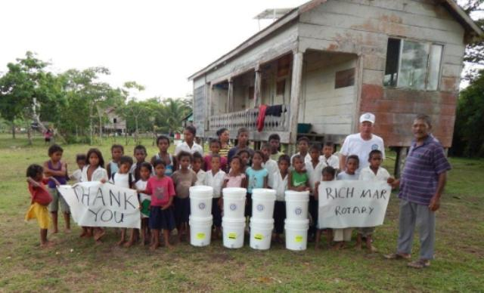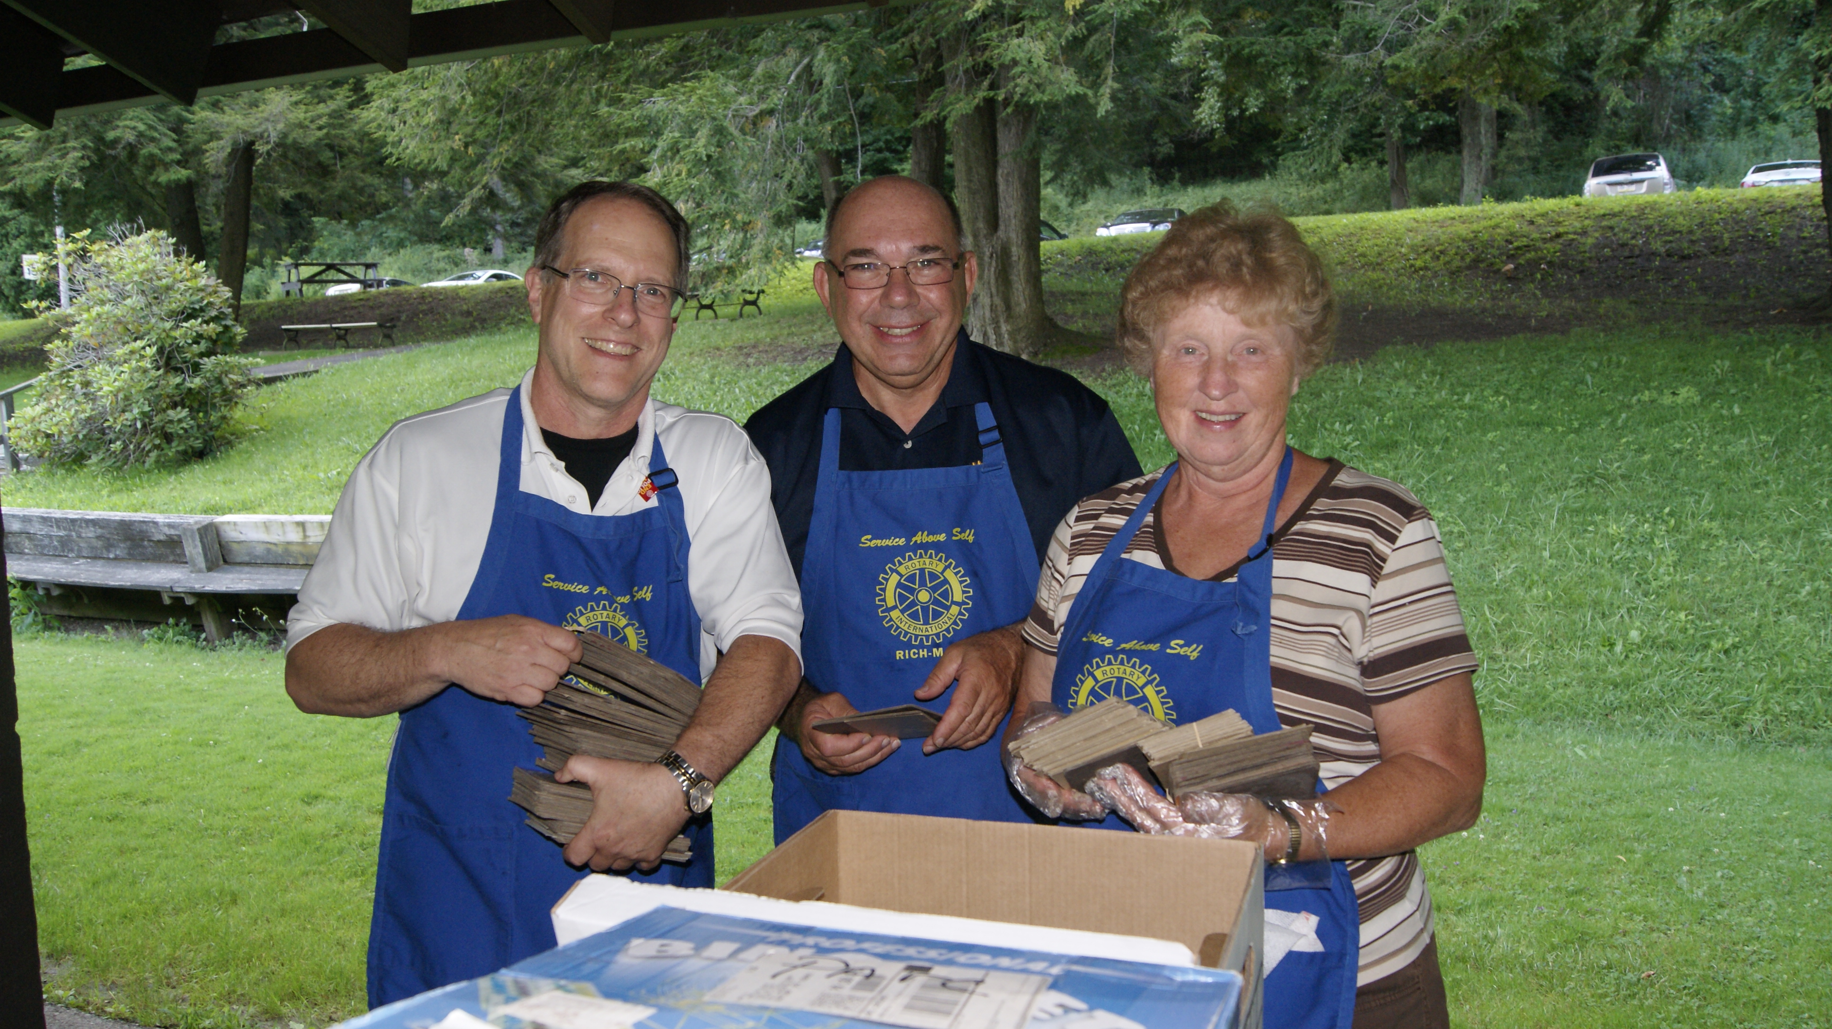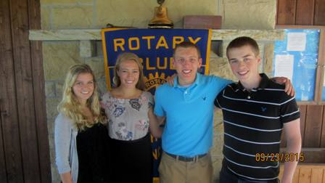
Who is the Rich-Mar Rotary Club?
Members of Rich-Mar Rotary are proud to share a long history of supporting your local community and the world through service. Raising funds and awareness throughout the year, members commit to be active participants in several events, including:
- Annual Charity Golf Tournament- held at Treesdale Golf and Country Club, raising funds for community projects, open to all
- PARC Picnic- held annually for the mentally challenged in Butler County and their families and caregivers
- TRY Picnic- also held for the mentally challenged and families from Northern Allegheny county
- Mars Applefest- a fun community event each first Saturday in October in Downtown Mars
- Dictionary Program - free dictionaries are distributed to elementary students in the Mars and Pine-Richland school districts
- Community Projects - helping fund projects like the barn in Richland park and a pavilion in Adams park and many others
- Rich-Mar Rotary’s Annual All-You-Can-Eat Pancake Breakfast raising funds to support community service projects
- Student-of-the-Month and scholarship recognition
- Roadside Clean-up projects

What are the benefits of membership?

- Develop new friendships through weekly meetings, committee participation and avenues of service. Rich Mar Rotary membership allows for the development of relationships and partnership which maximizes the club’s ability for greater impact.
- To support and participate in fundraising and community-raising events and projects. We are able to reach many because of the hands-on commitment of our members. This can include participation with planning and the day of event.
- Worldwide membership- through membership with the Rich-Mar Rotary Club, you will automatically be a member of Rotary International. This allows all members to visit and be welcomed to any Rotary organization and meeting world-wide.
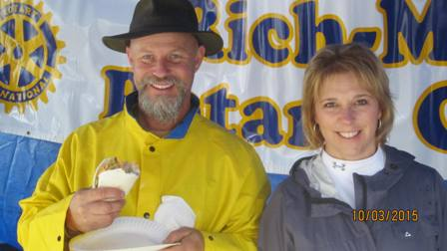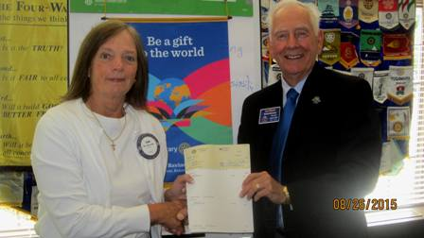

What are the Financial Commitments as a member of Rich-Mar Rotary?
Dues
Through semi-annual billing, The Rich-Mar Rotary strives to make the payment of your membership dues as easy and convenient as possible. We urge you to speak with one of our Rich-Mar Rotary officers for more information regarding the commitment and many benefits of Rotary Membership.
A. Dues Option 1- Members can opt to be billed semi-annually $70.00 for Rotary International/District dues and the cost of 26 lunches, which is $13.00* per week for 6 months. * Lunch cost is $15 but for prepaid dues members will receive a discount of $2.00 per lunch.
Or
B. Dues Option 2- Members can opt to be billed $70.00 semi-annually for Rotary International/District dues. Additionally, members will pay $15 + $1.00 surcharge for lunch at the door only when attending a meeting.
Rotary Foundation- We ask that each Rotarian support the Rotary Foundation with a monetary gift of $10 -$100 at minimum, each year. This keeps the club in good standing and will be directed to support critical projects locally and internationally.
Fundraisers- The Rich Mar Rotary encourages members to engage in fundraising activity by soliciting sponsorship for the Annual Charity Golf Outing and selling tickets to the Annual Pancake Breakfast. On occasion additional fundraising opportunities will be offered.

Can I attend a meeting if I am not a member?
We encourage and welcome those who want to know more about Rich-Mar Rotary, to visit! Your first lunch meeting is complimentary. No obligation to join. This is a great way to learn more about Rotary and how you can impact the world while developing meaningful and lifelong friendships.

If you would like to talk with someone from the club before your visit, simply complete the contact information below and a current member of the Rich-Mar Rotary Club will be in contact to answer your questions and provide meeting information. This person can also visit with you prior to the meeting and introduce you to fellow Rich-Mar Rotary Club members.

Who is the “Typical” Rich-Mar Rotary Member?
Rich-Mar Rotary Members are diverse. We welcome, men and women from all sectors of our community who are focused on service to others. Click links to see just a few profiles of current members.

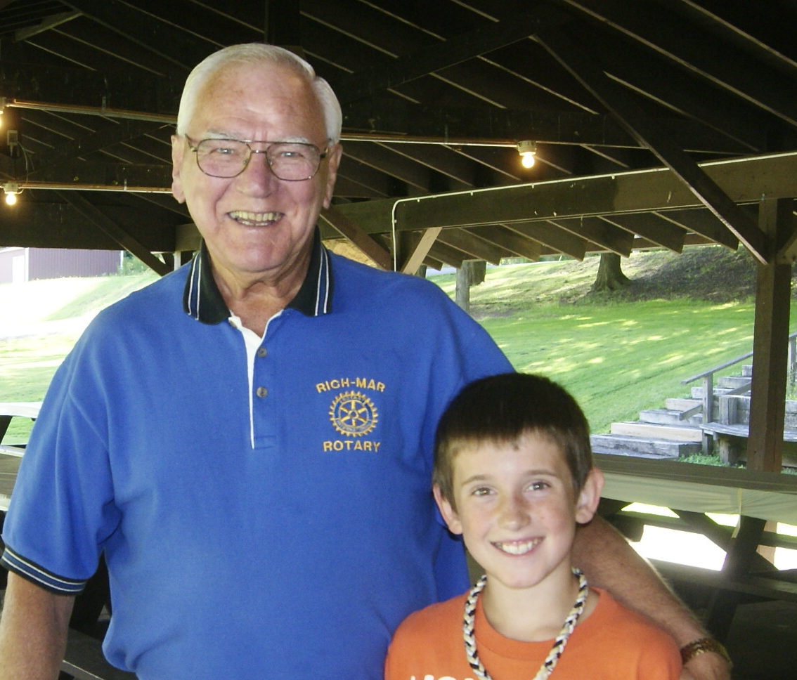
Meet Raymond “Ray” Johnson. Ray is a retired Metallurgical Engineer and Quality Assurance. Ray was introduced to Rotary through a friend and has been a Rotarian for 44 years. He has been a Rich-Mar Rotary Club member since 1972.

Rarely missing a meeting, Ray is committed to serving his community through Rotary.

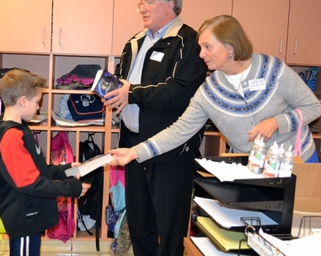
Meet Reverend Jean Smith, current Rich-Mar Rotary President. Jean found Rotary through a member of her church who invited her to attend a meeting. Jean recognized that this would be a great way to impact her community.

Jean has been a Rotarian since 2007 and her favorite Rotary activity is the Mars Applefest, a Rich-Mar Rotary sponsored event. Jean adds “I consider the members of Rich-Mar Rotary my friends. They are a wonderful group of people”.

Okay, I am ready. What is the next step?
Sponsor- All applicants will be assigned a current member to be a guide to Rich-Mar Rotary and path to membership. They will be available to answer any questions you might have and also introduce you to the Rich-Mar Rotary Club members.

Once you are prepared to apply for membership, your sponsor will work with you to complete the short membership application and present to the Rich-Mar Rotary Board for approval. Your sponsor will also serve as a guide throughout your first year of membership.

Once a membership decision has been made, you will be contacted by your sponsor or someone from the Membership Committee.

Additional Rotary Information
For more information about Rich-Mar Rotary please go to www.rich-mar.org
For more information about our District, please www.rotarydistrict7280.org
For more information about Rotary International, please go to www.Rotary.org

Getting Started
Please send your contact information below and a Rich-Mar Rotarian will be in touch soon to answer your questions and begin your path to membership!

Name

Address

City, State, Zip

Email

Home Phone

Work Phone

Mobile Phone

Organization/Company

Work Address

Work City, State, Zip

Profession, position or occupation

Referred by

How did you hear about the Rich-Mar Rotary Club?

As a member, can I attend a Rotary Meeting in another City? In another state? In another country?

Yes. With thousands of Rotary Clubs all over the world, Rotarians are encouraged to attend a meeting while traveling for work and pleasure or if you simply cannot attend a regularly scheduled Rich-Mar meeting. Below is a listing of meetings and locations in our local area.

Beaver Falls  Mondays at 12:00 PM  Z Pub  2580 Constitution Blvd  Beaver Falls | Butler  Meets Monday 5:45 PM  at YWCA at 120 W Cunningham Street, Butler | Butler AM  Meets Tuesday 7:00 AM  at Butler YMCA - 339 North Washington Street Butler PA
Cranberry Township  Meets Tuesday 12:00 PM  at Rose E. Schneider Family YMCA | Moon Township  Tuesdays at 12:00 PM  Sheraton Hotel  1160 Thorn Run Road  Moon Twp, PA 15108 | McCandless  Tuesdays at 12:00 PM  Diamond Run Golf Club  132 Laurel Oak Drive  Sewickley, PA 15143
Oakmont-Verona  Tuesdays at 12:00 PM  Longwood at Oakmont  500 Rt 909  Oakmont, PA 15139 | Evans City  Meets Tuesday 6:15 PM  at Evans City Library | Fox Chapel Area  Wednesdays at 11:45 AM  Pittsburgh Field Club  121 Field Club Road  Pittsburgh, PA 15238
New Kensington  Wednesdays at 12:00 PM  Hill Crest Country Club  3411 Leechburg Rd  Lower Burrell, PA 15068 | Pittsburgh  Wednesdays at 12:00 PM  Omni William Penn Hotel  555 Grant St. Check Marquee for Room #  Pittsburgh, PA 15219 | Beaver Rotary Club  Wednesdays at 12:15 PM  Wooden Angel Restaurant  308 Leopard Lane  Beaver, PA 15009
Hampton  Thursdays at 12:00 PM  Wildwood Golf Club  2195 Sample Road  Allison Park, PA 15101 | Sharpsburg-Aspinwall  Thursdays at 12:00 PM  Walnut Grove  911 Freeport Road | Oakland  Thursdays at 12:15 PM  Pittsburgh Athletic Assoc(PAA)  4215 Fifth Avenue  Oakland, PA 15213
North Boroughs  Thursdays at 6:00 PM  Shannopin Country Club  1 Windmere Road  Ben Avon Heights, PA 15202 | New Brighton  Thursdays at 6:15 PM  Grand Valley Inn  452 Constitution Blvd  Fallston, PA 15066 | Quaker Valley  Thursdays at 6:15 PM  Sewickley Speakeasy  17 Ohio River Boulevard  Haysville, PA 15143
Zelienople  Meets Friday 7:00 AM  at Spring Street Cafe at 101 Spring Street | Cranberry Twp. Sunrise  Meets Friday 7:30 AM  at Marriott Hotel-Cranberry Twp.

