Rotary International  RI President:  Jennifer Jones | The Club Bulletin: 5th July 2022  Volume 84 No 01  Email : rotarybm@acenet.com.au  www.bowralmittagongrotary.com |  | Board of Directors  President:  Leigh Robinson  Directors:  Secretary - Trevor Fair  Treasurer - Jo Chalmers  Carolina Torregrosa  Ian Law  Will Eddowes

Club Meetings:
We meet weekly on Tuesdays, 6.00pm for 7.00pm at various Southern Highland venues. (See below)

Meeting Apologies to be submitted by Sunday for the following Tuesday.
Please TXT Secretary Trevor.

Next 4  Weeks | Meeting Dates and Venues | Speakers/Topic | Invocation | Journalist
12 Jul | Kookabar Social Meeting |  | Rod Aistrope | David McCosh
19 Jul | Bowral Bowling Club | Lucy Earl/  Uniting Church Kitchen | Robbie Allen | Will Eddowes
26 Jul | The Hermitage | Nathaniel Smith MP/ Politics | Tim Bowland | Tim Rowland
2 Aug | Bowral Bowling Club | **Club Assembly** | Pamela Brown | Ian Langford

Journalist: Trevor Fair

Welcome:

“Sergeant Rosemary” welcomed everyone including President Leigh. Also welcome to Pamela Brown, Stephanie Robinson & Therese Leotta.

President Leigh announced the apologies.

Invocation: Given by Rod Aistrope

International Toast: Will Eddowes

Toast to the President and Members of the Rotary Club of Mindelo
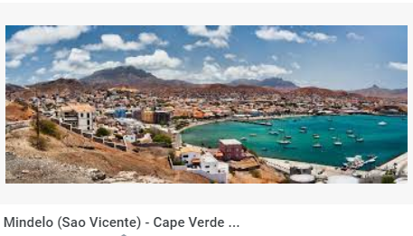

The Republic of Cabo Verde, previously known as the Cape Verde Islands consists of an archipelago of 10 fairly barren islands in the Atlantic about 600 km west of the Green Cape (Cabo Verde in Portuguese) in Senegal, the western most point of Africa.
The islands were uninhabited when settled by the Portuguese in 1793 and became a useful stop over for shipping especially for the slave trade. From 1838 the islands became a coal bunker for the British East India Company to refuel their stream ships on the long trip around Africa.
In 1884 Cabo Verde was an important point on the submarine cable from Europe through Africa to North America and a successful commercial and shipping centre. With the growth of air- travel it became an essential stop for South African Airways flights which were unable to
cross Africa on their way to Europe and the Americas.

Please welcome to our newest member!

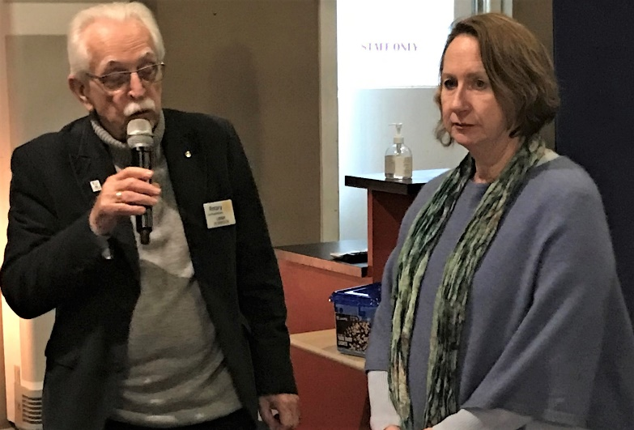
Pamela Brown is inducted into the Club.
She has lived on and off in the Highlands for last 30 years. Works part time at WSC at the Resource Recovery Centre and lives in Moss Vale

When Portugal withdrew from its empire in 1975 it left all of its colonies to their own devices unprepared for self-government however Cabo Verde is one of the few which made a peaceful transition to multi-party democracy.
The 485 000 Cabo Verdeans are celebrating their Independence Day today.

The second largest city with 70 000 people is Mindelo on the island of Sao Vincente.

The Rotary Club of Mindelo was Chartered in 1997 in District 9101 which covers 98 Clubs in West Africa.
President Maria Vieira leads 22 dedicated Members whose active fund raising is used in support of poor families in their communities.
In recognition of the Independence Day of Cabo Verde would you please stand and make our International Toast to the President and Members of the Rotary Club of Mindelo.

Announcements
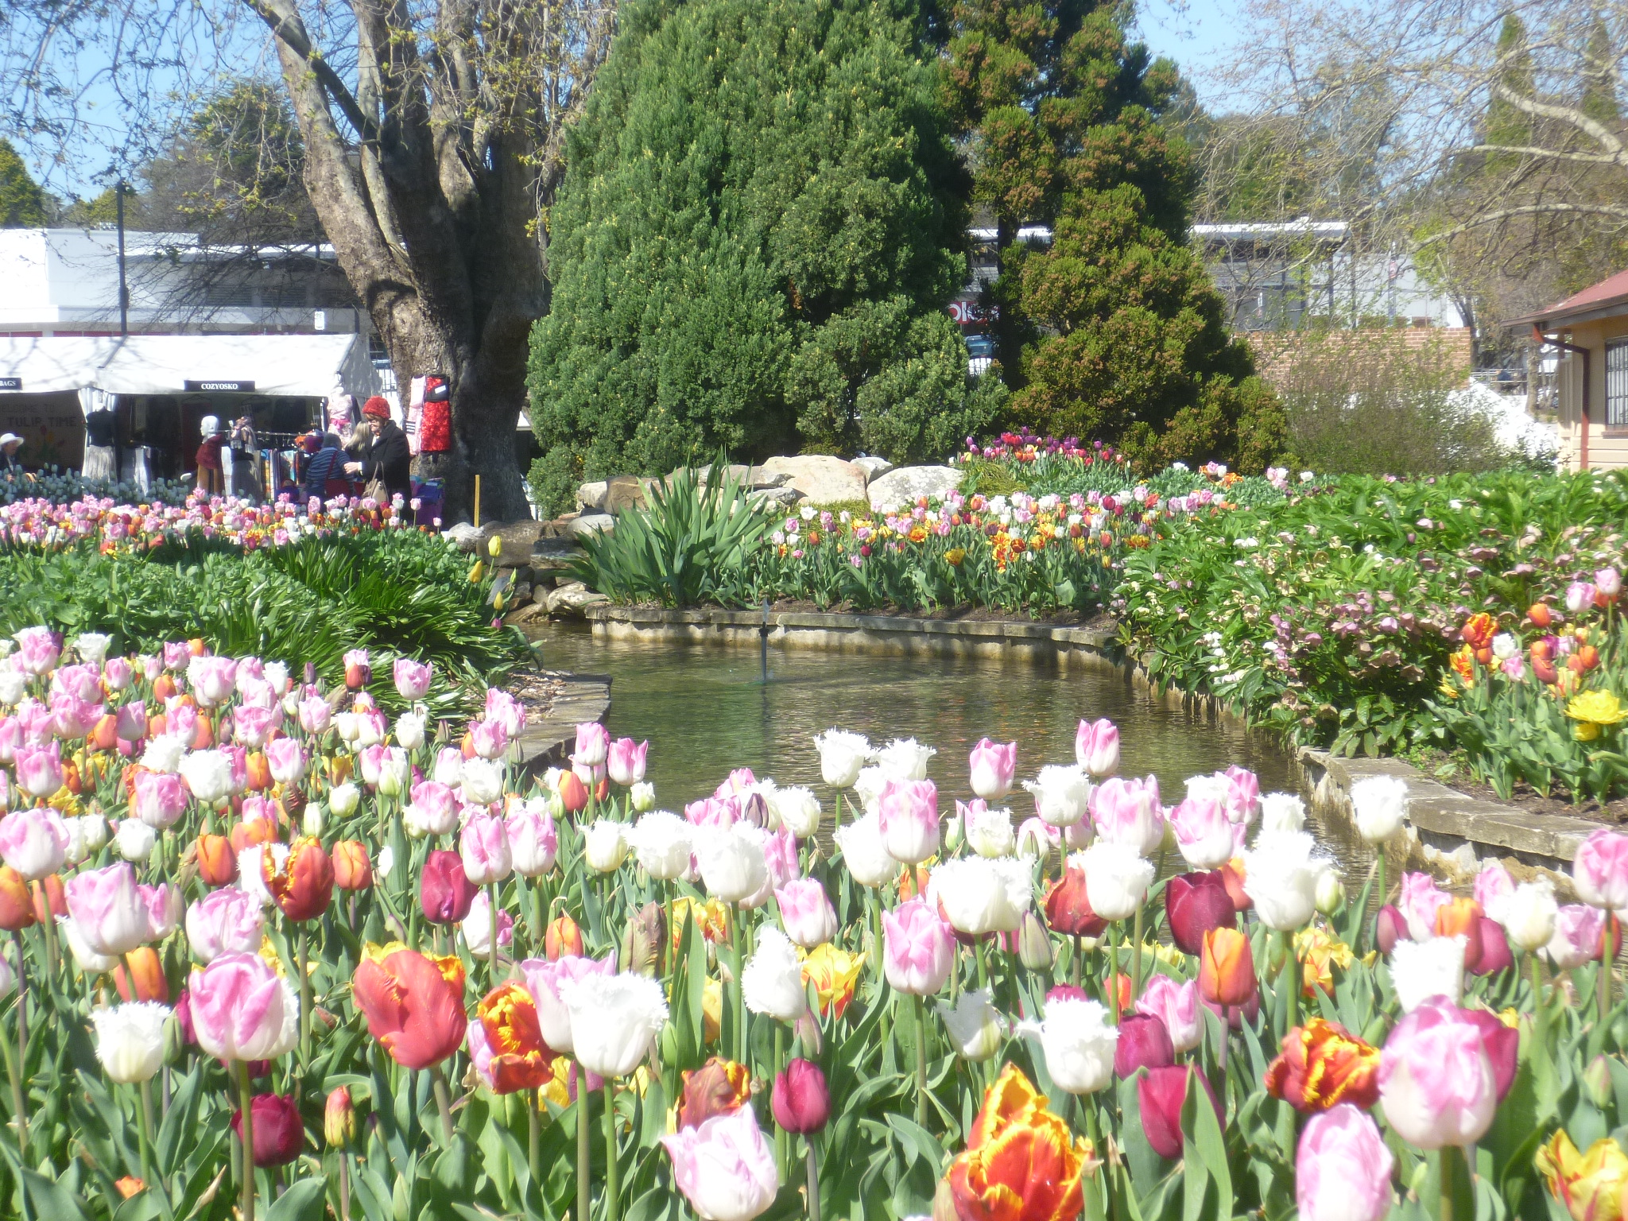
Yes,
It is Tulip Time again, - the Club’s major fundraiser and we need all members to give it their best effort!!

Quick Facts :-
Festival Dates : 16 Sept – 3 Oct
Festival Duration: 18 days
Shifts: 192 total
No payment processing

Ian Langford delivered a preliminary overview of the new festival arrangements. The Club has been invited to manage the entrance/exit gates. 2 sessions each day. No cash as all prepaid tickets. Task will involve scanning.

Buses will drop off in Merrigang St. Exit in Wingecarribee St. Each shift will include 2 entrance, 2 Merrigang and 1 exit. Also, there will be additional shifts on Friday and Saturday nights.

The blank Roster was circulated with the 192 slots. Please nominate early before the roster is circulated to external entities.

Please see Ian’s 6 July email sent to all members with further detail.

Seeking additional Meeting Journalists…...
A message from this bulletin’s editor …..

At every meeting one of our members documents the proceedings, types, and self-edits it before emailing it on to the editor for inclusion in this bulletin. That is all there is to it!!
The more members who take their turn, the less arduous it is for the others.
At tonight’s meeting new members Pamela Brown and Tim Rowland volunteered as did Ian Langford, Trevor Fair, and Will Eddowes.
The editor is seeking additional journalists to share the load. Please consider.

Invocation – President Leigh announced that every member will be asked to take his or her turn in giving the Invocation at the start of the meeting. The roster will be in alphabetical order and a reminder placed in this bulletin.

Club Assembly - The next Assembly is scheduled for the 2^{nd of} August. If any member has any items for discussion, please submit them to Secretary.

Board meetings - are to be held on the 2nd Monday of the Month. If a member has a project, idea etc that they would like the Board to consider, please submit to the Secretary by the first Thursday of the month.

Sergeant Session. Rosemary did a great job raising funds.

Raffle: Trevor
Will Eddowes – Fund raising

Sunday 17th July another attempt will be made at Marulan. Numbers will be closely monitored this time around after a disappointing previous event. A roster was circulated at the meeting.

Will Eddowes - Community Service

First Responders at Penrose. There will be another Catering event on 5th -7th August.

* * * * * * *

Speaker: President Leigh Robinson

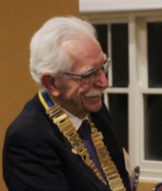

By way of introduction to Club members, Leigh gave us a summary of his life this far….

One of 5 kids. No 4 born at Royal Womens Hospital. Grew up in Carrs Park within walking distance of the Rockpool. Blakehurst PS and Blakehurst HS. Suffered with Rheumatic Fever as a child. Was a lazy student.

Finished 5th year in the mid 1960’s. Was offered 9 cadet ships and finally took a position with Unilever as a fitter and turner, while studying at NSW Uni at night. The lazy attitude to study did not work at Uni. Dropped out of studies and decided to seek a trainee management position in hotels.

Engaged by Millers Hotels, from storeman, waiter, cellarman, barman assistant manager etc. Due to an accident became manager, during the Vietnam War. Learnt a lot about life during these times.

Denise Coad – Meeting venues

As the Hermitage is fully booked until the year end we will attempt to make the Bowling Club our home venue for this duration.

Rod Aistrope - Science & Engineering Challenge

Southern Tablelands event at Goulburn. If you can assist, please see Rod.

* * * * * * *

Switched to selling real estate, which continued for 10 years. Then began working at a stainless-steel manufacturing company, initially as factory manager, then as salesman. Goal was to sell urinals.

Worked at AWA selling boom gates.

Selling backloads from Perth to East Coast was a tough gig. Installed Luxaflex blinds etc with his brother for a few years before going back to AWA where he assisted introducing e-tags into Australia. Trialled them in race cars at Bathurst one year.

Enjoyed Project Management systems. Went out on his own selling boom gates, and numerous technical items for caravan parks. Led to installing runway lights at airports, and then docking systems.

On retirement worked with the prison system and became trained as a mentor. One of his charity activities led him to work with Rotary, where he became a Rotarian. Has served as President three times at Wollongong and as AG.

Is learning about the new district and is looking to know more about our members and their activities.

Raised 5 daughters and a foster son. 16 grandchildren.

Next week is a social night at Kookabar.

