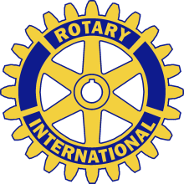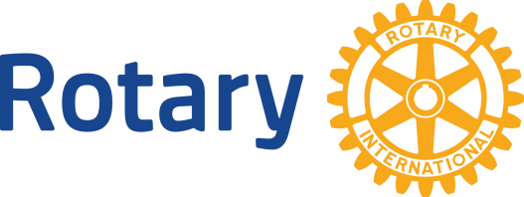
ROTARY CLUB OF RENO
NUMBER 567
RENO, NEVADA
ADDRESS ALL COMMUNICATIONS TO
P.O. BOX 1750
RENO, NEVADA 89505
E-Mail: info@renorotaryclub.org
For Immediate Release

Rotary Club of Reno Celebrates A Century of Service

(Reno, NV) July 5, 2016
The Rotary Club of Reno (Downtown) celebrates its 100th birthday Monday August 1 with a special dinner event at the Atlantis Casino & Resort. Rotary International President John Germ will be the special guest speaker for the event which is open to the public.
Chartered August 1, 1916, the Rotary Club of Reno held its first meeting August 9, 1916 with Judge Willis Brown as the first president. The club is the oldest Rotary Club in Nevada and the largest in northern Nevada. The club has nearly 200 members made up of business and civic leaders who share a common commitment to service locally and around the world.
“This is real milestone for our club and for the Reno community, “said club president Craig Wesner. “Having the opportunity to celebrate with International President John Germ is a real credit to our club.”
The dinner will begin with a reception at 5:45 pm with dinner following at 6:45 pm. The evening will include a gourmet meal, a celebration of the club’s history, entertainment and a keynote address by Rotary International President Germ. Reservations are available through the club’s website at www.renorotary.org.
More information is available at info@renorotary.org.

#####
The Rotary Club of Reno was the first Rotary Club established in Nevada. Founded in 1916 the club has nearly 200 members and is the largest Rotary Club in northern Nevada. Members of the club enjoy participating in various community events, as well as, the opportunity to network on a weekly basis. Rotary Club members come from all vocations and engage in projects that improve the community and promote world understanding and peace. PolioPlus has been Rotary’s flagship program to eradicate polio worldwide.

