Rotary Club Of Reno  Community and Global Impact 2014-2015  Service Above Self | 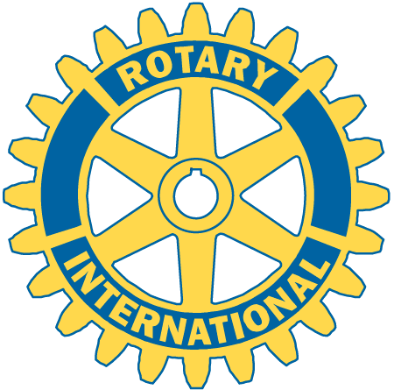
Donated $136,510 during July 2014 through June 2015 in the following areas:

Community Service – Donated $37,500

- Major Project- WCSD Lemelson STEM Academy (Science, Technology, Engineering and Math)
- Food Bank volunteers
- Salvation Army Bell ringing
- Career Coaching at Vaughn Middle School
- Rotarians at Work Day
- Nevada Science Fair
- Pant Donations to Homeless Shelter
- Role Model Summit
- Challenger Space Program
- Blood Drive at Harrah’s
- UNR Freshman Orientation Program
- Support for KNBP
International Service – Donated $53,360
- Donated to the Bodhi Tree Foundation /cow farm project in Nepal
- Children’s Peace Initiative in Kenya; the
- Children’s Cancer Center of Lebanon
- “Free The Girls” program supporting human trafficking victims.
- Panama Project grant for orphanage,
- Paul Harris donations,
- Polio Plus donations

Vocational Service – Donated $16,300
- Master Teacher Award, Law Enforcement and Teacher of the Quarter Awards
- Rotary Means Business network events
- TMCC Scholarships for unemployed adults.
- Vocational Scholarships at TMCC
- District Scholarship Match

Youth Service - Donated $29,350

- Funded and co-sponsored an expanded Most Improved Student Program
- Sponsored & funded 25 Students to the Rotary Eight Grade Leadership Program
- Sponsored & funded 12 students to the Rotary Youth Leadership Program and funded.
- Participated in the District Music and Speech Contests
- Sponsored & funded two in-bound and two out-bound Rotary Youth Exchange students
Membership: Over two hundred (200+) men and women who are community leaders
For more information: www.renorotary.com

