PRESS RELEASE

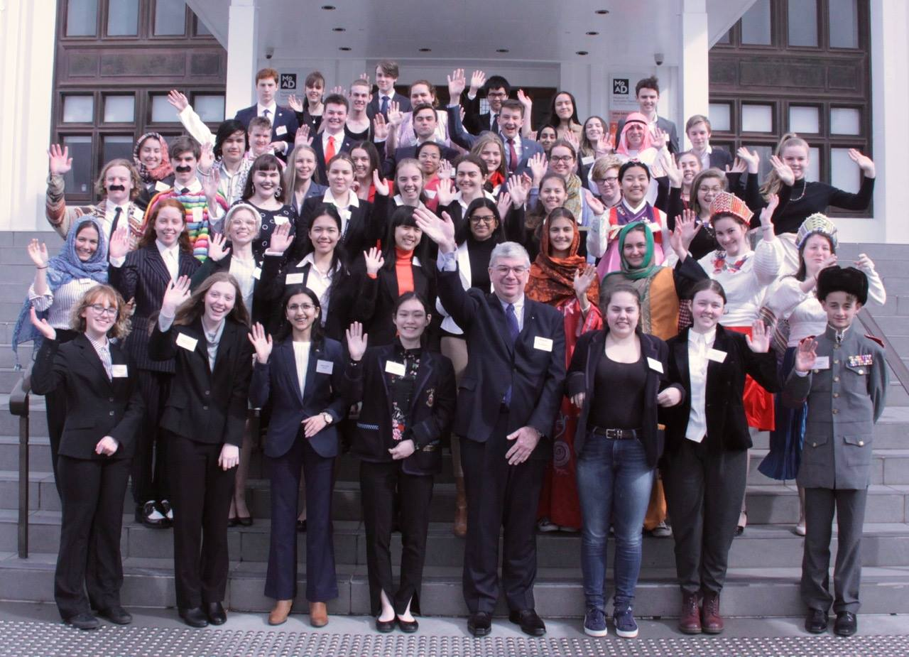

ROTARY AND ANU BRING THE UNITED NATIONS TO CANBERRA

The Rotary national Model United Nations Assembly (MUNA) was conducted in the historic House of Representatives Chamber of the Old Parliament House, home to the Museum of Australian Democracy from 17-19 August. This was the 22nd consecutive MUNA event that the Rotary Club of Canberra Sunrise has run on behalf of Rotary District 9710, with the aim of increasing international understanding and goodwill. Club President, Simon Cullen hailed the event a great success, noting the high quality of debate throughout, great enthusiasm from the participants and involvement of a number of embassies and high commissions in supporting the students.
Fifty-four Year 10 to 12 students from schools in Queensland, NSW, ACT, Victoria and Tasmania participated in the event. Teams of two or three students made up 20 teams, each representing a country to debate six real-world United Nations resolutions over the weekend. The topics, all of which were well researched by students and debated with passion were:
- Measures to prevent the proliferation of nuclear weapons in the Korean peninsula;
- Regulating international migration;
- The situation in the South China Sea;
- Protection of the global climate;
- The situation in the Syrian Arab Republic; and
- Permanent sovereignty of the Palestinian people.
We truly believe that all participants in MUNA are winners, coming away with a greater awareness of world issues and the way that the UN operates to bring about change. Testimonies from some of those that have attended past events show that MUNA can be a life changing experience. Our adjudicators had a difficult task identifying winning teams for the debate because the standard was high across the board. The results this year were:
- 1st: United Kingdom - St Philip's Christian College - Newcastle; sponsored by Rotary District D9670.
- 2nd: Israel - Hurlstone Agricultural High School; sponsored by Rotary Club of Lower Blue Mountains.
- 3rd: Jordan - Box Hill High School; sponsored by Rotary District D9810 (Victoria).
- Highly Commended Russia - Oxley College, sponsored by the Rotary Club of Bowral-Mittagong.
- Totenhoefer Peace prize: South Korea - Berwick Grammar and St Margaret's School; sponsored by Rotary District D9820, with special mention to Mexico - St Columba Anglican School and Bishop Druitt College; sponsored by Rotary District D9650.
The MUNA dinner was also a highlight with guest speaker, Catherine Stubberfield, External Relations Officer at UNHCR. Catherine spoke about not only the problems, but also the value and rewards of working for refugees around the world and shared her experiences in building a career in the UN system.
Another highlight of MUNA was the involvement and support from a number of Embassies and High Commissions for the event. Several teams were hosted by their supporting Embassy for a visit and provided information on the country’s position in relation to the debate topics. A number of diplomatic representatives joined the participants at the MUNA dinner, and one also came along for part of the debate. This opportunity to meet diplomats and to understand some of the factors influencing a country’s position on world issues was grasped by many participants.
Once again, the Australian National University sponsored the event. The Museum of Australian Democracy also provide great support for the event, and this year showcased their new Daring Dames tour for the students.
MUNA 2018 was a fantastic event and showcased Rotary, contributing clubs, districts, schools and, of course, the participants themselves in a most positive light.
Much of the debate was captured on video and in photos that are available on the MUNA Facebook page - https://www.facebook.com/D9710NationalMuna/.

Media Contact: Peter McDermott on petermcdermott1@me.com
or Peter Hill on munaregistrar@gmail.com

