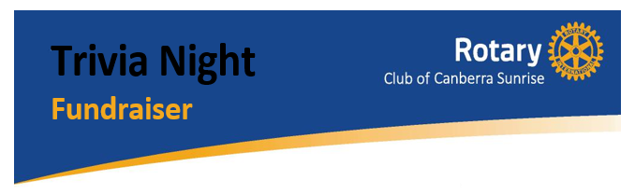

Friday, 4th October

Join us for a night of fun, trivia, raffles, a silent auction and much more!
All funds raised will go to Rise Above - Capital Region Cancer Relief, who provide financial assistance and support to cancer patients and family residing with them within the ACT, Queanbeyan and surrounds. Their mission is to reduce the emotional and financial burden on families who have a member undergoing treatment for cancer.
To learn more about Rise Above, visit: https://riseabovecbr.org.au/

Where: Olympus Room, The Hellenic Club, Matilda Street, Woden
When: Friday, 4th October 2019
Doors open at 7:00pm
MC: Andrea Ho, ABC manager and personality
Trivia Night will start at 7:30pm and finish around 11pm

Bookings Are Essential
Tickets: $31.50* per person (book individual or group tickets, or a table of 10)
From: https://www.trybooking.com/529720

The Rotary Club of Canberra Sunrise are a small and motivated club with a goal to serve our local community with a strong focus on youth. Check us out at http://www.rotaryclubofcanberrasunrise.org.au/

For more information, please email: RCCSTrivia@gmail.com, or phone 0488 471 458
*including web site booking and credit card fees.

Note that meals are available from several restaurants in the Hellenic Club before the event (not included in the price).

