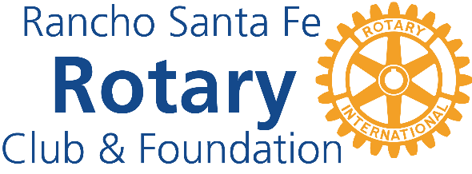 | Rancho Santa Fe Rotary Club Foundation Grant Guidelines (2026 Grant Cycle)

Purpose The Rotary Club Foundation is committed to improving lives in our community by supporting local nonprofit organizations. Our goal is to fund meaningful, measurable, and sustainable projects that align with Rotary’s values of service, integrity, and community engagement.
Available Funding
- Total funds available: Approximately $125,000 to $175,000
- Grant range: $1,000 to $10,000 per organization
- Project duration: Must be completed within 6 months of award
Eligibility Criteria To apply, organizations must:
- Be a registered 501(c)(3) nonprofit for a minimum of two years with CA 23701 tax exempt status
- Be in or near San Diego County
- Demonstrate a history of sound financial management and accountability
- Align with at least one of the Rancho Santa Fe Rotary Club's areas of interest:
  - Homelessness
  - Children’s Services
  - Military and Veterans
  - Food for Needy
  - Animals in Need
  - Other Abled Persons
  - Anti-Human Trafficking
  - Mental Health
  - Medical Research
Funding Priorities Preference will be given to projects that:
- Directly serve vulnerable or underserved populations
- Have clear and measurable outcomes, such as a project
- Encourage community engagement and volunteerism
What We Do Not Fund
- Individuals or scholarships
- Religious activities (faith-based organizations may apply for non-religious projects)
- Political campaigns or lobbying efforts
- Endowment funds, bank or investment accounts
- Fundraising for other organizations
- Pass-through grants or general reserve funds
- Projects that discriminate based on race, national origin, ethnicity, gender, political affiliation or religious belief.
- Organizations with outstanding reports from previous Rotary Club grants
Application Requirements Applicants must submit:
- Completed application form
- Copy of current organization budget with projections if prior year
- IRS Federal Determination Letter for 501(c)3 and CA State (23701) tax identification charitable status in place for two years with latest IRS 990 form filed.
- All requested supporting documentation must be provided with the application
- Submit completed application form and all additional required documentation and/or attachments in PDF format by email
Review Process Applications will be evaluated based on:
- Community need and project impact
- Projects where we feel our contribution makes a difference
- Alignment with the Rancho Santa Fe Rotary Club’s areas of interest
Final decisions will be made by the Rancho Santa Fe Rotary Club Foundation Board of Directors. Selected applicants may be contacted for more information, invited for an interview, or site visit.
Reporting Requirements Grant recipients must:
- Submit a final report within 30 days of project completion or no later than six months from receipt of funds
- Post the Rancho Santa Fe Rotary Foundation logo on organization website or other social media when awarded the grant
Key Dates
- Application opens: August 1, 2026
- Deadline to apply: October 31, 2026
- Award notifications: No later than March 31, 2027
- Final project completion deadline: Six months from receipt of funds
Contact Information For questions or to request an application form, please contact: RSF Rotary Foundation Chair
Email: RSFRotaryFoundation02@gmail.com
Website: RSFRotary.com

