PoipuRotary.Org
KOLOA MIXED SOFTBALL RULES AND REGULATIONS
2026

- FIELD REQUIREMENTS

  - Distance between bases: 60 feet (measured from the tip of home plate to the outside corner of first base)

  - Distance to pitcher’s mound: 46 feet (measured from the forward edge of home plate to the forward edge of the pitcher’s plate). A pitcher will pitch with one foot within the pitcher’s box upon delivery from a distance measuring 46 feet to 52 feet from home plate.

  - The strike mat, measuring 19 inches wide by 34.5 inches long, will be placed over home plate and be aligned with the front edge of home plate. DEFENSE: A defensive player making a play at home will be allowed to complete the play by touching any portion of the strike mat. If a defensive player kicks or moves the mat during the play the runner scoring will be declared safe.

  - A strike is a legal pitch touching any part of the strike mat.

  - DOUBLE BAGS: Double bags at first base shall be used for league play. A double bag (hereafter referred to as the “inner” or “outer” bag or “base”) of equal size shall be used at first base. The outer bag shall be placed in foul territory abutting first base. If there is a play on a batter-runner going to first base, the batter-runner shall touch the outer base and, if not, shall be declared out unless in the Umpire’s judgment the batter-runner is avoiding a collision.

After the batter-runner has safely reached first base, the double base is treated as one base and the fielder or runner may use any portion of the double base.

  - SCORING PLATE: Refer to Diagram located in Rule Book
    - The scoring plate shall be placed with the back tip of the plate 8 feet from the forward left corner of the home plate. The scoring plate shall be situated on an imaginary extension perpendicular to the third base foul line. The scoring plate shall be anchored to the ground to prevent slippage and change of position during the game.
    - A foot down on the scoring plate prior to the ball being received by a defensive player touching home plate is the same as a foot down on home plate for the purpose of scoring a run.

1.6.1 TWENTY (20) F00T LINE:

    - A 20-foot line measured from the tip of home plate towards third base will be used for all league games.

    - At the spot marking the 20 foot distance, there will be another commitment line approximately six (6) feet long intersecting the runner’s line. (Three feet on each side of the runner’s lane)
    - For this rule, any base runner that either touches this line or passes this line is committed to home plate and the play will be considered a force play at home plate. A player who re-crosses the commitment line back to third base will be declared out.
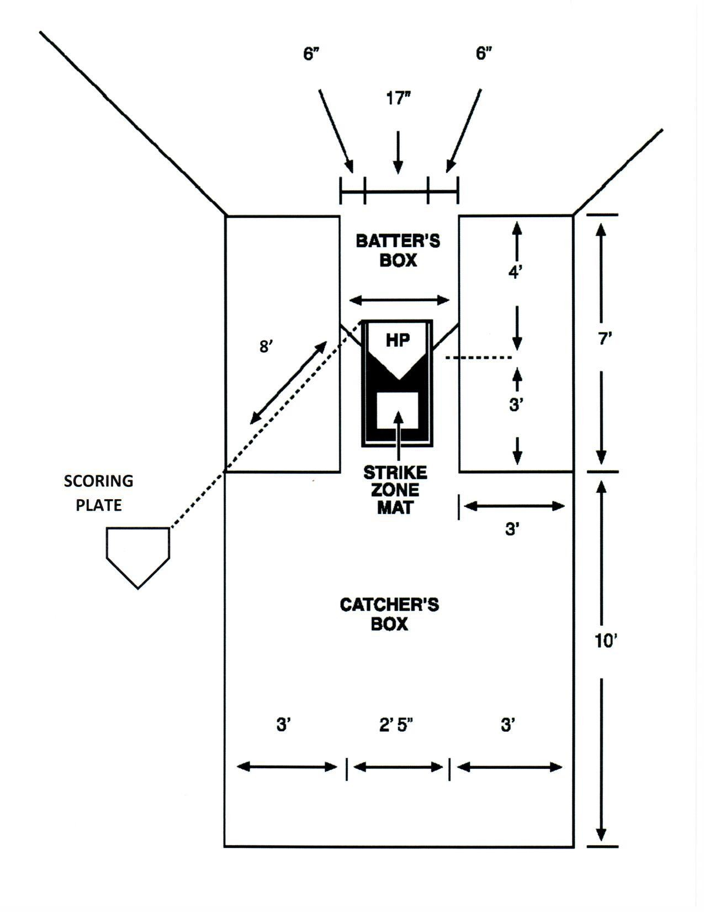

- OFFICIAL BALL

  - Fourteen (14) inch inseam type balls shall be used for all games during the league. Eleven (11) inch ball pitched to Wahine.

- GAME LENGTH, RUNS, TIES

  - An official game must be not less than four and a half innings if the home team is ahead.

  - A 12-run TKO rule will be in effect for all games. However, teams must complete five (5) innings of play or 4 ½ innings if the home team is ahead.

  - After 45 minutes has expired, that inning will be completed and one additional inning will be played. Time outs taken for injuries, protests, or weather delays shall be excluded from the 45 minutes allotted play time. Home Team or designee will be scorekeeper, and shall ensure that the time clock is stopped and restarted in accordance with this rule.

  - Batters start with 1-1 Count. One courtesy foul ball on 3rd strike, then foul out.

If, in the Umpire’s judgment, a team is intentionally delaying play to manipulate the time clock the Umpire may issue a warning. Additional delays may be cause for the umpire to call a ball on the pitcher.

  - A fifteen minute grace period may be permitted for the first game only. When there are multiple games on a specific field, teams scheduled to play shall be ready to play their game not less than 30 minutes prior to the scheduled game.

  - Except as otherwise provided, there shall be a maximum of five (5) runs per inning, except for the final inning of the game in which each team can score an unlimited number of runs. The umpire shall announce the last inning unless it is the seventh inning.

  - When teams are tied and going into extra innings, each team starts each inning with a runner on second base. The runner must be the last person who batted the previous inning, whether he/she made the third out or not and no substitute or courtesy runner may replace him/her until he/she has reached third base. NOTE: If the last player at bat cannot continue to play due to injury, illness, etc., he/she will be declared out and the next previous batter will be the tie-breaker runner.

  - The Chief Umpire shall declare the starting time right after the first pitch.

- PLAYER ELIGIBILITY

  - All players must be 18 years and older to participate and shall only be added to a team’s roster upon reaching the age of 18.

- ROSTERS

  - There is no limit to the number of players on a team’s roster.

  - Final and complete rosters must be submitted to the League Coordinator, no later than January 14, 2025.

  - All players must sign the roster/waiver form, prior to play.
  - If a team is short players, up to 2 may be “picked up” from another team, for that game.

  - Only official roster/waivers will be accepted. Only League Coordinator & Coaches will be involved in discussions if any problems should come up.

- PITCHING

  - Any player 18 years or older may pitch.

  - There is no limit to the number of innings one may pitch.

  - * The pitched ball must be delivered with a perceptible arc and reach a height of at least six (6) feet from the ground. NO maximum height.

  - A pitcher is allowed five warm-up pitches prior to the start of the game and three (3) warm-up pitches between innings.

  - The use of a pitcher’s mask is recommended for all pitchers.

- EQUIPMENT AND UNIFORMS

  - All players must use a glove.

  - Use of a catcher’s mask is optional.

  - Playing with bare feet is not allowed. Metal spikes are not allowed.

  - UNIFORMS: OPTIONAL Only the cap, visor and jersey need to be alike in color and trim provided that use of caps or visors is optional. Pants and shorts must be the same color excluding trim. Anytime a player is found to be out of uniform, the opposing team must file an appeal to the umpire PRIOR to the player playing, and if not, the opposing team forfeits its right to any future appeal. The Umpire, upon an appeal, must prohibit play by the player until the player is in compliance. An Umpire, with or without an appeal can prohibit play by a player out of uniform.

  - Six (6”) inch high numbers on uniforms are required.

  - Only official softball bats may be used.

  - Titanium bats are not allowed.

  - The base size shall be 15” x 15” x 2”.

- PHYSICAL VIOLENCE

  - A member (player, coach, scorekeeper, umpire) who is involved in a physical fight, violent contact or verbal abuse of any other member or tournament official shall immediately be ejected from the game, and upon approval of the island coordinators may also be banned from the league.

  - Any player(s) who physically or verbally abuses or makes contact with any umpire or tournament official shall be barred from the game and league from that point on.

- PLAYING RULES

  - BASE RUNNING:

    - Players may overrun a base, but, when doing so, may not advance to the next base unless the over-run base is re-touched first. The only exception is overrunning first base where re-touching is not required. The defensive team must appeal the play if there is an infraction.

    - Sliding is not allowed. Players who slide shall be called out

    - A base runner shall be called out if he/she does not remain on the base until the ball is hit, whether the ball is fair or foul. However, if the batter swings and misses, the runner will not be declared out for leaving the base.

    - Foul ball over road into field = OUT. Foul ball in parking lot into stream = OUT.
.
Once a pitched ball hits the ground the ball is dead.

Once a non-batted ball hits the ground, a runner may step off the base. However, if in the judgment of the umpire, the runner is making an attempt to advance to the next base, the runner will be called out.

If a base runner slips or falls he/she must not use his/her hands to touch the base or will be declared out. Exception: This rule shall not apply if there is no play at the base.

    - Knocking A Ball Loose. If a runner knocks the ball loose from a defensive player by physical contact, the runner will be declared out and the ball automatically becomes dead providing that in the Umpire’s judgment the defensive player has possession of the ball. This rule is intended to discourage “bumping” and unnecessary physical contact between players.

    - On plays at second or third base, the base runner finding the base blocked by the defense must run by the base and be declared safe or out by the Umpire.

To avoid contact, a runner does not have to touch the base. He/she must run on either side of the base. However, if it is a force play, the defensive player must touch the base with the ball in his/her possession and control.

If it is a tag situation, the defensive player must show an attempt to tag the runner as follows:
    - On Base. A runner shall be called out when the defensive player, on base and in possession of the ball, breaks the plane of the base on the side the runner is running.
    - Between bases. Defensive players in possession of the ball shall physically tag the runner.

Both situations are judgment calls by the Umpire.

INTERFERENCE
      - Interference by the batter or runner will be called when, in the judgment of the Umpire, the base coach at third base or first base physically assists him/her in returning to or leaving third or first base. Penalty: the runner will be called out and the ball is dead.
      - Interference is the act of an offensive player that impedes or confuses a defensive player attempting to execute a play. A base runner must avoid a fielder making a play. Penalty. The offensive player shall be called out and the ball is dead.
OBSTRUCTION
Obstruction is the act by a fielder, who is not in possession of the ball, or not in the act of fielding a ball or not about to receive a thrown ball, who impedes the progress of a runner who is legally running the base. The ball is dead and all runners are awarded the base they would have reached.

  - Courtesy Runner

    - Unlimited courtesy runners are allowed each inning. Wahine for Wahine. Wahine can run for Kane.

    - Any player on the official line-up sheet including available substitutes may be used as a courtesy runner.

    - A courtesy runner is in the game when he/she touches the base.

    - If a second courtesy runner replaces the original courtesy runner who has touched the base the umpire must call an out.

    - A courtesy runner whose turn at bat comes up while he/she is on base will be declared out. He/she will be removed from the base and come to bat. A second courtesy runner cannot be substituted at this time.

    - A player may be a courtesy runner only once per inning.

    - A courtesy runner may not run for an existing courtesy runner except for an injury.

    - A runner who is replaced with a courtesy runner may not be used as a courtesy runner for the remainder of the inning.

  - A batter hitting foul on the third strike, second foul on third strike = OUT!

  - Extra Player (EP)
    - Use of an extra player is optional, but, if one is used, the EP shall be designated on the official line-up sheet. If the EP is used, he/she must be used the entire game.

    - The EP must remain in the same position in the batting order for the entire game.

    - A team may use unlimited EP’s (optional) on offense, however, only ten (10) players must be used on defense. Three Wahine required on DEFENSE.

    - The EP may be substituted for at any time. The substitute must be a player who has not yet been in the game. The starting EP may re-enter. An EP may interchange positions with another player in the game provided that each player remains in the same batting order.

  - Should an offensive player become injured, or for any other reason, which causes the team to drop below the original batting line up, the team will not be forced to forfeit the game and an out will declared only the first time that position comes to bat. However, no team shall play with less than 9 players.

  - If an out is recorded, the ball must go immediately back to the pitcher. There will be no throwing the ball around the infield after an out is called (no “around the horn”) and if so the consequence shall be:
    - 1st time: Warning
    - 2nd time: A ball will be recorded for the next batter.
  - EJECTED PLAYER. When the player who has left the game because of an ejection is scheduled to bat, and no eligible substitute is available, an out shall be recorded for each turn at bat. If an ejected player is discovered participating in the game, the game shall be forfeited.

  - HOME RUN. A batter that hits a ball over the fence to register a home run only has to touch first base to complete the at bat. Any player that is on 1st, 2nd or 3rd base only has to advance to the next base to complete the play.

  - At no time shall a batter carry his/her bat to the base.

- MISCELLANEOUS RULES

  - League FEES; $150/Season. The League fee will be set to cover balls. Scorekeepers & umpires may be paid and teams assessed for cost.

  - RAIN OUT. Teams in uniform must be present until the Umpire or the Tournament Director declares the game unplayable.
  - LINE-UP SHEETS. Line up sheets must be legible and include
    - First and last name of each player in batting order and their positions, including all eligible substitutes.
    - Jersey number

- RULES NOT COVERED

All rules not covered will be according to the Official Senior Softball –USA Rulebook.

- PROTESTS

Protests must be made at the time of the disputed play. All protests will be resolved before the game proceeds. Decisions of the protest committee are final. The protest committee shall consist of the Island Coordinators plus the Tournament Director. Alternates shall be used if a committee member is a player.

