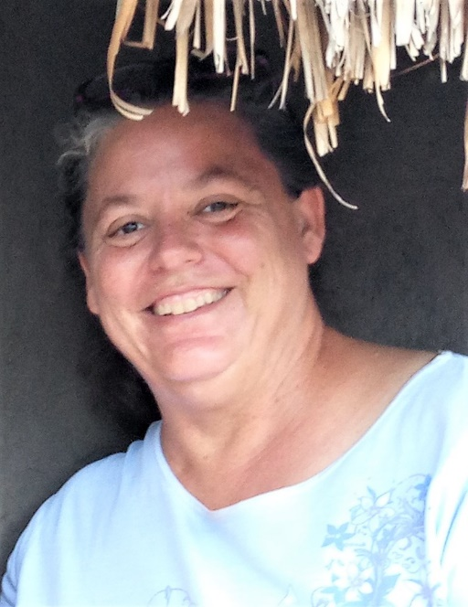
Rtn. Janine M LeGrand, Masindi Rotary Club 27430, District 9211, Uganda, East Africa

Janine is a 57-year old single missionary serving with SAMS (The Society of Anglican Missionaries and Senders) doing health work in Masindi, Uganda, East Africa. She is a graduate of Kapiolani Community College with an AA in Medical Assisting and of The University of Hawaii at Manoa with a BA in Zoology and a Professional Diploma in Secondary Science Education. She also attended Fuller Theological Seminary studying Cross-cultural Health Care for 1 year with a GPA of 3.92.
She has been high school science teacher both in Japan (US DoDDS) and at Sacred Hearts Academy on Oahu. She has also worked as a Certified Medical Assistant for Kahu Malama Nursing and as a veterinary lab tech and veterinary assistant, as well as having been sole care-giver for her father for many years.
Janine LeGrand under the eaves of a Ugandan local home with mud walls and a thatched roof which she was visiting to follow-up on a sick child.
Janine has served as a full-time cross-cultural missionary with SAMS since April 2008, serving for 1 year as a Missionary and Community Health Advisor, then for the last 10 years as the Diocesan Health Coordinator for the Diocese of Masindi-Kitara in Uganda. She is responsible for health activities in the entire Diocese and coordinating with other organizations - both within and outside Uganda in areas relating to health. Most of her work focuses on preventive measures such as clean water, nutrition, sanitation, malaria prevention, and helping people get access to quality clinical care. She helps organize the Ugandan side of medical outreaches with US medical teams, which come 5-6 times a year from several organizations, mostly OneWorld Health. She also teaches at the Diocesan Training Centre educating church leaders in training to be good examples of healthy behaviors and to be a resource to their communities. She helps ensure quality care at the local health center serving as a Medical Bureau Medicines Management Supervisor and doing quality control assessments. She even has a program to help ensure church workers preaching the Bible have reading glasses, so they can study the Bible and be more effective in their work, since reading glasses are still scarce where she works.
Janine is a new member of the Rotary Club of Masindi and is excited to be part of Rotary. The local Rotary club is involved with a number of health activities - such as participating in a Cancer Run to raise money for the national referral hospital’s cancer ward, local community health days, and Janine is even working on a plan for a possible Maternal-Child Health Rotary program to help get high-risk pregnant mothers to be able to deliver near where emergency obstetrical care is available.
Janine lives by herself on a small home farm in Masindi with a cat, three dogs, five sheep, two cows, and numerous chickens, though she employs some workers to help her on the farm and with security. She grows a variety of fruits, vegetables, and herbs. Janine enjoys cooking, reading, and helping people in many ways. In addition to Rotary, she is also a member of the Christian Women’s Fellowship and The Order of the Daughters of the King.

