MAJOR GENERAL ROBERT G.F. LEE US Army (Retired)

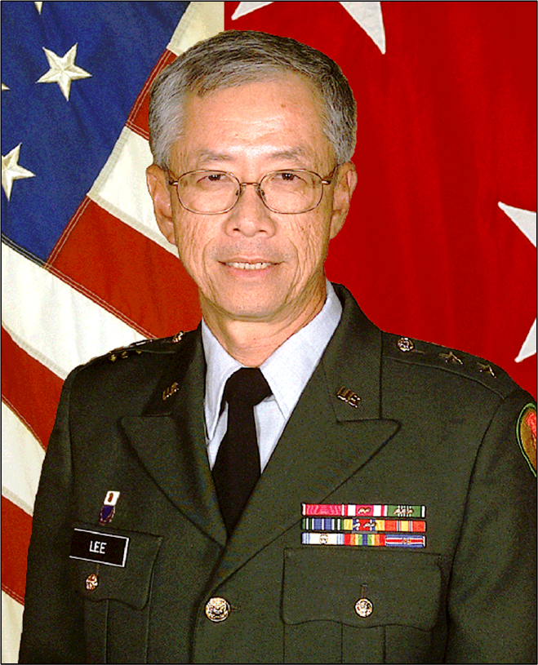
The Adjutant General
State of Hawaii, Department of Defense
Major General Robert G.F. Lee was appointed the Adjutant General, State of Hawaii, Department of Defense, on January 1, 2003 and served until January 8, 2011. In addition to commanding 5,500 soldiers and airmen, he served as the director of State Civil Defense (Emergency Management), heads Homeland Security for the State of Hawaii, provides direct support to the Office of Veterans Services, and mentored Hawaii’s at risk youths toward high school diplomas with the Youth Challenge Academy.
During his tenure as Adjutant General, he also served as a member of the Secretary of the Army’s Reserve Forces Policy Committee from January 2005 to January 2008. He was appointed by President George W. Bush for service on the Secretary of Defense’s Reserve Forces Policy Board from September 2007 to September 2010.
General Lee managed an operating budget of nearly $400M annually for the State Department of Defense of which $315M is allocated to the Army and Air National Guard and $85M funds Homeland Security, Civil Defense, Veterans Services, and Youth Challenge Academy. During his tenure, the Hawaii Air National Guard airlift squadron converted from C-130 medium airlift aircraft to new C-17 heavy lift airplanes, doubled the size of the KC-135 refueling squadron, and is currently transitioning from F-15 fighters to the new F-22 stealth fighters. Every operational unit in the Hawaii Air National Guard is a mix of Active Duty and National Guard airmen, the first State to achieve Total Force Integration in the US Air Force.
The Hawaii Army National Guard deployed to the Middle East in support of Operation Iraqi Freedom and Operation Enduring Freedom these past 8 years. Soldiers of the 29th Infantry Brigade Combat Team have twice deployed to Iraq and Chinook and Blackhawk aviation units have also deployed twice to Afghanistan and Iraq. Over 5000 soldiers and airmen in the Hawaii National Guard have deployed to the Middle East, yet the Hawaii Army National Guard is currently at 101% strength and the Hawaii Air National Guard is at 99% strength.
The Hawaii National Guard enhanced emergency preparedness to the State and Pacific with the certification of its Weapons of Mass Destruction Civil Support Team in 2003. This team is able to quickly analyze biological, chemical, and radiological hazards and determine the corrective actions required to mitigate the hazard. The Chemical, Biological, Radiological, Nuclear and High-Yield Explosive Enhanced Response Force Package was certified in 2006 to medically treat victims of a mass casualty event; to decontaminate victims of a chemical or biological attack and to perform urban search and rescue in the event of an earthquake or other natural disasters. As the Homeland Security Advisor to Governor Lingle since the inception of the Department of Homeland Security in 2003, General Lee provided the leadership for Pacific territories such as Guam, American Samoa, and the Commonwealth of Northern Marianas in disaster preparedness, response, and mitigation. The Hawaii Catastrophic Plan, developed in concert with FEMA Region IX in 2009, is now being replicated in these territories. General Lee understands the role of Defense Support to Civilian Authorities (DSCA) with the quick support to the Governor of American Samoa and FEMA during the earthquake and tsunami of September 2009 with Hawaii National Guard assets.
As part of the National Guard’s outreach to emerging democracies, the Hawai‘i National Guard began a State Partnership Program (SPP) with Indonesia in 2007. The SPP fosters a positive relationship between the United States and the world’s most populous Muslim nation. As a result of the devastating Aceh tsunami resulting in the death of over 250,000 people, the State Civil Defense in partnership with the Pacific Tsunami Warning Center and Indonesian Emergency Management authorities have expanded the tsunami warning network from 7 to 51 deep ocean tsunami warning buoys world wide and helped to establish the tsunami warning network in Indonesia. Hawai‘i Guard representatives and their Indonesian counterparts regularly engage in exercises designed to enhance response to natural disasters and train Indonesian military forces for UN peace keeping duties Lebanon.
Commanding General, 9th Regional Support Command (Brigadier General)
General Lee received his commission in May 1971 through the ROTC program at the University of Hawaii and was assigned to the 100th Battalion, 442nd Infantry, US Army Reserve. He served in successive assignments as platoon leader, company commander, and various battalion staff assignments and finally as battalion commander. During this period he also served two years on active duty with the 100th Battalion, 442nd Infantry as air operations officer.
Following command in 1991, he served as assistant chief of staff for operations and training (G-3), IX Corps (Reinforcement). In 1996, he served as the chief of staff, 9th Army Reserve Command until assignment as Commanding General of the 9th Regional Support Command, U.S. Army Reserve - Pacific from February 8, 1999 to his appointment as Adjutant General. General Lee commanded 3000 US Army Reserve soldiers in Hawaii, Alaska, Guam, American Samoa, Saipan, Japan, and Korea. The command consisted of soldiers with Infantry, Engineer, Civil Affairs, Medical, and Signal skills. During this period, he deployed Civil Affairs teams in support of US operations in East Timor and Kosovo.

Pacific General Manager-Perot Systems Government Services/ADI Technology
General Lee served 3 years (2000-2003) as the Pacific General Manager in charge of maintenance on fast attack nuclear submarines based at Pearl Harbor Hawaii. Additionally, the Hawaii office managed the maintenance of mini submarines in direct support of SEAL Team One at Pearl Harbor.

Nuclear Engineer
General Lee’s civilian career includes 27 years of service overhauling nuclear submarines at Pearl Harbor Naval Shipyard (PHNSY) with his final assignment as Superintendent of Nuclear Regional Maintenance for the Pacific nuclear submarine fleet. He started his career at the shipyard serving as a nuclear shift test engineer on Skate and Sturgeon Class submarines. He served as Nuclear Chief Test Engineer on USS Tunny overhaul in 1979. This overhaul was completed on schedule and within budget. Following active duty, he served as Deputy Director of Nuclear Facilities preparing the shipyard to overhaul Los Angeles class submarines. In 1986 he transferred to Submarine Base Pearl Harbor to head Nuclear Planning until consolidation with Pearl Harbor Naval Shipyard in 1995. He retired from PHNSY in March 2000.
Education:
Bachelor’s degree in Mechanical Engineering, University of Hawaii, Honolulu, HI (1971)
Master’s degree in Business Administration, University of Hawaii, Honolulu, HI (1983)
Licensed professional engineer in mechanical and nuclear engineering

Military education: Executive General/Flag Course (Asia Pacific Center for Security Studies), Army War College, the Command and General Staff Officers Course, the Infantry Officer Advanced Course, and the Air Force Ground Operations School.

Awards:
University of Hawaii Distinguished Alumni Award (2006)
McKinley High School Hall of Honor Award (2007)
Hawaii Council Engineering Society’s Lifetime Achievement Award (2013)
University of Hawaii College of Engineering Outstanding Service Award (2014)
Patriot Award by the Navy League (2016)
Ihe (Spear) Award by the Hawaii Army Museum Society (2018)

Military awards and decorations include the Army Distinguished Service Medal, Legion of Merit, Meritorious Service Medal, Army Commendation Medal, and the Army Achievement Medal.

Appointed by Secretary of Defense Ashton Carter as Hawaii State Chair, Employer Support of the Guard and Reserve (ESGR) October 1, 2016-present
Appointed to the Engineering Council for the College of Engineering, University of Hawaii at Manoa (2011-present)
Appointed to the Homeland Security Advisory Council assigned to FEMA (June 2011-June 2014)

Owner and President RL Security LLC
Consultant to Sierra Nevada Corporation for cyber security, intelligence, surveillance, and reconnaissance
Board of Governors, Go For Broke National Education Center
Member, 100th Infantry Battalion Veterans
Member, Chinese American Citizen Alliance (Seattle Lodge)
Member, Chinese Chamber of Commerce Hawaii

