[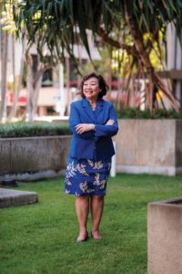](http://www.hawaiibusiness.com/wp-content/uploads/2019/04/HB1905-AY-Naomi-Masuno-1566.jpg)