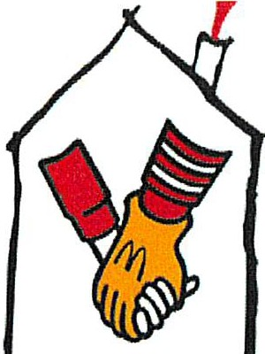
RONALD MCDONALD
----·®
HOUSECHARITIES
Ronald McDonald House Charities® of Hawaii, Inc.
Volunteer Release and Waiver Form

I, the undersigned, wish to volunteer at Ronald McDonald House

Chari- ties of Hawaii (RMHC-HI). I understand that there may be certain risks involved in participating as a volunteer. Knowing this fact, I hereby release, discharge and hold harmless RMHC, its directors, officers and agents from all liability for personal injury, death, property damage and other loss or damage arising from or related to my own actions, the actions of RMHC-Hl's clients, volunteers or RMHC-HI. I hereby agree that I, my heirs, legal representatives and assignees will not make any claim against RMHC-HI for personal injury, death, property damage, or loss resulting from negligence or other acts, whether caused by the negligence of RMHC-HI or otherwise.

I hereby release and discharge RMHC-HI from all actions, claims or demands that I, my heirs, legal representatives and assignees now have or may hereafter have for personal injury, death, or property damage in connection with or arising out of my volunteer work with RMHC-HI, even if caused in whole or part by the negligence of RMHC-HI. I further agree that I shall indemnify and hold harmless RMHC-HI from and against any and all claims, damage losses, expenses, including litigation costs, arising out of or resulting from my actions in connection with my RMHC-HI voluriteer activities, provided that any such claim, damage or loss is caused in whole or in part by my own negligent act or omission, regardless of whether it is caused in whole or in part by the negligence of RMHC-HI.

I expressly agree that the foregoing Release and Waiver is intended to be as broad and inclusive as permitted by the laws of the State of Hawaii, and that if any provision is held as invalid, it is agreed that the remaining provisions shall, notwithstanding, continue in full force and effect. I understand and intend that this Release and Waiver shall remain effective from the date of execution.

I have carefully read this Release and Waiver, and fully understand its contents. am aware that this is a release of liability and I have signed it of my own free will.

X
Print volunteer name

X
Volunteer signature Date
X
Signature of parent or guardian Date (If volunteer is under 18 yrs. old)
Volunteer forms for minors without a parent/guardian signature will not beaccepted.

Criminal Record Disclosure & Verification
I understand that RMHC-HI holds a position of trust with the children and families who are guests at its facilities, as well as the community at large. To protect this trust, RMHC-HI may ask me to provide personal references, and reserves the right to do a criminal record check on me. By signing this application, I agree to disclose to RMHC-HI any potential conflict of interest and anything in my background that may affect the trust between RMHC-HI, the fami­ lies, children and community. While RMHC-HI is grateful for all interest in its volunteer pro­ gram, I understand and agree that RMHC-HI reserves the right to decline a person's offer to volunteer.

Volunteer Guidelines
I agree to abide by all the guidelines and policies set forth in the RMHC-HI Volunteer Pro­ gram.

X
Print volunteer name

X
Volunteer signature Date

X

srgnature of parent or guardian (If volunteer is under 18 yrs old)
Date

Volunteer forms for minors without a parent/guardian signature will not beaccepted.

Photo Release Section

Yes_(lnitial), I hereby authorize Ronald McDonald House Charities of Hawaii (RMHC-HI) to use my photographl and/or story in all materials related to media coverage and RMHC-HI publications.

No (lnitial), I hereby choose not to have Ronald McDonald House Charities of Hawaii
(RMHC-HI) to use my name, photograph, and/or story in any materials related to media coverage and RMHC-HI publications.

Print volunteer name

Volunteer signature Date

Print parent or guardian's name (if volunteer is aminor)

Parent or guardian's signature (if volunteer is a minor) Date

EMERGENCY CONTACT: (REQUIRED)
Print name:

Name: Phone#:

Relationship:

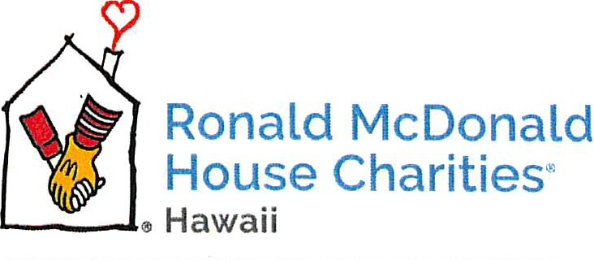
Volunteering at the Ronald McDonald HOuse
on Judd Hillside Keeping families close··

Mahalo for volunteering your time to help the families staying at Hawaii's Ronald McDonald Houses! Here are some friendly reminders:
- If you are feeling ill, please do not come to the House to volunteer and notify the House at (808) 973-5683 AND the Volunteer Services Manager, Kiree Higa, (808) 304-2399.
- Please wash your hands often, including after using the restroom, after using cleaning products and before preparing any food.
- Volunteers are asked to follow house rules.
- We ask that volunteers find street parking.
Please see the next few pages for information about where to park, etc.
- If you'd like a ride from your parking spot to the house, please contact the On Duty Staff Member at 351-2755 and they will pick you up as soon as they have a spare moment. Mahalo for your patience!

Getting to the RMHCH House at
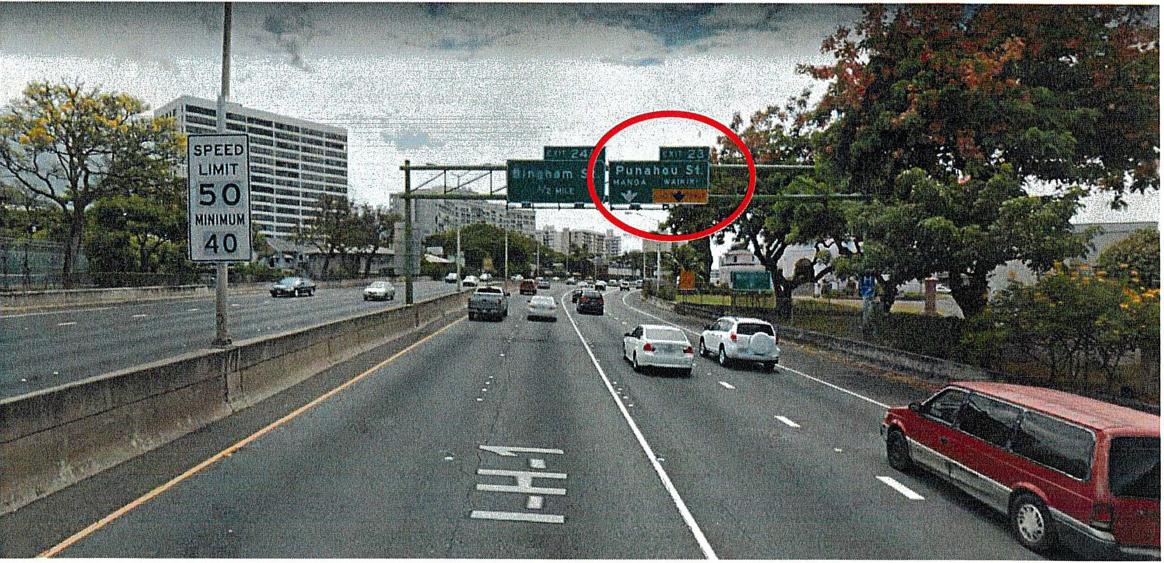
1970 Judd Hillside (from H1 Eastbound)

Getting to the RMHCH House at
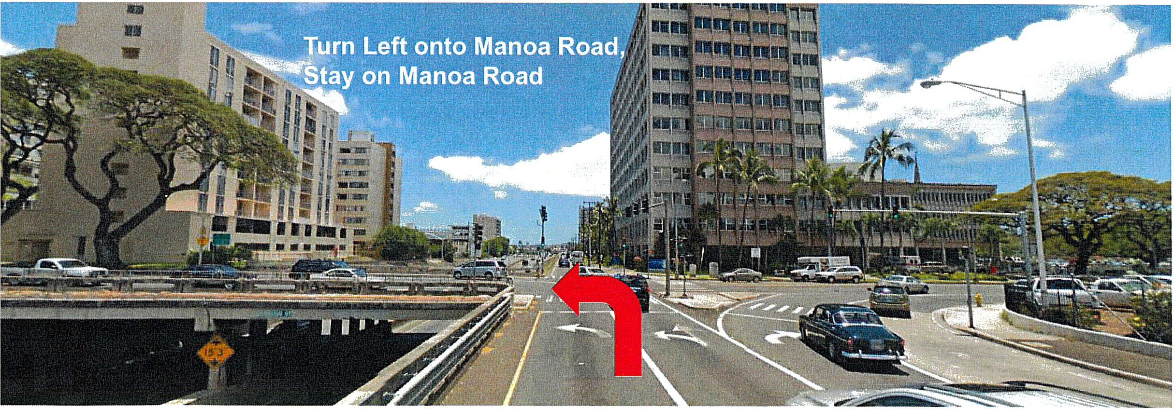
1970 Judd Hillside {from H1 Eastbound)

Getting to the RMHCH House at
1970 Judd Hillside {from H1 Eastbound)
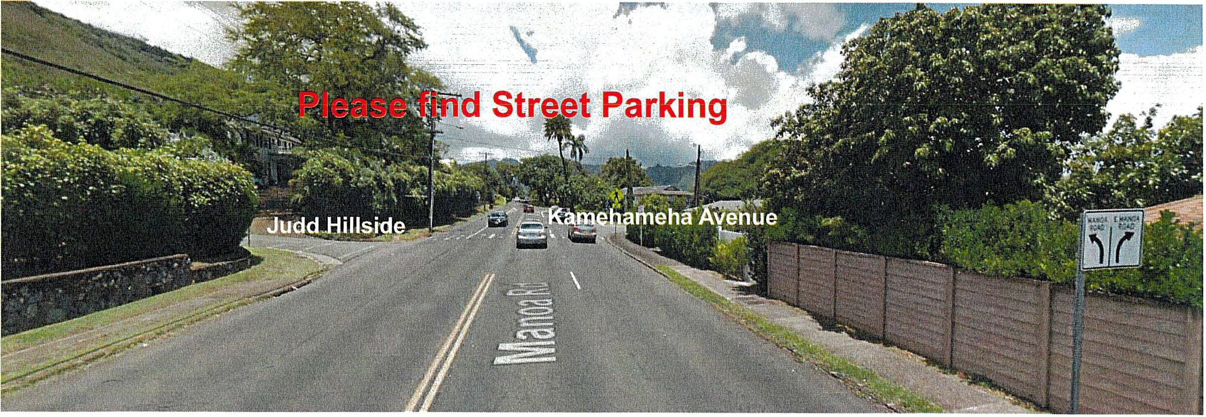

Mahala for Volunteering with
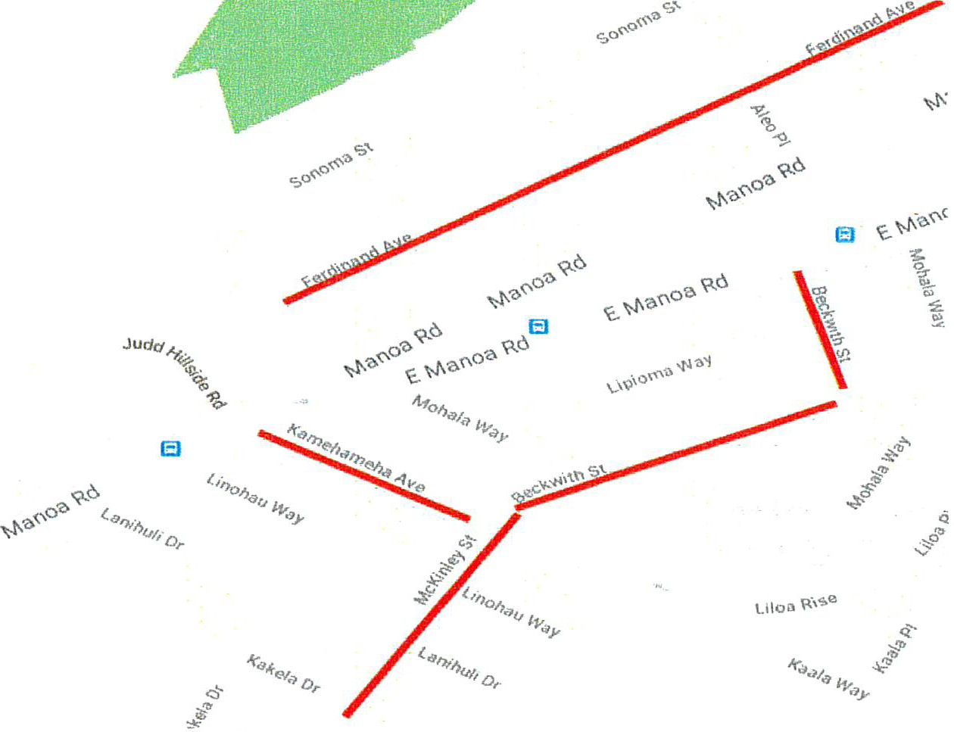
Ronald McDonald House Charities® of Hawaii!
Please find street parking in these locations:
- Kamehameha Ave.

- McKinley St.
- Beckwith St.
- Ferdinand Ave.

,Iii Placo
Ronald McDonald House 9

midyar K-1 elghborhood

l G o o g le
a,,,£

Keeping families close
RM H c·
Need a ride to RMHC from your car?
Call 808-351-2755 and a staff member will pick you up!

Getting to the RMHCH House at
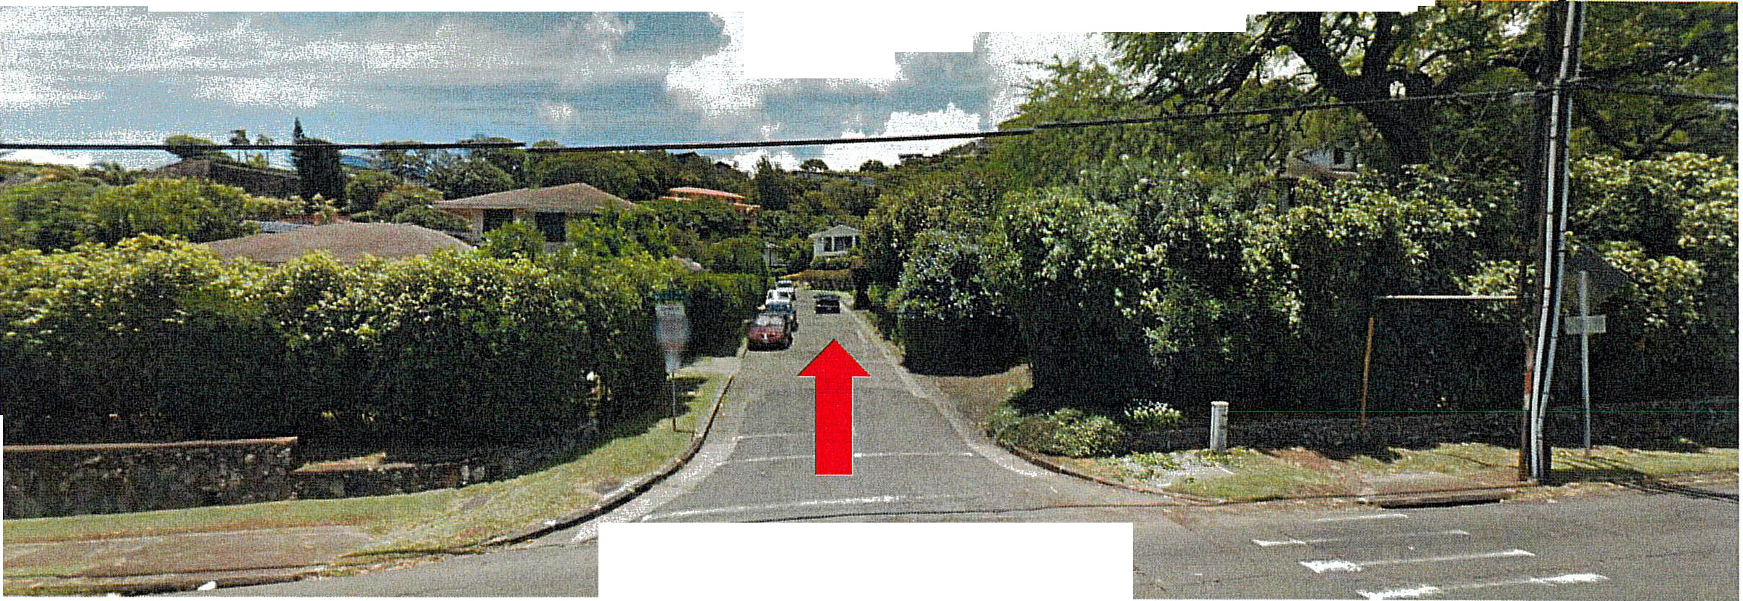
1970 Judd Hillside {walking to the house
.
::t; ,- .;,: -; "_...;.:.
. '
..
- - ---- - ·----- -·----
Wall< l!J tluaa Hillsic:te Roac:t

Getting to the RMHCH House at
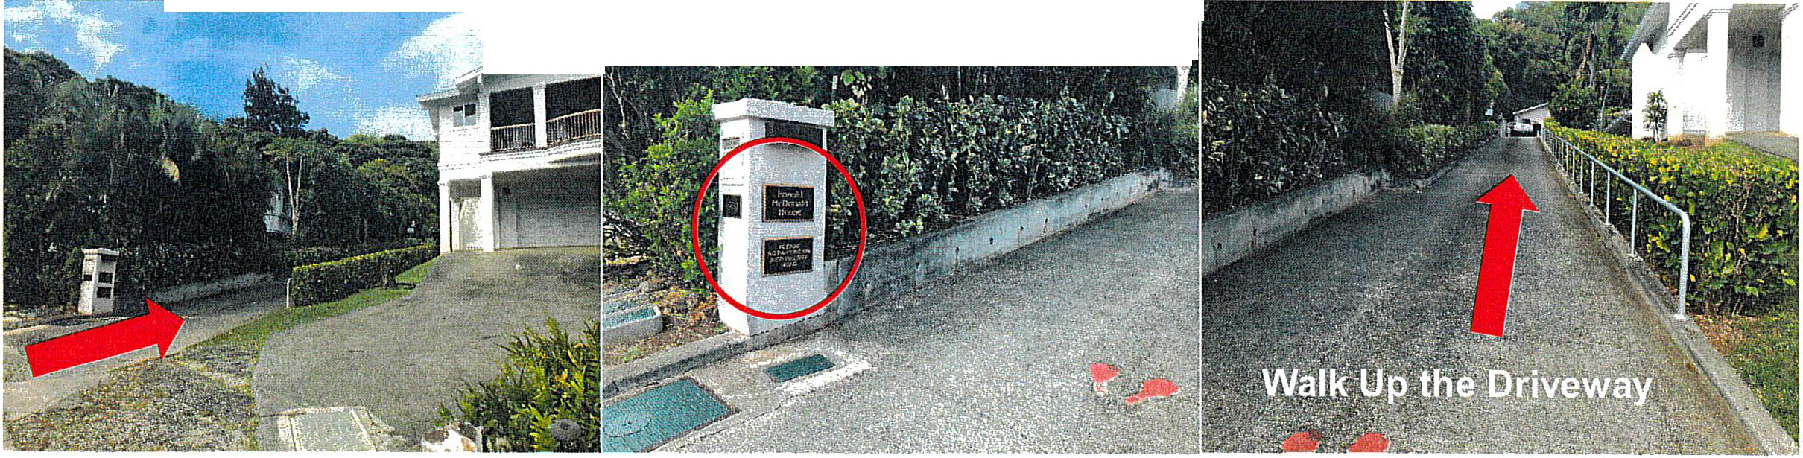
1970 Judd Hillside (walking to the house)
'
j
. r, ;
'
/.
,

Getting to the RMHCH House at
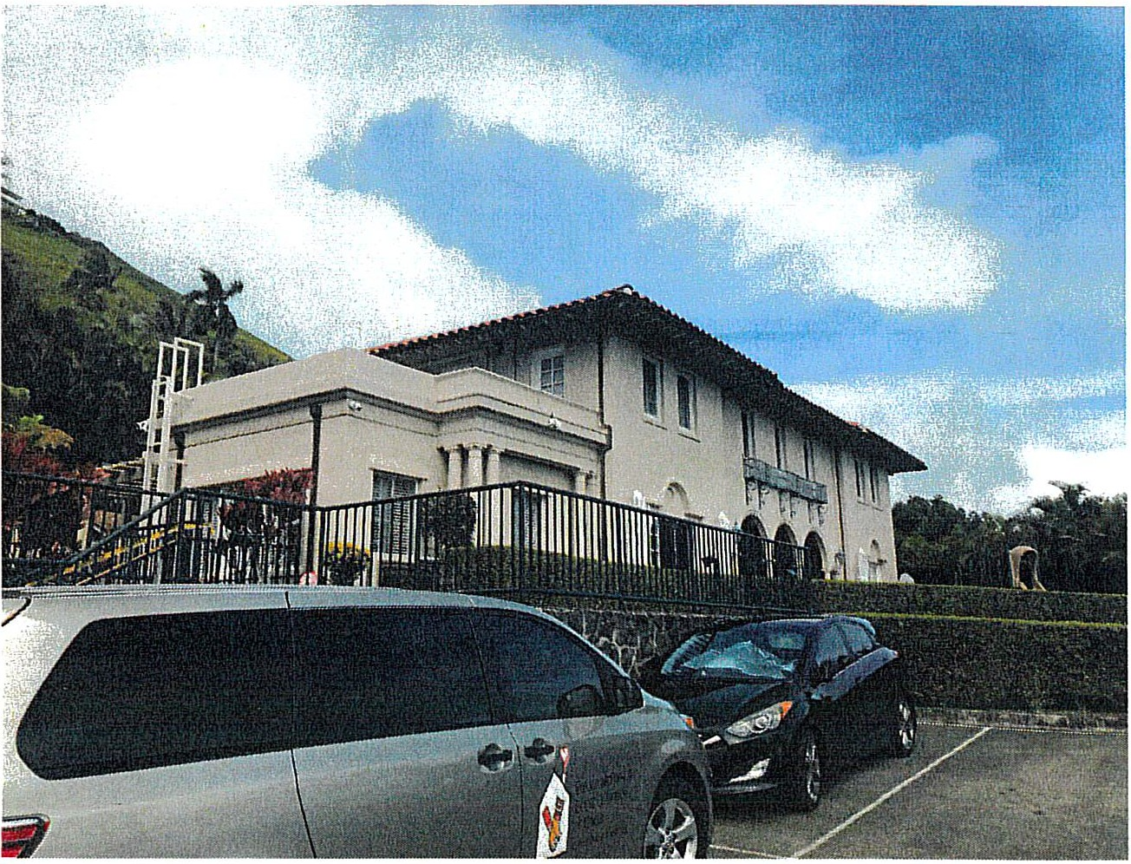
1970 Judd Hillside {walking to the house)

Please enter the house and check in with a staff member. Our offices are located on the right side of the house.
We truly appreciate your time and kokua!

