.• ·ASSETS
. .... SCHOOL

Paul Singer Head of School

A self described "Assets student," Singer came to Assets in 2007 from The Country School in Los Angeles where he'd been Head of School for nearly 30 years, serving students with a profile very similar to Assets'. He has served on the faculty at California State University, Northridge (CSUN) since 1975, has a B.A. in Sociology,
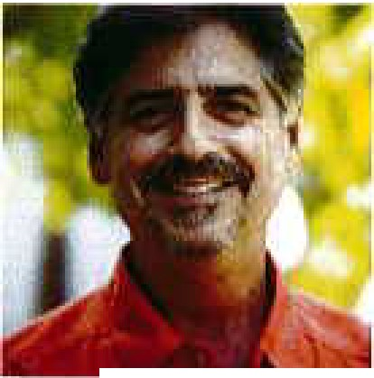

an M.A. in Social and Philosophical Foundations of Education and an M.A. in Educational Administration and Supervision, all from CSUN. He completed all Doctoral coursework in Educational Leadership and Policy Studies at the University of Southern California. Singer graduated high school with a 1.9 GPA and his parents were told he was never college material. It was only through his luck being born into a family of means, the perseverance of his mother and grandmother, and the intervention of education mentors that he sought assistance and found his calling in education.

K-8 Campus • One Ohana Nui Way, Honolulu, Hawaii 96818 High School Campus • 913 Alewa Drive, Honolulu, Hawaii 96817

P 808.423.1356 • F K-8: 808.422.1920 HS: 808.595.0259 • info(wassets-school.net • www.assets-school.net

