Franklin Don Pacarro, Jr., Esq.

[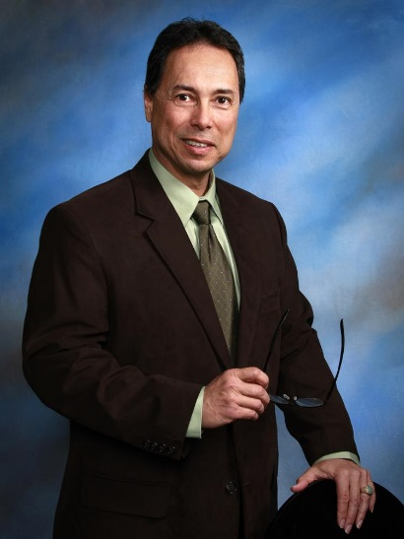](https://www.bizjournals.com/)

Mr. Pacarro has been the Administrator of the Honolulu Liquor Commission, City & County of Honolulu for approximately 4 and half years (7/1/14 to present). He was in private practice at the law firm of CLAY CHAPMAN IWAMURA PULICE & NERVELL for approximately 3 and half years (10/18/10 to 6/30/14), where he practiced various aspects of law, including civil litigation, business transactions and real estate law. Before entering private practice, Mr. Pacarro was a Deputy Prosecuting Attorney for the Department of the Prosecuting Attorney, City & County of Honolulu for 24 years (9/86 to 10/15/10). He tried over 85 jury trials and prosecuted 21 defendants successfully obtaining life sentences.

Pacarro was born in Honolulu and graduated from St. Louis High School, the University of Hawaii at Manoa, and the University of Hawaii's William S. Richardson School of Law.

He currently is a member of the Permanent Committee on Equality and Access to the Courts having been appointed by Chief Justice Mark E. Recktenwald for 3 terms and appointed by former Chief Justice Ronald T. Y. Moon for 2 terms.