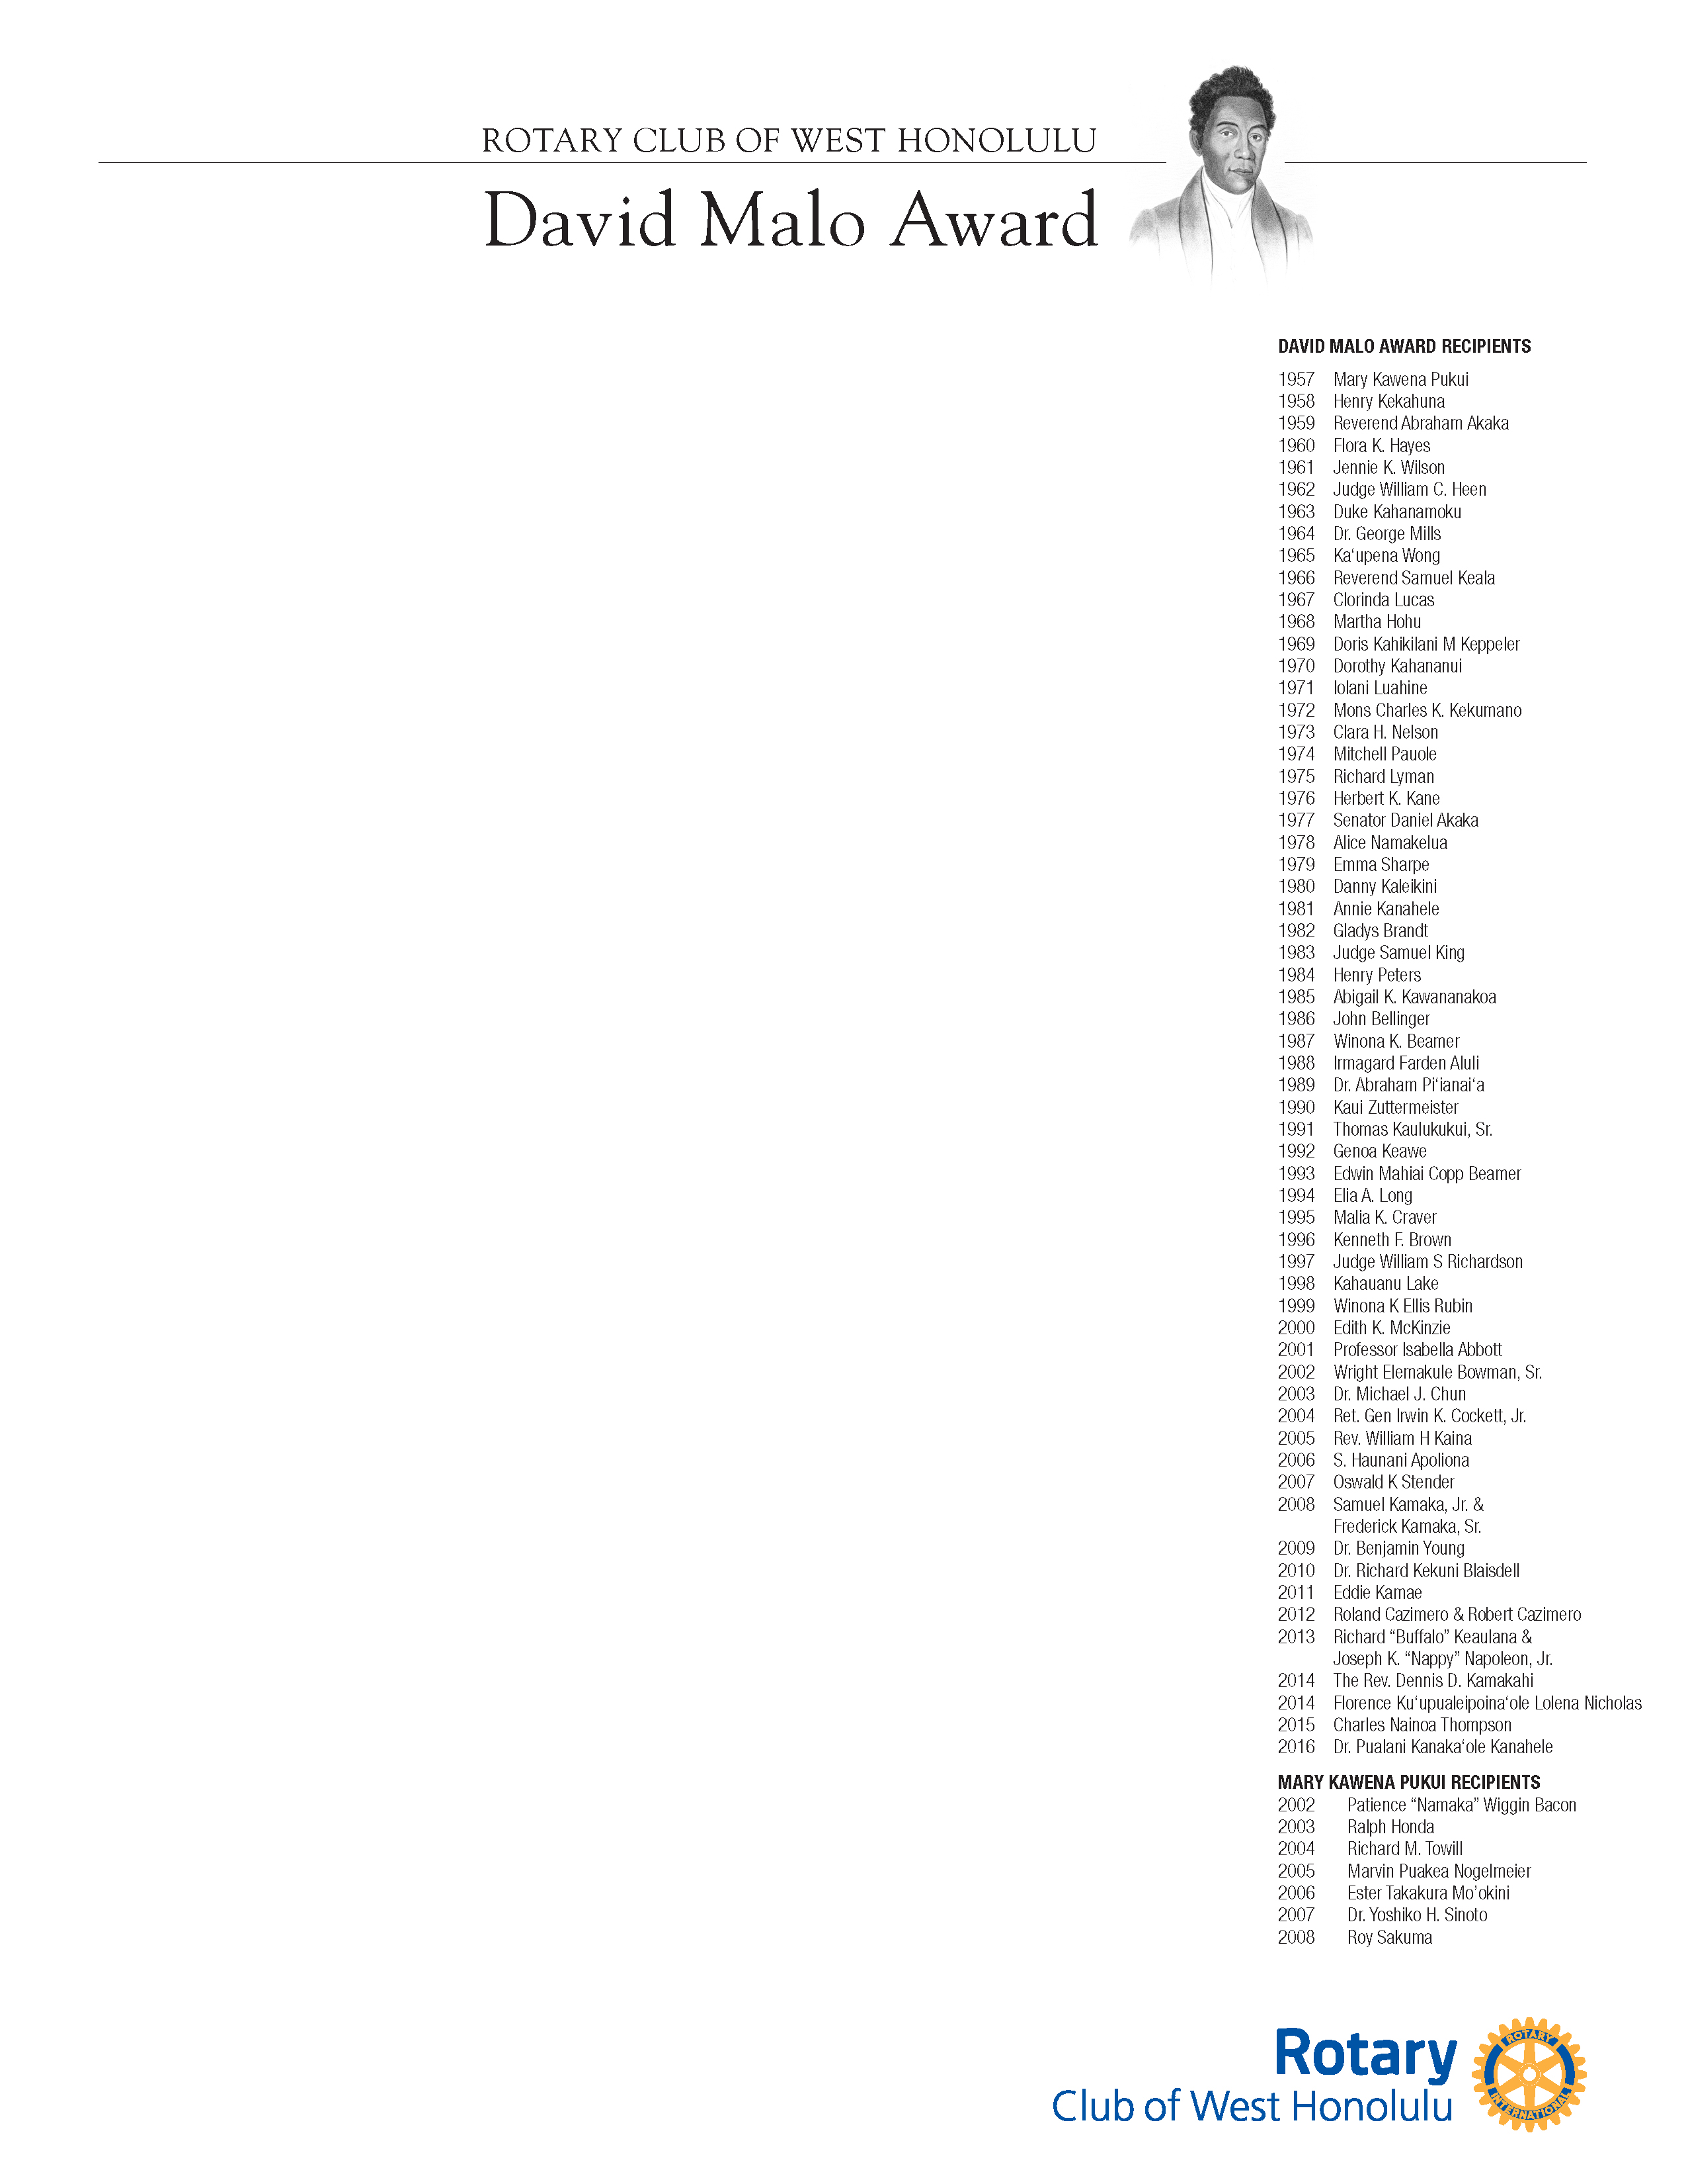

In Honor of Dr. Claire Ku'uleilani Hughes

Friday, October 20, 2017

Hale Koa Hotel, Waikiki Ballroom

2055 Kalia Road, Honolulu, Hawaii 96815

**Program**

6:00PM to 6:30PM No Host Cocktail Reception

6:30PM to 8:00PM Dinner

8:00PM to 9:00PM Award Program

**Reservation Request:**

#______ of Sponsor Table for 10 at $1,000 each

#______ of Individual Adult Seating at $80.00 each

#______ of Children Seating at $20.00 each

Name: ________________________________________________

Address: _______________________________________________

Telephone: _____________________________________________

Email Address: _________________________________________

Fax Number: ___________________________________________

Name under which Sponsorship Table will be: _________________

**Method of Payment**

$______ Check (Payable to West Honolulu Rotary Club)

$_______Credit Card [ ] Visa [ ] MasterCard

Card Number:____________________ Expiration Date ___________

Print Name of Cardholder ___________________________________

Signature: ________________________________________________

**Payment is required with this reservation form. You will not be**

**registered as a guest if payment is not enclosed. Thank you**

**Send form and payment to:** Deadline to register is October 10, 2017

**Dr. Stanley Wong, DDS,**

**1600 Kapiolani Blvd., Suite 1021**

**Honolulu, Hawaii 96814. Phone: 955-3522 WDA88@juno.com**

**Reservation Deadline: Friday, October 6, 2017**