Showcase your company’s ad and gain exposure in the community with Rotary club of West Kauai Partnership program.

Our Rotary Club recently integrated ClubRunner into our club and as such we would like to present you with a partnership opportunity! This partnership is designed to give maximum exposure to your business through our website. We invite you to display your company’s ad on our website, which we will display throughout our website as well as on our weekly bulletin.
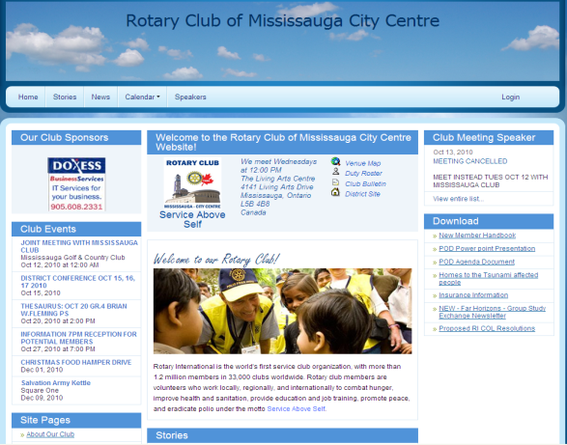
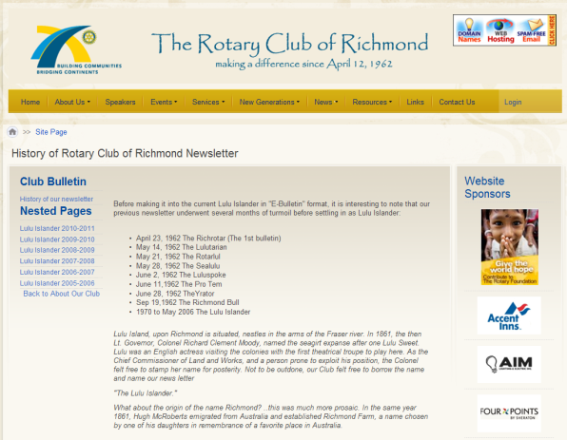
Ads will be displayed on the home page, on the right hand side of all secondary pages and on the weekly bulletin.

Ideal for your business

The majority of visitors to our website are members of our local community and the concentration of these Internet visitors are neighbors. It is uncommon to find such a high concentration of Internet visitors coming from the same neighborhood. This makes our website an ideal site for businesses offering products and services in that area. Partnering with our non-for-profit club will also enhance your business’ public image.

What’s more is that your company’s ad comes with real time tracking. Every time a visitor clicks on your ad, our software will record the click. Through us, you now have the ability to see how your sponsorship dollars are working for you.

We welcome you to participate in our Partnership program. Your sponsorship advertisement will be visible for 1 year and will be tracked by us throughout the term. To get started, we will need the following:

- Copy of desired logo in either .jpeg, .gif or .png format
- Company name as you would like it to appear
- URL or e-mail address you wish your ad to link to

Please complete the following form and e-mail or fax it back to us.
Business Name:
Contact Name:
Phone Number:
E-mail Address:
Sponsorship Amount (1 Year): $100 $150 $200 Other: $
Signature/Initials:
Comments (Optional):

Business Name:
We Thank You for Your Interest in our Partnership Program.

