West Kauai Rotary Club
Waimea Plantation Cottages
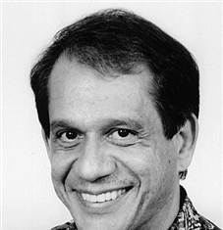
Speaker: Thomas Lodico

VOCATION/OCCUPATION: Tom is a Financial Advisor for Ameriprise Financial Services. His office is located in Lihue. He has won several first place honors for his client service.
ROTARY EXPERIENCE: He has been a member of the Rotary Club of Kauai since 1997. Tom’s experiences with Rotary are: Past-President of the Rotary Club of Kauai (2001-2002), Founding President of the Rotary Club of Kalepa Sunrise, Kauai’s Assistant District Governor in 2003-2004 & 2004-2005, District Staff from 2005-2011, and currently the District 5000 Treasurer. He also has been the Rotary Youth Leadership Awards chair for the past eight years. He is a graduate of Rotary Leadership Academy. Tom is a 2 time PHF and a benefactor. Tom also has received an award for perfect attendance for the past 11 years.
COMMUNITY SERVICE: Tom sits on seven community service boards and instructs Parliamentary Procedures at UH/KCC.
EDUCATION & MILITARY: His holds a Bachelor of Science degree from San Diego State University, a Master of Business Administration from National University at San Diego and an Executive post-degree in Advertising from the University of Texas at Austin. Tom was an officer in the United States Army.
INTEREST: Tom is also an advance speaker in the Kauai Toastmaster Club on Kauai. He has a passion for improving communication skills. Tom also is a member of the Kaiola Canoe Club.

ABSTRACT

